# Comet™ Change Log for January 1, 2020 to December 31, 2020

**2020-02-20D**

Improvements to the rights remapping module.

Report #77 shows the contract status on the far right column

**2020-01-25**

Producer report expense import has a new expense ID filter:

We have improved the import interface so  you can choose an expense record ID range for both the checking and the transfer. This gives you precise control over what expense records you transfer over.

When opening the screen, Comet will remember the last ID of existing records.   It will remember that number until you close Comet, so you can re-open the producer reporting screen on the same session.

By opening the list on button 3 and 6, you can see the expense ID number in the first column. The records are sorted by this column. The current Comet version does not display this ID number.

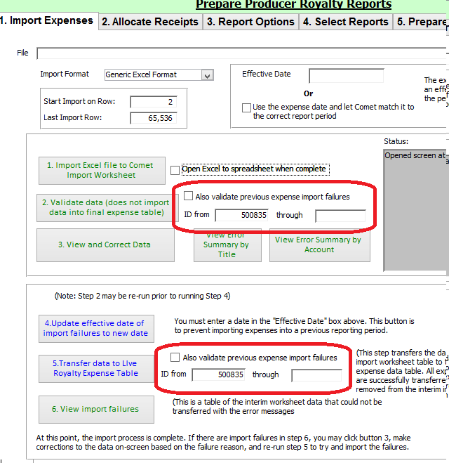

**END OF 2020 CHANGE LOG**

**© Saturn Software Inc. All rights reserved**

2019 Change Log: <http://www.saturnsoftwareinc.com/CometSupportFiles/CometChangeLog2016-2019.docx>