# Comet™ Change Log for January 1, 2016 to December 31, 2019

2019-10-02 start date and end date override in rights detail popup

2019-09-24 added Contract Type, Currency Country, Contract Currency license fee total to report #157

2019-09-14

* Add new feature in receipts to allow user to select unpaid default amount.
* Fix comma error in receipts for 0.000,00 number format
* Block void titles from being imported on Royalty interface
* Title group Excel import feature

2019-08-19

1. The Contract invocing and the All invoices by title screen show cents now.

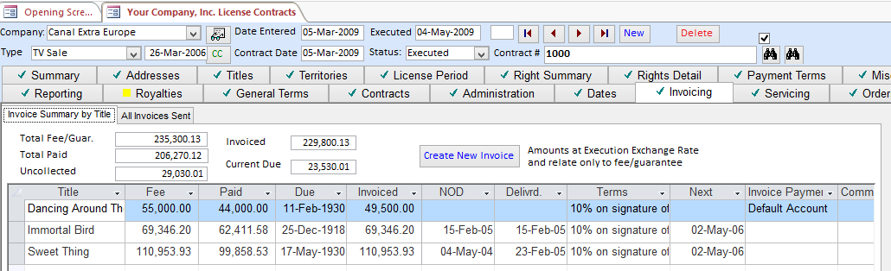

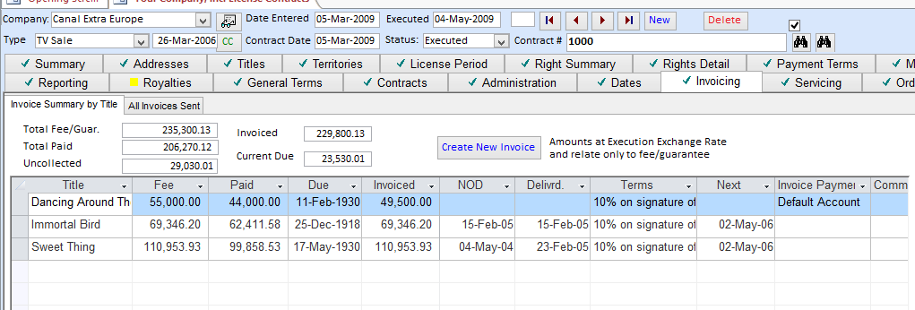

This table in User setup is now active:

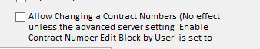

**New mailmerge fields**

New Copy to New Title button, allows easy copy of series to a new season

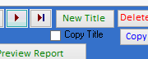

New Mailmerge Field: <<LC>> = License currency

New Mailmerge field:- <<MC>> = Materials currency

Program Details table:

The materials fee is taken from the Title Misc Delivery tab under Hourly Recharge Price, using the materials currency set in the Misc. Misc. tab.

|  |  |  |  |  |  |  |  |
| --- | --- | --- | --- | --- | --- | --- | --- |
| **TITLE** | **FORMAT** | **YOP** | **Nº of Hours** | **License Fee per Comm. Hr (<<LC>>)** | **Total License Fee  (<<LC>>)** | **Material Fee per Hour   (<<MC>>)** | **Total Material Fee  (<<MC>>)** |
| <<Program Detail Table>> |  |  |  |  |  |  |  |

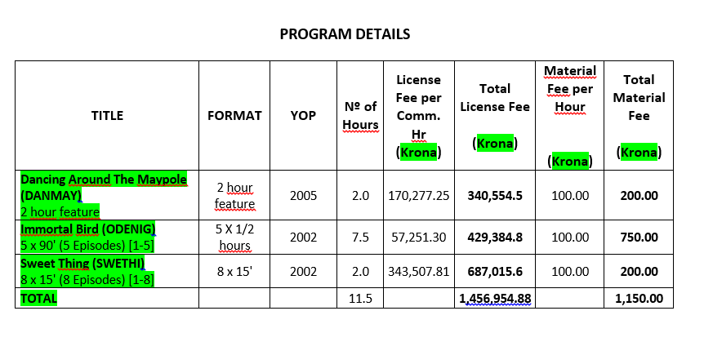

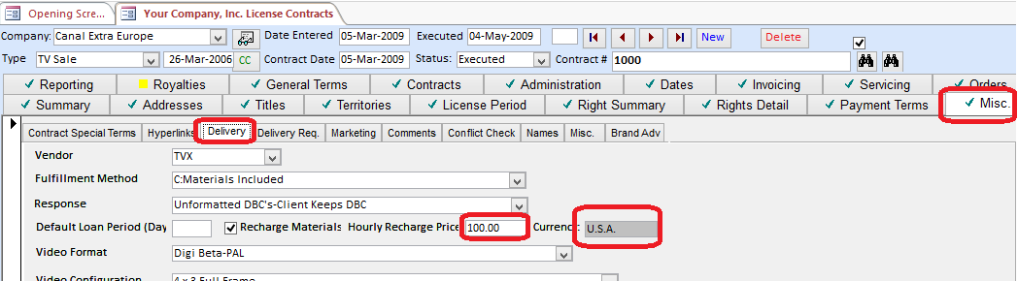

|  |  |  |  |  |  |  |  |
| --- | --- | --- | --- | --- | --- | --- | --- |
| **TITLE** | **FORMAT** | **YOP** | **Nº of Hours** | **License Fee per Comm. Hr (Krona)** | **Total License Fee  (Krona)** | **Material Fee per Hour   ($USD)** | **Total Material Fee  ($USD)** |
| **Dancing Around The Maypole (DANMAY)** 2 hour feature | 2 hour feature | 2005 | 2.0 | 170,277.25 | **340,554.5** | 100.00 | **200.00** |
| **Immortal Bird (ODENIG)** 5 x 90' (5 Episodes) [1-5] | 5 X 1/2 hours | 2002 | 7.5 | 57,251.30 | **429,384.8** | 100.00 | **750.00** |
| **Sweet Thing (SWETHI)** 8 x 15' (8 Episodes) [1-8] | 8 x 15' | 2002 | 2.0 | 343,507.81 | **687,015.6** | 100.00 | **200.00** |
| **TOTAL** |  |  | 11.5 |  | **1,456,954.88** |  | **1,150.00** |

<<Delivery days after payment>>

<<License Fee Clause With Total and Per Episode Amounts>>

<<Materials Fee Clause With Total and Per Episode Amounts>>

<<CH>> US$/hr

<<CCS>> US$

<<Materials Fee Clause With Total and Per Episode Amounts>>

<<Program Detail Table>>

**<Total Episodes Licensed>**

<<Total Episodes Licensed>>

**<Total License Fee (Contract Currency)>**

<<Total License Fee (Contract Currency)>>

**<Total License Fee (Contract Currency) With Currency Name>**

<<Total License Fee (Contract Currency) With Currency Name>>

**<Total License Fee Description (Contract Currency)>**

<<Total License Fee Description (Contract Currency)>>

**<Total Materials Cost Description (Servicing Currency)>**

<<Total Materials Cost Description (Servicing Currency)>>

2019-05-28 Add “Include no owned rights contracts” when adding titles

2019-05-19 add new mailmerge fieldnames

<<All Title Versions>>

2019-05-19 add new title version on the fly

2019-05-17 When adding new titles or renaming titles, splash title search no longer says “#DELTED#

New server setting "Exclude all languages when single-language territory excluded" for avail reports.

2019-03-22

With the “Show payment terms unchecked”, Comet will show the NOD date and delivery date on the screen view only, not Excel.

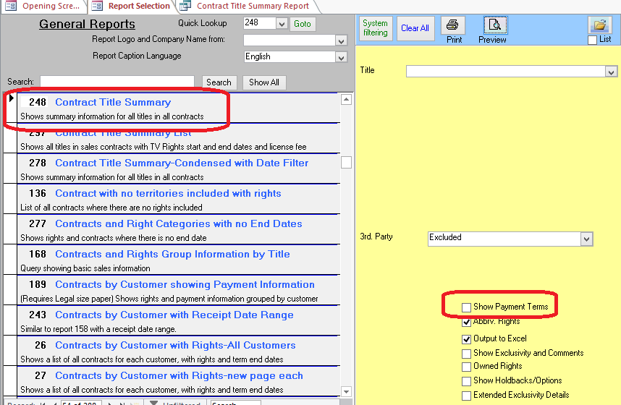

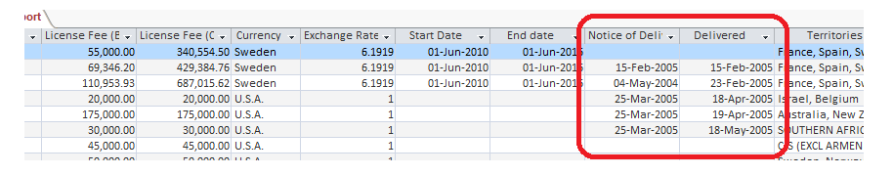

2019-03-07

Contract Total available on Contract Search screen

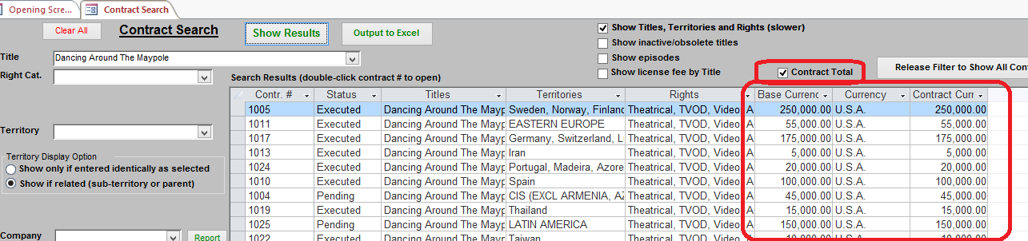

New report 297 Shows start and end date for TV rights as well as contract level start end date.

2019-02-26

Report 156 has a date range

Comet won’t prompt to update the exchange rates if the setting “Prompt to update exchange rates” is set to No

2019-02-17

We have completed upgrading Comet on the NewFilms server so that you can easily copy the territories from another contract or rights group.

1. Here, you can copy all territories from another contract in the Contract Territory setup. It also copies the language selections:

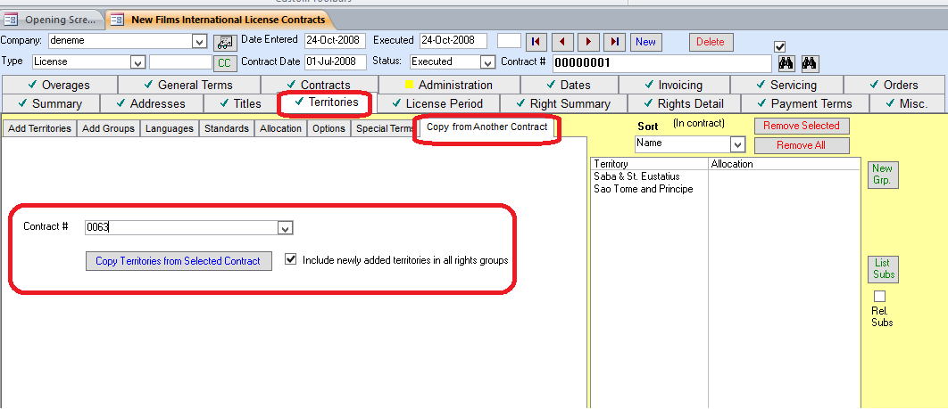

In the Included/excluded territories by right, you can copy the included territories from either another right in the same contract, or from a right in another contract. If you want to copy from another contract, you must first go to the other contract and select the right in that contract, then return to the contract you want to copy the rights to.

The number selected will match the Right Category ID on the upper right as circled. In the example below, the territories from Right Category 171411 will be copied to the right category shown which is 179099. You can also enter the source Right Category ID number manually.

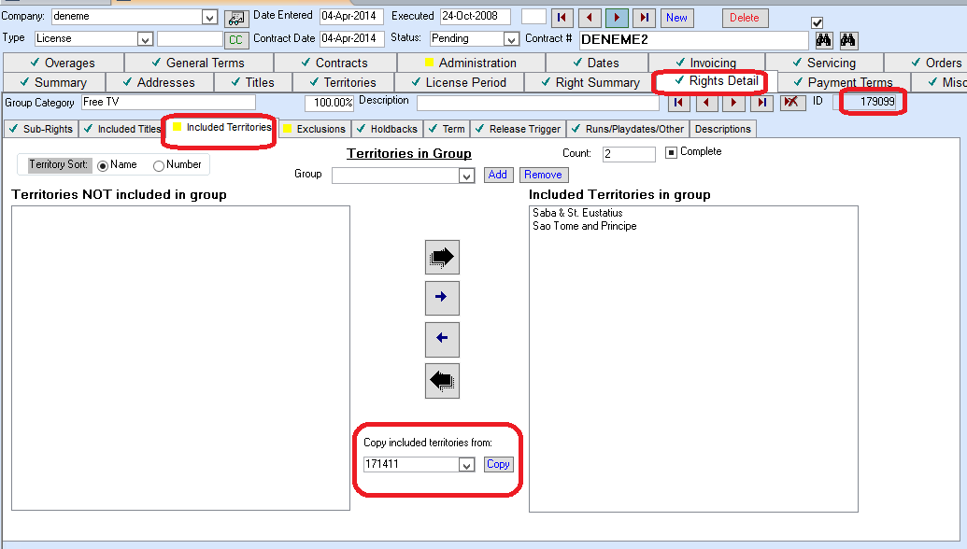

2018-11-20

New checkbox to disable auto CC on conflict check reports

2018-05-08

Orders improvements

Better speed

Improvements to Contract Producer reports screen-report log-faster navigation

2018-02-20 Option to show holdback/option rights (non-licensed rights)

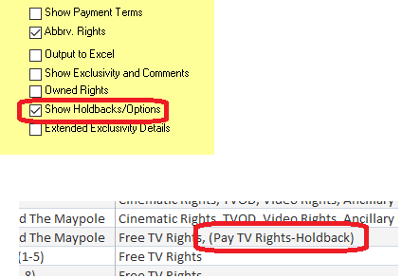

**2017-08-29E** Support for MDB

**2016-11-08**

Improvements to the reporting requirements fields.

The Title is now visible in the “Screen View<>List” spreadsheet view.

The base currency license fee and contract currency license fee are visible with the contract currency.

Reported app crashing problem when clicking Screen View<>List button fixed.

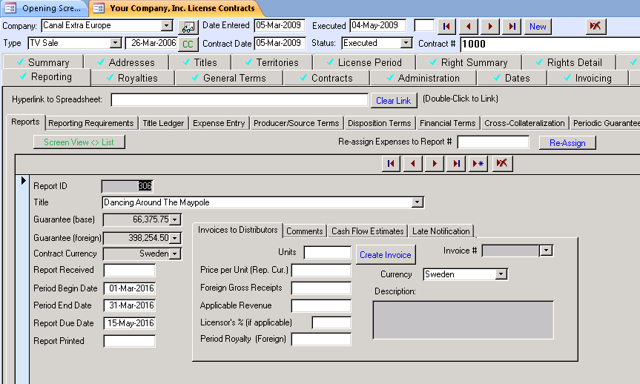

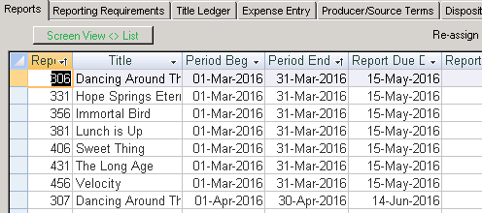

**2016-09-15**

* New Word contract mailmerge field, **<<Titles and License Fees No Episodes>>**
* New Word contract mailmerge field **“<<Title List No Episodes No Title Code>>**
* New avail report checkbox, for “No Rights” territories, shows sub-territories where there are active rights for the cell with the caption “Exclusions”

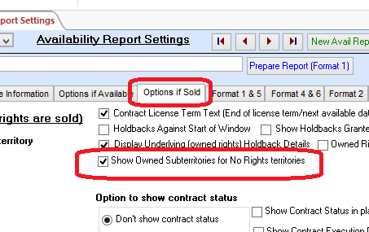

**2016-08-13B**

* Fix to conflict check popup error “Item not found in collection”

**2016-08-13A**

* Increased capability with automated sync and interfaces between Comet and other systems
* New Format 1 Availability Report option to show detailed sub-rights and mediums (level 2 and 3) in the report, for both owned and sold rights.

This option is in the “Rights” tab

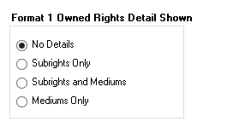

This option is in the “Options if Sold” tab.

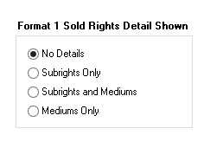

* Problem fixed with system filter-when filtering on title (popup “item not found in collection”)
* Reports 256, 207, 226 have an option to limit the invoices and receipts to invoice types that are marked as “Report to Producers” in the Invoice Type setup table (report 56).

New Word Merge fields:

* <<Exclusions by Right Category>> (lists exclusions by right category if any)
* <<Title List Excluding Episodes>> (Lists titles without showing episodes)
* Numerous improvements to screen design, including the Title Setup screen which had scrolling problem.
* Improvements to Comet Loader, updating for Office 365 and Office 2015
* Improvements to the Comet Email Client and Drop and Drag to clipboard

2016-05-25B

New Excel deal memo “TV Deal Memo Type 3”

2016-05-23A

* Numerous CRM features added to the Sales Interest Tracking module, with one-click e-mail button and drill to contact in Company Profile.

There is a one-click e-mail button, where you can click on the user and Comet will open an e-mail in Outlook with the address, subject, and link to the title screener.

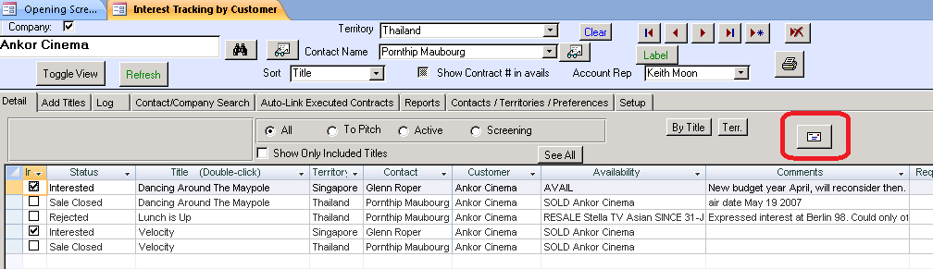

Here is a sample e-mail with data populated.

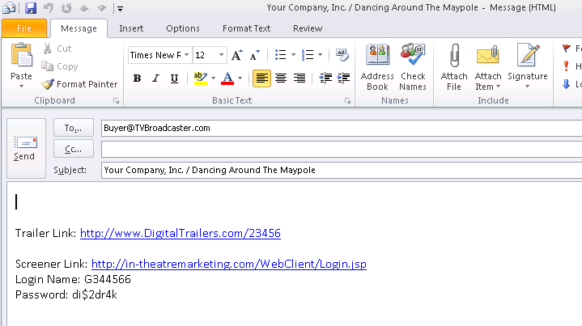

The Interest tracking contacts are linked with the addresses in the Company Profile. Comet will also automatically link to existing contacts based on the name, or add all contacts in the company profile if the “Sales Address” checkbox is set ON.

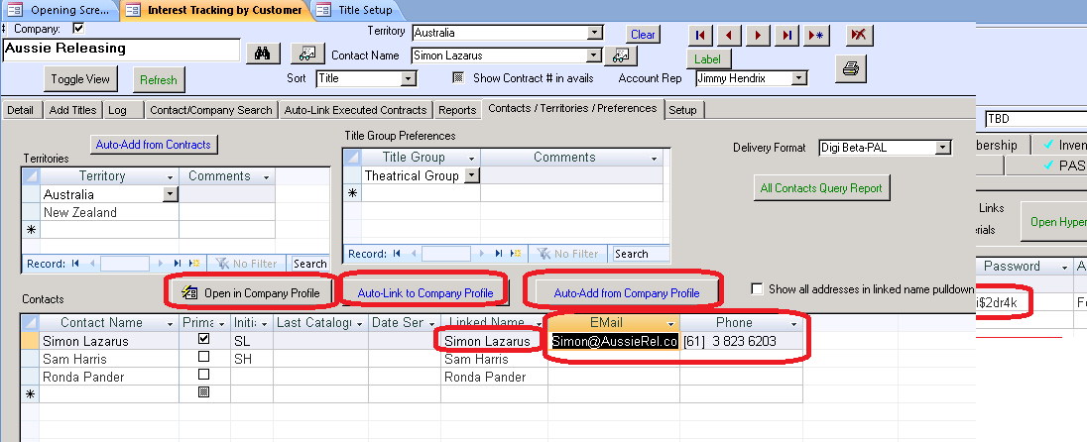

The source of the hyperlinks is from the Hyperlinks tab in the title setup. Links may be checked as Program View or Screener view links. It is possible to add a user name and password for program view links that gets inserted into the e-mail.

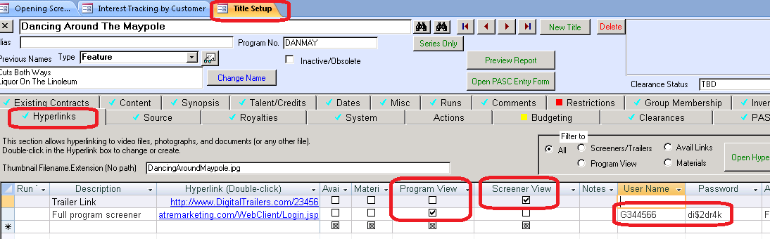

* Comet has a new function to provide a list of files in key Comet folders. Enabled for Avail reports folder, Royalty Reports, and Contracts folder.



2016-03-24B

* Harmless popup with Comet for Office 2007 on startup fixed.
* When adding episodes to a contract and being prompted to check on the episodes, Comet shows the count of episodes for the title.

2016-03-19

* The Producer Royalty Report shows a new column with a count of the linked expenses.
* A new button shows the royalty reports in a list view.

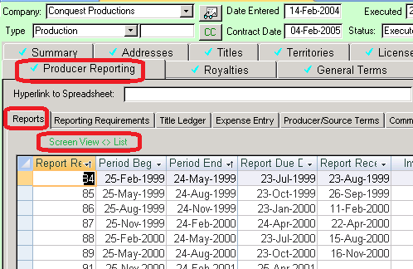

* Also, all dates on contract screen are showing as 4 digit year

2016-03-17

Comet makes it easier to create special language territories for availability reports. You can copy a non-territory language with a command button (circled) and add the language.

Also, any territory can be set up as a single language territory by selecting a language in the “Limit Language when running avail reports to” pulldown.

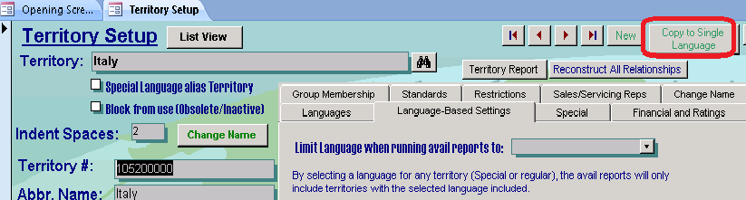

2016-03-14A

Comet supports episodic inventory under a series title.

2016-03-03B

* The availability reports indicate which contracts are 3rd party sales.

|  |
| --- |
| **Video** |
| *SOLD (3rd Party) Acorn Intl.  ----------- Owned Rights:(THE WORLD)  Perpetuity |

* The availability reports show availability as non-exclusive if the sold rights are available or sold exclusively, and the owned rights are also non-exclusive.

2016-03-01A

* Comet has a new availability report option as to how non-exclusive windows are shown after exclusive windows when within the “show as available” months window.

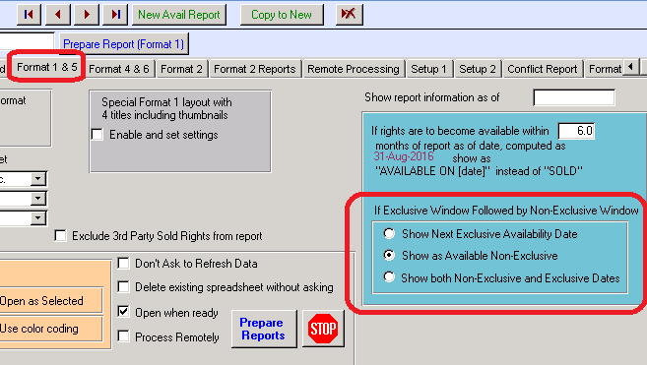

* The Comet Orders screen allows conversion invoices to License Fee invoices. The total amounts by title will automatically be added to the title license fees, and any order titles not in the contract will be added.

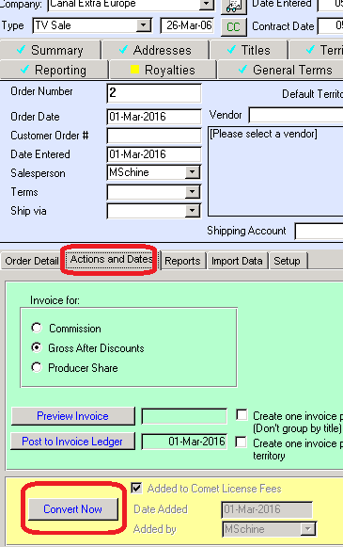

* The Comet Payment terms screen has been re-designed, and includes a count of how many terms there are for the contract.

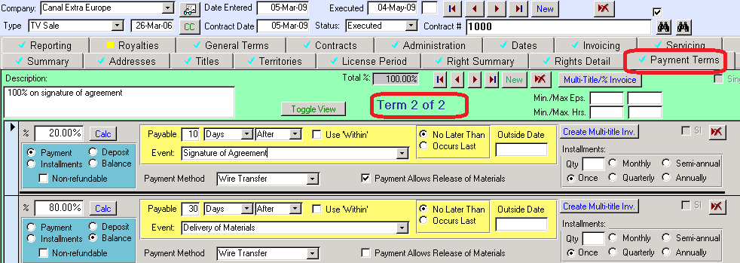

**2016-02-29A**

* Significant improvements to the Orders modules, including improved interfaces to accounting systems
* Significant improvements to the way Comet displays availability if there is a non-exclusive period after an exclusive period.
* Harmless popup “in fncPopulate_YY_tlkpTitlesLocal” fixed.
* Popup fixed in report #141

**2016-01-13C**

* Contract Search screen allows entry of part of a contract
* Report 78 Mini screen improved
* Various ACT buttons hidden in the Sales Interest tracking modules unless ACT is being used.
* Option to use customer logo as splash background
* Screen re-positioning of the Development Project module, new Rights tab added to increase text box size, reduce scrolling and reduce clutter.
* MDB trial version field name fixes
* Splash screen has a “Quick Navigation” button

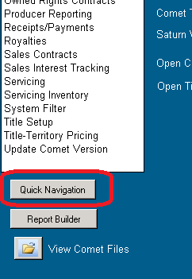

**2016-01-05B**

Avail format 6 (Word format)-Duplicate sheets prevented from printing. Also Comet provides warnings and information if there is no data.

**2016-01-04A**

* Dates in avail reports now show full 4 digit year
* Problems with Development Module menu quick filter and report menu fixed
* Various improvements to the Comet screens, Development Module
* Many screens resized for 1366x768 “HD” resolution
* Total Hours and Broadcaster added to Contract Summary Report
* Report #248 has new option to show exclusivity details. Performance should be improved.

**END OF 2016 CHANGE LOG**

**© Saturn Software Inc. All rights reserved**

2015 Change Log: <http://www.saturnsoftwareinc.com/CometSupportFiles/CometChangeLog2015.docx>