# Comet™ Change Log for January 1, 2015 to December 31, 2015

2016-01-04

* Dates in avail reports now show full 4 digit year
* Problems with Development Module menu quick filter and report menu fixed
* Various improvements to the Comet screens, Development Module
* Many screens resized for 1366x768 “HD” resolution
* Total Hours and Broadcaster added to Contract Summary Report

**2015-11-16A**

* There is a new Technical details tab in the Title Inventory tab.

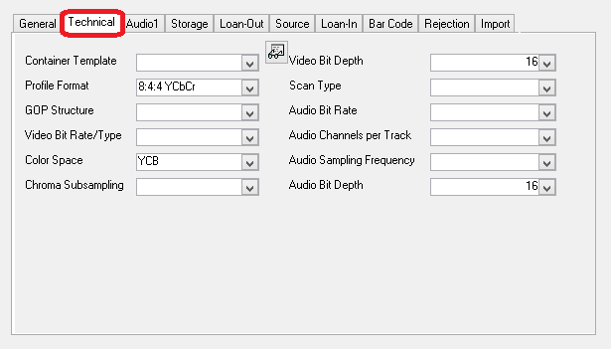

* New option in Contract Territory input, Languages tab, there is an option to copy all languages from one territory to all others. User is prompted to delete all existing languages or just add languages to all territories.

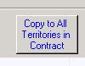

* Warning when adding territories into the orders tab without an MCPS code.
* The Title Hyperlinks screen has a user defined pulldown list, set in Advanced Settings, Server Settings, General Settings“Title Hyperlink Description”
* Columns in new rights screen wider
* Royalty expenses show more file source details in reports.
* Previously on detailed format 1 avail reports, Comet would show “Starts: [date]” for the start date of a license period. Now, if the start date is in the future, Comet will show “Holdback until:[Date]”. If the start date was in the past, Comet will show “Started on:[Date]”
* New options in Contract Search to show/hide episodes, prices, and obsolete/inactive titles

**2015-09-21B**

* Availability Reports Title selection now has option to add all titles for a single producer code
* Report #257 has an option to show Trailer and Program hyperlinks in a separate column, along with producer code and HD Description. The Hyperlinks can be shown in full, or just as “View” (Will open with a single click)





* Various new options on the Contract Summary territory listing



1. Show parents: If all sub-territories are selected, Comet will only show the parent. This is reiterated to The World
2. A-Z sort: Default is by territory size, this sorts alphabetically
3. Largest: Enter the maximum territories to show
4. All: show all territories
5. Abbr.: Show the abbreviated territory name instead of the full name

* Fix to binocular search button fail to find record on Title Setup and elsewhere.
* Fix to avail report settings filter checkbox “Include conflict checks” tie to “Block edits by other users”

**2015-09-16A**

When adding a new title or renaming a title in the title setup with the contract title entry screen open, Comet will refresh the title list and the title pulldown, and copy the new title name to the “Single Title” pull-down box.

**2015-09-09B**

* Popup “Item not found in collection” for conflict check report fixed.

**2015-09-03**

* Agent pulldown added to participant setup
* There are two new checkbox columns in the hyperlinks tab list of the Title Setup to identify a link to a Screener/Trailer or a Program. A new title list report with a filter option is available to show hyperlinks for all titles.

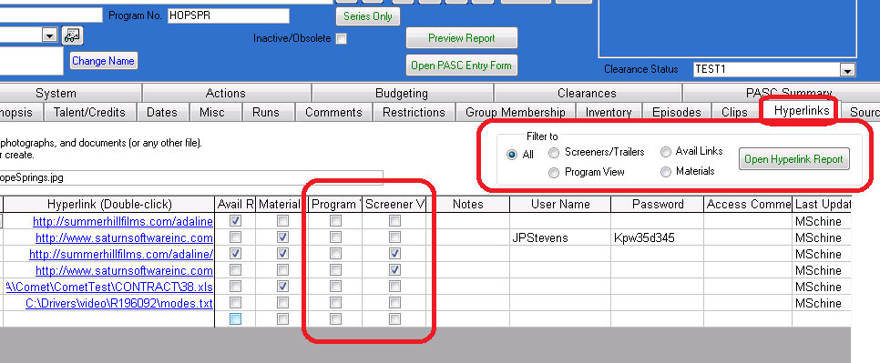

* Numerous improvements to the Development Project module and Clearance module, including a new Clearance reports interface with filter options.
* There is a new Music Cue sheet report that combines cue sheets from external files into one report.
* Title Inventory # and House Title Number added as filter criteria to title search
* Changing clearance status adds to activity log
* Report 291 opens “Clearance Reports” screen that prints several reports with different filter options.
* Underlying Rights on splash changed to Owned Rights
* New owned rights contract status “Potential”. This is to be able to report on rights that you know are available to acquire but there is no pending contract or option.
* Significant improvement in the way owned rights with options and mixed licensed and option rights are displayed.
* Optioned or potential acquisitions may be shown as “No Rights” or “Available”. There is a new option to show how the availability report displays options and potential acquisitions. The default is position 3 “Show as Available with Details”

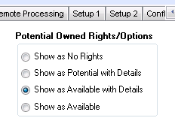

* When opening the Contract List, it is filtered to the Owned Rights or Sold Rights
* Fix to report 226
* Clearance Status added to title setup. Pulldown choices are in Advanced Settings, Server General.
* Title type and title code added to system filter

**2015-07-27A**

* Additional improvements to the new Development Project module, including reports, interface, better drilling and an “Add New” option for talent, companies and agents.
* The “Show all talent” button in the Talent setup includes all talent. Previously, it only included talent added to the Title Setup talent screen.

**2015-July-13C**

* Extensive improvements to the new Development module
* There is a link to the Company Profile from the Talent Setup screen
* Problem fixed with Contract Summary report using Excel 2007
* Report #34 has output to Excel option
* Problem launching Comet in some configurations with SQL connection failure popup fixed.

**Update 2015-06-01 Release K**

* New setting in producer royalty reports, “Use formulas in Royalty Reports”, Comet will use formulas whenever possible instead of plugged values in the Excel royalty reports.
* Contract search includes Contract Type, Contract Status and Execution Date. Results shows Execution Date. Also Show Titles, Territories and rights defaults to OFF.
* New report #289 Sales period end date, shows all contracts with a sales period end date at the contract level.
* Sales period end date added to the contract list (far right side)
* Year of Production system filter changed from date to whole number fixing problem.
* Comments in company profile moved to first tab from Misc. tab
* Double-clicking on the right category in the Contract Rights summary tab drills to the rights detail tab (on the same right category).

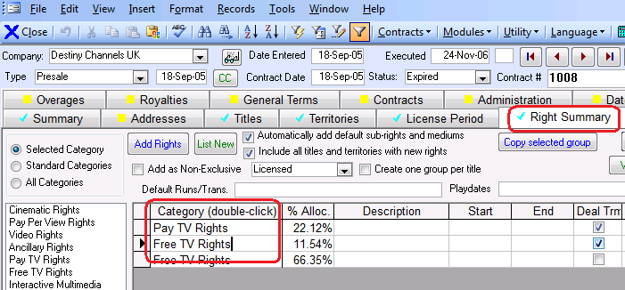

* Territories list width expanded in avail settings territory selection
* Fix to Copy Rights (SQL versions) where it would fail with error message and only partially copy the rights.
* New command button to open reports folder in General Reports screen

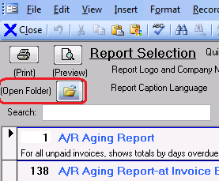

* New command button to open Comet Support folder on lower left of splash screen
* Contract Summary Report opens in Excel 2007+ instead of 2003 format.
* Improvements to the General Terms tab, better lookup of existing values, tab order, improved popup clarity, better performance.
* Auto-allocation of rights with no weight setup and 0 values allocates equally across rights.

**2015-03-02H**

* The system filter allows selecting if the library filter is applied to
  + Contracts
  + Titles
  + Invoices
  + Receipts

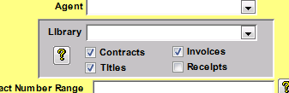

* The Comet toolbar in Office 2007 and newer shows Office Menu and Comet Menu instead of Home and Add-ins

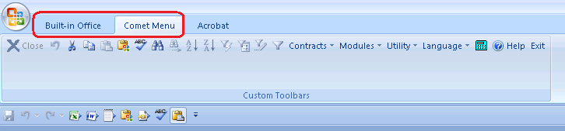

* Reports #88 “Statement of Unpaid Invoices-All Customers”, #170 “Unpaid Invoice Summary by Customer”, #172 “Invoice Statement By Customer-Foreign Amounts” shows the multi-title invoice number instead of the internal invoice number.
* Bug fixed adding servicing items to contract, “could not find servicing rate”
* Multi-title invoice number in payment terms not cut off
* Address details on the contract refresh faster

**2015-02-16G**

Improved Updates and Patches Operation 53 to find date values outside a normal range.

**2015-02-07F**

* Report 282 and 249 speed optimization.
* Faster System load time and system filter application/removal
* New feature for easy switching Comet to new servers, both for the SQL data and the file share location. Enter settings into the file “ServerConnectionSettings_TEMPLATE.txt” released with each update, and rename it to “ServerConnectionSettings.txt” in the Update folder. All users will switch to the new settings on loading Comet.
* Talent setup has a Find and Change Name option

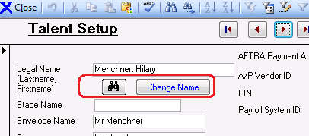

* New report #288, “Producer Royalty Expense Caps”. The report assumes you have entered the royalty terms for the owned rights agreement.

**Comet Update 2015-01-27C**

* Fix error message with Report #248 and #278
* In the contract status setup table (Modules>Setup>Contract Status), there are two columns, “Block from Producer Report Sales History” and “Block from Report #248”. Previously, setting “Block from Producer Report Sales History to YES would also block it from report #248/278. Now, the values are independent, but this release will copy the values of “Block from Producer Sales Report” to “Block from Report #248” to minimize the impact.

**Comet Update 2015-01-27B**

* Report #193, "Receipts and Application Reconciliation Summary", currency code and currency name added after receipt currency country
* Report #163, the following columns were added to the report for data entry:
  + Units
  + Price per Unit (Rep. Cur.)
  + Foreign Gross Receipts
  + Currency
  + Applicable Revenue
  + Period Royalty (Foreign)
  + Estimated Applicable Receipt
  + Estimated Payment Currency
  + Expected Payment Date
* Report #75, error popup message fixed
* Improvements to the Holdback copy to all rights groups-option to prompt by each right
* From the Title Setup screen in the Existing Contracts tab, the Broadcaster and Licensing Entity are showing the correct value instead of “#Name#”

**Comet Update 2015-01-19B**

* On the title search (first binoculars), if the title is not found because there is a filter on, the filter will be released and the title search redone
* There is a new option to copy a holdback to all rights in a contract. There are checkbox options to replace existing holdbacks, and to prompt for each right. This button is in the holdback entry tab in the Contract Rights Detail tab.

**CometUpdate2015-01-19A**

* The availability report has two new title information selections, Original Language and Running Length (Minutes)

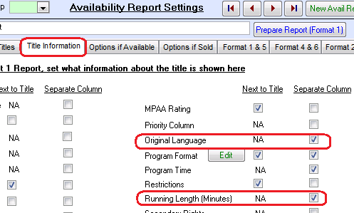

* There is a new separate color option for rights that are in the “Available On [Date] status, that are currently sold but will become available soon. It will default to the Resale color, but may be set to the Sold or Available or a completely different color.

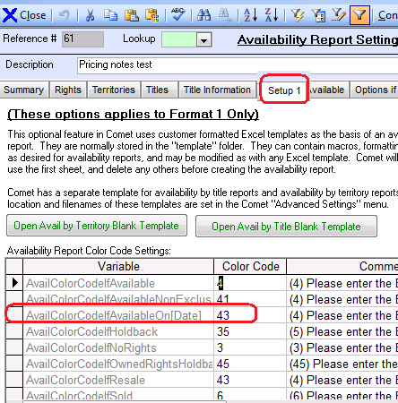

* The Word based avail report summary, formerly associated with Avail Format 2, is now part of the Format 1/Format 4 report engine and can be printed after creating a Format 1 or Format 4 report. There are two formats and a checkbox option to show start/end details by right.

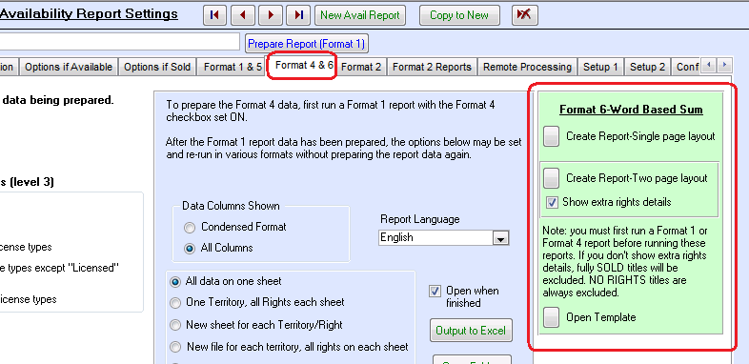

* There is a new “HD Materials Description”
* A “New Contact” button was added to the Title Setup, Clearances tab. The contact name instead of the company shows in the box.

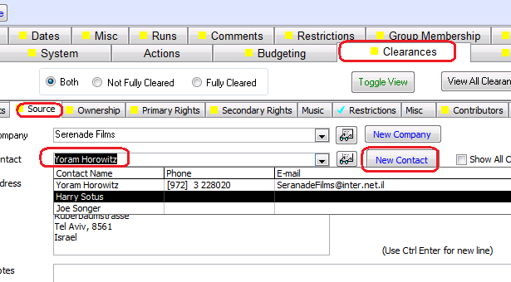

* There is a new checkbox option in the contract status setup table, “Block from Report #248” which will do as stated.
* New checkboxes added to addresses in Company profile:
  + Sales
  + PR/Marketing
  + Vendor
  + Other

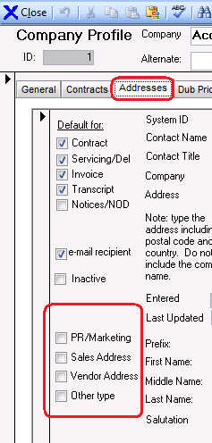

* Also new field “Address Source” and “Entered By” added to Company Profile
* The Copy Selected Group now copies all subrights and mediums. Previously, it only copied the right category which required manual entry of the subrights and mediums.

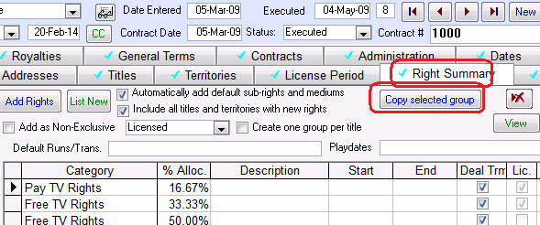

* Fix to update problem where the running length (minutes) was converted to HH:MM:SS format.

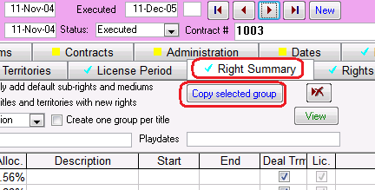

* Report 88 number width increased to prevent truncation
* Data update problem fixed where running length represented in HH:MM:SS was converted incorrectly
* There are improvements to the way files can be added to the hyperlink fields in various places.
  + A popup box will appear which allows you to either drop and drag the files into the text box, or click the Browse.. button.
  + Either way the file path will be copied to the clipboard. It may be pasted into the Hyperlink box using CTRL V or Edit Paste.
  + To revert back to the original method, change the Advanced Setting “Use Drag and Drop File Browse Popup” to No
  + The box can be kept open if there are multiple files to link from the same location. The Browse function will look to the same location as the last file selected.

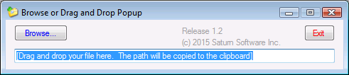

* Report #278 has improved messages if there are problems with the data

**END OF 2015 CHANGE LOG**

**2014-12-09F:**

Various updates with the Title Setup screen, PASC entry screen, particularly with the clearances and contributors/talent areas.

* New Company button for owner and source company
* Talent write-in capability
* Popup error message fixed with contributors toggle view from datasheet to form.

2014 Change Log: <http://www.saturnsoftwareinc.com/CometSupportFiles/CometChangeLog2014.docx>