# Comet™ Change Log for January 1, 2014 to December 31, 2014

2015: <http://www.saturnsoftwareinc.com/CometSupportFiles/CometChangeLog2015.doc>

**2014-12-09F:**

Various updates with the Title Setup screen, PASC entry screen, particularly with the clearances and contributors/talent areas.

* New Company button for owner and source company
* Talent write-in capability
* Popup error message fixed with contributors toggle view from datasheet to form.

**2014-11-17E:**

* New option in Updates and Patches #51 allows user to set contracts to expired where the expiration dates for all windows/rights can be computed and all rights have expired. It requires that Report #75 is run with the “Show Unresolved Calculations” checkbox ON. See screen for other option settings.
* This version changes the invoice amount shown in the Contract Invoice>All invoices Sent screen from the Base Currency at Execution Rate Net of VAT to the Invoice Total Amount Including VAT at the Invoice Exchange Rate
  + Previously, the Invoice amount was the Value only net of VAT, base currency at the Execution rate.
  + The Due column shows the amount due including VAT, Base Currency at the Invoice Exchange Rate.
  + Previously, the amount due was the Base Currency Execution Rate Net of VAT.

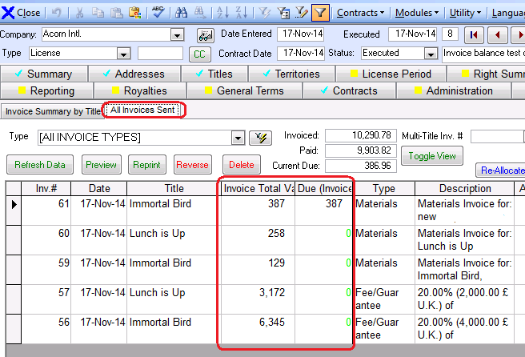

* When closing a receipt, Comet only warns of the royalty effective date if it is different than the receipt date
* Salesperson, Uncollected Net of VAT, Uncollected Including VAT added to report #280
* Broadcaster, Licensing Entity, and Contract Date added to report #256 and #195
* Rights, Broadcaster, and total license fee (base currency) added to right side of contract list.
* There is a new field “Materials Payment Terms” in the contract Misc>Delivery tab. It will appear on the Excel deal memo
* Report 280 rounds all values off to 1/100 (penny/cent) to prevent excessive digits with foreign currency conversions.
* The Title Restrictions pull-down had been concealed since the previous version, now at the top of the entry box.
* Updates and patches item #50 copies rights level license term to contract level if contract level blank and all rights have the same license term text.
* Synopsis and logline on title setup have copy buttons
* Royalty report expense “Linked to Royalty Report” pulldown title column widened.
* (Plus other additions to be documented upon release)

**2014-11-07D**

* Company Profile address screen re-designed
* Producer Reporting informational text boxes increased in size and screen layout improved
* Problem fixed when entering new contracts with presetting contract expiration date to 1899 (since 2014-10-21C)

**2014-10-21C**

* New option to open Excel using 3 methods in the event Comet can’t open Excel reports. See advanced setting “Excel Launch Method” and set to 1,2 or 3 (Default = 1). If using method 3, you must put the path to the Excel EXE file in the setting “Excel EXE filespec”
* Problem fixed where double-click hyperlink in contract opened explorer not link.
* New “Re-apply with new settings” button in system filter for one-click re-application of new filter settings.
* System filter dates have 4 digit year instead of 2

**2014-10-13A**

* All hyperlinks require double-click to open or browse. Previously, a single click would launch the browser but this interfered with pasting in web links so it was disabled.
* On Title Setup form, “Film ID#” caption changed to “Program No.”
* Address records have an “inactive” checkbox which prevents them from being selected in the pull-down menu.
* The Word Long form and Notice of Delivery Word template supports new merge fields that enable Comet users to quickly generate a document with instructions for buyers on how to access their materials from a lab download site or other digital delivery web site. A login and password can be stored for each Comet company or each title. Multiple materials locations may be specified for each title

<<Materials Access Title Hyperlink>>

<<Materials Access User Name for Company>>

<<Materials Access Password for Company>>

<<Materials Access User Name for Title Hyperlink>>

<<Materials Access Password for Title Hyperlink>>

<<Materials Access Comments for Title Hyperlink>>

The notices may be generated directly from the Notices and Delivery screen. There is a new filter option as shown

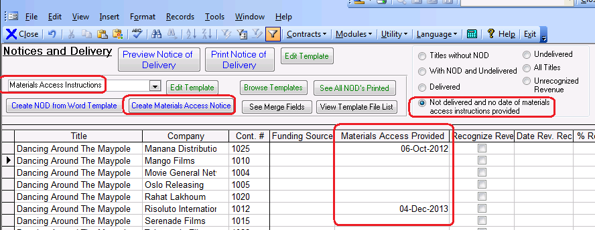

The materials access web site hyperlink, user name and password is set up in the Title hyperlinks area.

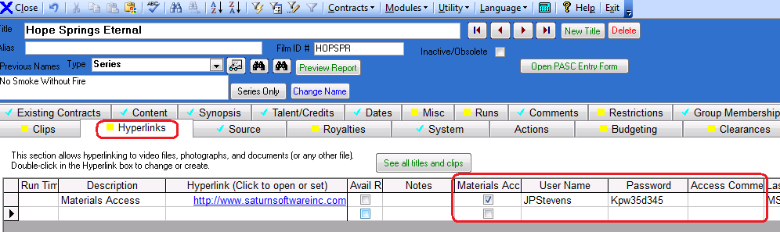

A company based user name and password can be entered in the Company Profile Master Selection tab.

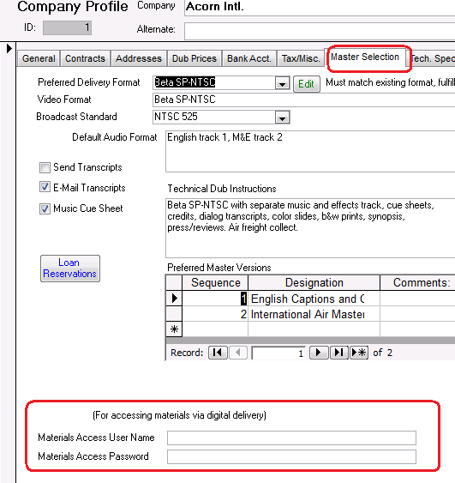

* When creating a Comet Word based contract, Excel based contract, or NOD or Materials Access notification, Comet saves a link to the document in the Hyperlinks tab for the contract.
* In Event Setup (Modules>Setup>Contract Status) you can disable a contract type from being included in the event management. This is expected to be used to block fully paid and/or expired or fully delivered contracts.

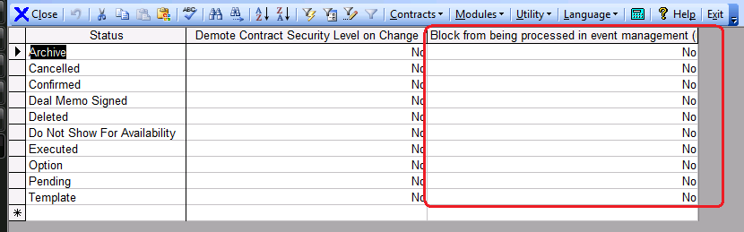

* A new field Materials Payment Terms may be entered in the contract MISC Delivery section, it appears in the Excel based deal memo formats and is a new Word mailmerge field “<<Materials Payment Terms>>”

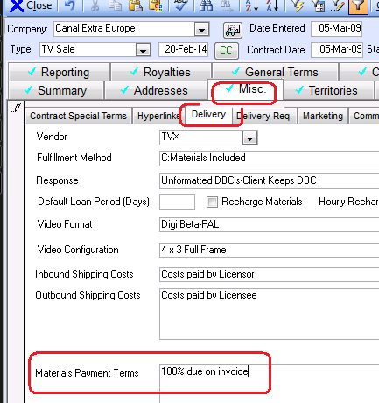

* When blocking a title from being invoiced using the checkbox in the Contract Invoice All Titles tab, Comet prompts for a reason which is added to the activity log.
* When entering a new title, Comet checks if the title code has already been used for another title.

There is a new option to create a territory group based on an availability report selection:

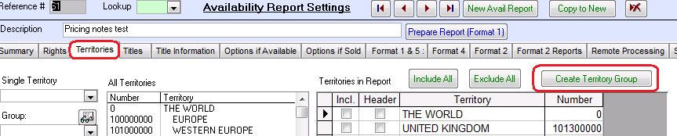

**2014-10-02P**

* The Comet advanced Setting “ShutDownSystemNow” will log off all users within 5 minutes.
* Various improvements to the layout of Comet contract tabs
* New option to “Show Territory Restrictions” on avail report Format 1 in the “Options If Available” tab.
* Problem fixed in Contract Rights Detail tab, where mediums were not showing up after clicking on right unless mediums box clicked.
* Excel TV Deal memo format 2 has improved title and license fee display, with option to show original version.
* Fixes “Deleted” results error in contract search
* Fixed failure popup with multi-title condensed title list no-VAT base currency invoice.
* Layout of multi-title invoice modified to reduce chance of moving to two pages.
* These fields added to the Word contract mail merge list:
  + Financial Report Requirements
  + Cost Recoupment Terms
  + Commission Terms
  + Approval Requirements
  + Collection Agent
* Report #5 “Acquisition/Production Contract Summary” (and the single title variation form the Producer/Source sub-tab of the acquisition contract Producer Reporting tab has the contract currency and the base currency in separate columns.
* General cosmetic improvements throughout Comet with layout and details like the size of the pull-down selection list.
* Increased size with scroll bars of the Contract Title Billing/Deal memo text boxes.

**2014-07-22K**

* The receipt screen does not show “Mixed currency” when the receipt is closed.
* On contract screen, binocular contract search option, if Comet cannot find a contract number using the current contract type filter, it releases the filter and searches again.
* The e-mail notification module now notifies about incomplete tasks from the Contract Administration and Fulfillment modules.

**2014-07-22J**

* Report 282 with territory allocation filtered to Contract Date not Execution Date
* Improvements to the pull-down and list selections system wide including improved performance.
* Start date added to report #282
  + If the start date is blank, the report works as it did before, which includes sales and owned rights contracts up to the end date (unless expired etc.)
  + If there is a start date, and the checkbox “Incl. owned rights contracts before start date” is CHECKED ON, then the report will include all owned rights agreements with a contract date prior to the start date, but will exclude sales contracts made prior to the start date.
  + If there is a start date, and the checkbox “Incl. owned rights contracts before start date” is CHECKED OFF, then the report will include all owned rights agreements and sold rights agreements prior to the start date.

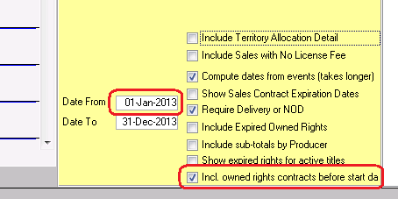

* General reports “note” tab box moved to default group tab to prevent sudden change in view on selecting a report
* Clicking on the Delivery Requirements box in the Contract>Misc>Delivery Requirements also includes the delivery requirements description from the Company profile.
* Comet populates the Immediate Run dates in the EMail notification log to start on the day after the most recent EMail run and to end on the current date.

2014-07-06 H

* Office clipboard added to toolbar

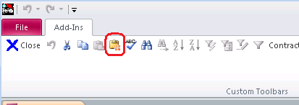

* Reported problem with address screen pulldowns not refreshing should be fixed
* When changing contract currencies, Comet will not move to the address tab and back.
* The TitleDetail start and end date columns were moved to the left most columns before the commission column as they are apparently the most frequently used columns in the view.
* There is a new option “Prompt to add default inventory items when adding a new title”.
* There is a new avail option to prevent referring to large cells in a text file.
* Numerous improvements and fixes to the new PASC Title entry screen, including editing and adding talent and detail items.
* Avail reports has a new tab for avail-related advanced settings
* There are two new avail report settings that are set in the global settings.

“Holdback status has priority over Non-Exclusive Status on avails". If set to YES, a non-expired holdback will have status priority over a cell with Available Non-Exclusive status. Comet will set this to YES by default on update.

"Consider unsold rights in holdback status as available" If set to Yes, rights that are in holdback status that are otherwise available will be treated as available. If you request to only show available rights, and the cell is in holdback status, Comet will exclude it from the report. Comet will set this to Yes on update.

Just to be more clear, Comet has an avail report option “Show Rows with Available Rights Only”.  Currently, if a cell is in holdback status, but otherwise available (not being sold or no-rights), Comet will consider it available and show it in the report. This new option if set to NO will consider all cells in holdback status as not available and treated like the “Sold” or “No Rights” cells.

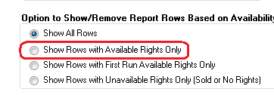

* Comet royalty reports expense report on the Import Expense tab of the Producer Royalty Report module, button 7 has an output to Excel option. The Title and Title Code added to the report.

**2014-04-28**

* EMail notification module interface upgrade
* Comet shows the base currency and foreign currency on the summary tab

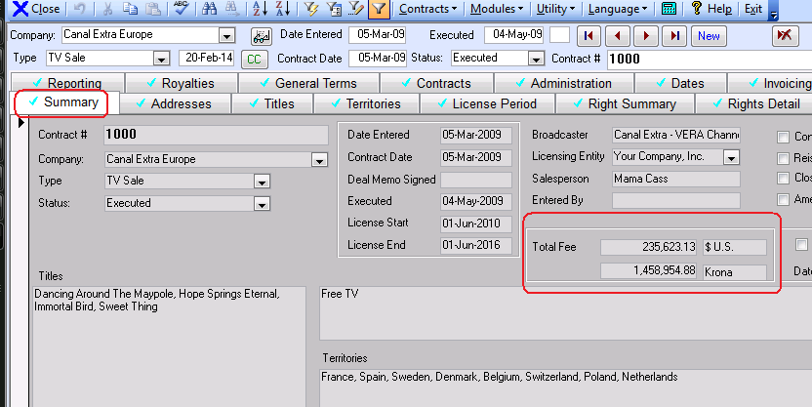

**2014-04-28**

* Comet has an Availability report option to show pricing notes in the avail reports. The pricing note is entered in the pricing module, and the option to show it is on the Options if Available tab.

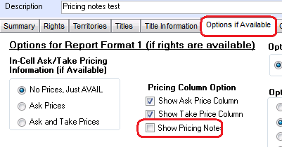

* Comet has a new option to publish and update Availability reports to a wedrive folder, which can be synced with Microsoft OneDrive (formerly known as Sky Drive), Google Drive or Drop Box. OneDrive and GoogleDrive offer a free web-based Excel app that will open any Excel spreadsheet on any device, including Windows, IOS +IPhone, IPad, Android, and Linux. The report can be published using a one-click button next to the file name in the Availability settings.

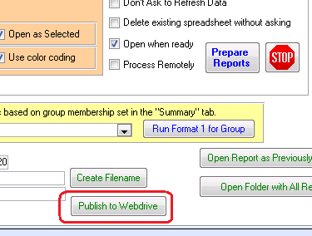

* There are three new options related to e-mail notification. Depending on the default settings, Comet will make selections as shown in the EMail Notification Interface.

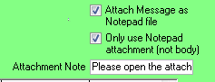

1. **“Attach Message as Notepad file”**. The default is the advanced setting “Attach Text File to EMail Notifications” in Server System. When sending an e-mail notice, attach a text file of the message with the e-mail. This file normally has a more uniform format than the message added to the body of the e-mail.
2. **Only Use Attachment:** With this option set to Yes, Comet will send a notepad attachment only. The body will not contain any information, but will show the message entered after “**Attachment Note”**.

The two default settings are “Use Text File Attachement Only for EMail Notification” and “EMail Notification Message if using text file attachment only”

Report #280, heading typo fixed “Exclusivity”

Report #283, “Simplified Producer Report” documentation:

* By default, Comet fills in the period end date which is the last date of the previous quarter from the current date.
* The output folder is set up in the Advanced Settings, Local General, “Royalty Report Output Root Subfolder” but can be set with the button
* The list of producers is all of the producer codes in the title setup, no blanks though.
* If you put in an invoice/receipt start date cutoff, it will only show invoices with an invoice date after the start date cutoff and for receipts, the producer report effective date must be after the cutoff. Otherwise it will show all invoices and receipts from the beginning of time.
* The contract Status setup “Recognize Revenue” must be yes and “Block from sales Lists” must be set to NO
* The invoice type “Report To Producers” must be Yes
* The Contract Types setup “Reportable” must be set to Yes
* The values are all base currency at the invoice rate.
* The report is set up with formulas so that Andrea can change one value and the entire spreadsheet will update

Comet can now update the SQL server without Management Studio Express if the user has SQL Admin permission, or is a member of the Windows Domain Admins, or is using an SQL standard account with SQL “sysadmin” permission such as sa. Screen prompts to use SQL script are available. If using direct update, Comet will prompt for a user connection using either Windows Authentication or SQL Server authentication.

The SQL script logic to prevent running steps twice has been removed since there is no harm to doing so.

Producer royalty report screen, when entering a start date, it does not set end date to same date

Report 271 shows additional VAT information and company code information.

**2014-03-07D**

Report 271 was showing the contract address, now showing the invoice address with fallback to the contract address

Comet SQL server updates no longer require using Management Studio since the update steps are run directly from the Comet app.

The Notices and Delivery Screen, selecting a contract type filter resulted in fields with “#NAME?” due to a query update. Problem fixed.

**EMail notification changes:**

1. The e-mail notification module has a new Advanced setting, “Create Notepad File of EMail Notifications” (Local User Settings/System) which will check on the box circled below.
2. Instead of opening the notepad file, it will be created to the location specified in the new Comet advanced setting “DrivePathOfEMailNotices” (User setting/System), which will default to the reports folder when created, but may be set to any location.
3. By clicking on the folder shown, the location of the notepad files will open.

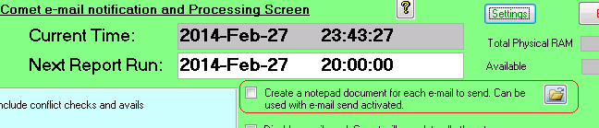

**2014-02-27C**

* The Multi-title invoice has a checkbox to include a “*Reprint* banner for reprinted invoices (it is disabled if the invoice has never been printed) and the option to condense titles into a Title1, Title2, Title3 format is not a checkbox instead of a popup.

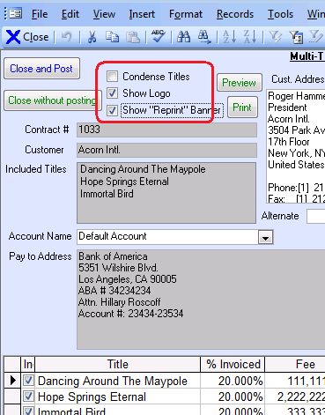

* Report #278 has an option to include all contracts with a contract date between Jan 1 and the report as of date.

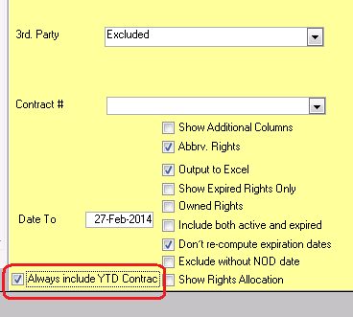

* New button added to automatically link receipt applications to owned rights if there is only one right category in the sales agreement and a single matching right category in the owned rights agreement.

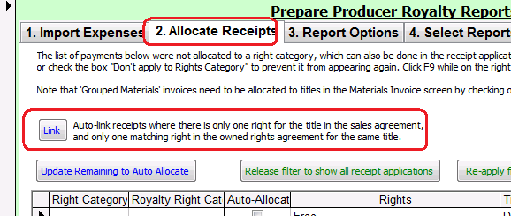

* Receipt application invoice movedown improved to work with all hardware and international formats.
* New contract button added to splash screen
* Rights re-mapping feature improved to work faster with less RAM requirements, also provide easier path to re-map rights and find mapping errors
* Notices and delivery screen has a “Delivered” filter status
* Tab font changed for easier navigation
* Report 278 includes additional rights
* Report 157 doesn’t truncate after 256 characters
* Added Contract Entered date to system filter

2014-02-12A

* Extensive improvements to the new Clearance and Release module
* Launch of title setup and new title entry from splash screen
* New PASC entry screen for users familiar with that format.
* Addition of Turkish language to Comet interface

2014-01-20B

* New clearances and contributor release module in the title setup, for entering and tracking program, music, and clip releases and clearances.
* Report #207 fixed (report would fail with popup)
* Browse for files opens into the contract folder instead of C:\
* Overall browsing performance of Comet improved with screen resizing improvements

2014-02-05A

* Add all contract types to email notification set to true as default
* Title Misc Detail choices-sort order added, and PASC form option checkbox.

2013: <http://www.saturnsoftwareinc.com/CometSupportFiles/CometChangeLog2013.doc>