# Comet™ Change Log for January 1, 2012 to December 31, 2013

# 

Fix to report #207, SQL query popup

2013-12-17

Report #280 title filter and licensee filter working

2013-12-07 Comet Avail Format 1 with all territories on the same sheet shows selected title information columns

|  |
| --- |
| Alias Title |
| Genre 1 |
| Genre 2 |
| Director |
| Title Code |
| MPAA Rating |
| Restrictions |
| Produced |
| Awards |
| Origin |
| Type |
| Format |
| Priority |
| Source |
| Length |
| Web Link |
| Logline |
| Synopsis |
| Talent |
| Title Groups |

2013-11-27 New report 287, sales summary with episodic pricing.

2013-11-23

In many percentage columns, when entering a 100% or 1, Comet would divide by 100 to get 1%. This has been fixed.

Headings improved in the Royalty shares

2013-11-09

* Copying duplicate exclusions has been fixed.
* Exclusions are copied in the same order as the source exclusions.
* If some of the exclusions have sub-right or medium exclusions that don’t exist in a destination right category, they are excluded from the copy. All other exclusions are copied.

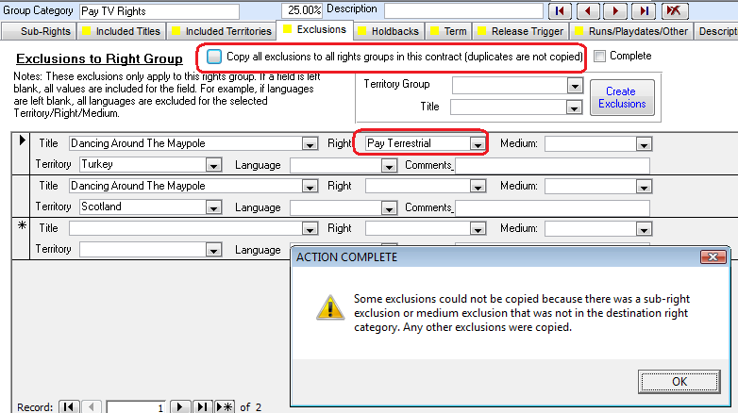

2013-10-15 Opening avail reports, event management and general reports screen does not close all open screens.

2013-09-23

Extensive changes to servicing financial information and materials invoice

Can add library to avail report titles

2013-08-31 Comet rights detail tab, included territories, allows adding and removing territory groups

2013-08-28 When blocking or unblocking titles from invoicing in title detail, a log entry is created.

2013-08-25

If adding a series title, and there is no “Series” title type, an error would occur. This has been fixed.

2013-07-26

Report 168 has extended title information

2013-10-05 In interest tracking reports, the auto-linker requires that the contract date is >= the pitched (informed) date

The Comet multi-user loader for remote desktop or Citrix can be named any of the following filenames:

"WTSDirector.exe" "CometForRDS.exe" "CometRDS.exe" "CometMultiUser.exe"

2013-04-19 Avail report simplified Client-avail/sold only layout will show language access from inventory.

Report #282 has a new column for cumulative sales to date for previous year

2013-04-07F

New report #286 Title Metadata report. Some values come from the Title Misc. Detail. Updates and Patches button #49 will add the new choices to the pulldown and also prompt to add them to all titles.

2013-04-05E2 Special Format 1 report auto-adjusts row number column width

Numerous improvements to the Accounting Interface.

New feature to select multiple titles in reports.

2013-04-03 Adding Genre to avail report includes Genre2 now.

2013-03-24 Notices and Delivery screen has added delivery and technical acceptance additional information columns.

2013-02-25B Report 207 column G was showing net receipt instead of Gross, value fixed

Report 207 headers changed to License Fee for TV distributors, and kept as MG/Advance for Film companies.

* Amount due changed to formula
* Spacing reduced between contracts
* Lines drawn under each contract
* Receipt screen tab order updated

2013-02-19T

Report #282,

* 3rd party contracts are blocked
* Negative license fees are included in the report if the “Include Sales with No License Fee” is checked ON.

2013-02-14

* Improvements to the Contract Search screen
  + Option to show titles, territories, rights
  + Output to Excel option
  + Full-screen view
* Invoice balance A/R adjust auto populates data if empty
* On the A/R Balance adjust screen, it is possible to enter payment values for all invoice types including materials and royalty invoices. Previously, it was only possible to enter payments for license fee invoices.

2012-12-10

Report 282, Allocated Profitability Report, has a new option to hide/show subtotals by producer.

Also, the report always shows a report grand total. Since the producer subtotals are counted in the total, if showing the producer subtotals, the grand total is divided by 2 in the formula to prevent double-counting.

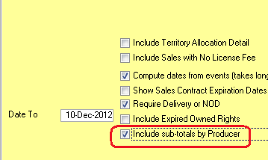

2012-12-03

Genre2 added to the title list. MCPS columns moved to right, other re-arrangements

2012-11-29

Add contract titles screen, now supports displaying and sorting by a user-selected list.

The default is set in Advanced Settings as “Default Title Selection Second Column” (default is Type)

Also, inactive checkbox works in conjunction with hide episodes button.

The “Sort” checkbox, if on, will sort the values by the column selected. Otherwise, the title sort name will be used.

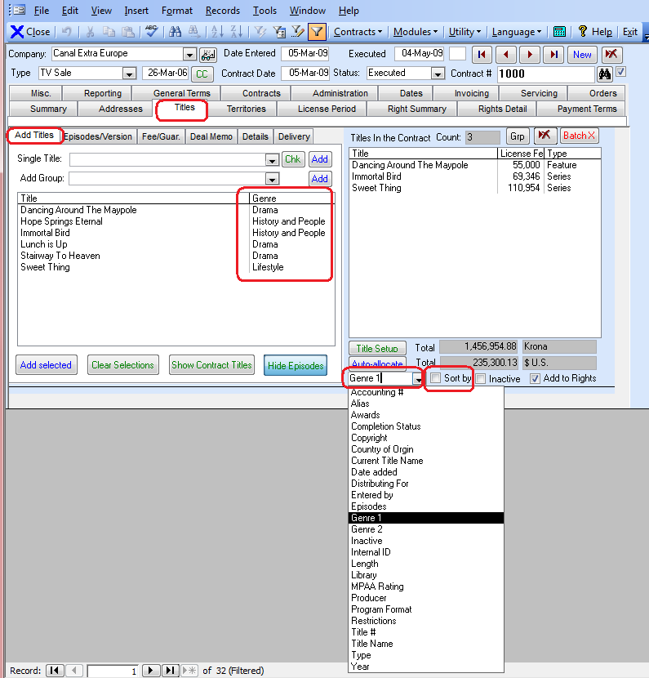

**2012-10-30D**

* Reports 88, 141, 170 Date cutoff for some languages fixed. VAT% format on report 141 improved.
* Fix to automatic conflict check e-mail notification (to create a new report and delete the previous one)
* Improvements to report #256 regarding exclusion of materials invoice issues. Comet now uses the “Report to producers” checkbox in the invoice type setup, instead of including or excluding “Materials” invoices. To view or edit the settings, see report #56 “Invoice Types”

2012-10-30A

* New server system setting, “Enable Missing VAT Status Popup”. If set to No, Comet will not prompt for missing VAT status.
* Report 75 and 256 SQL view modified to be much faster and reduce SQL server resources.
* Address selection pulldowns refresh on auto select and when clicking new refresh button
* Popup box “You may now enter a new address” disabled.
* Report #256 has a new checkbox option to include or not include Royalty invoices or Materials invoices

2012-10-25A

* Comet has a new external report writer to allow users to create and save reports
  + It requires a file be provided by Saturn and connected to your database
  + The server system setting “Enable User Reports” must be set to YES

2012-10-23S

* New landscape avail report format 2 with thumbnails
* New option in report 256 to remove sales from the report that are not reportable to producers (based on checkbox in contract title details “Exclude Sales from Producer Reports”

**2012-08-30H**

* Receipt screen reorganized.
* Email notification screen re-organized.
* Email notification new option to run conflict checks and delayed avail reports with “Immediate Run” button.
* New option to switch all users to a new server with one setting on the server to replace their connection string. The variable name is “ReplacementSQLConnection”, which must be set in Server System settings.
* “Entered By” now on contract summary screen, and on contract list
* Email notification error message fixed regarding “item not found in collection in fncConstructExpirationNoticesStep02”
* New report layout option in Format 2 shows thumbnail and additional title information

**2012-08-23**

If using Office 2007 or greater, 255 limit on titles or territories removed on format 1 reports

**2012-08-06E**

* Comet has a “New Contract” option in the menu and on the splash panel left side.
* The Comet activity log has includes better logging of title additions, deletions, and does not include some unnecessary entries.

**2012-08-02D**

The automatic conflict check reports are filtered to the above Licensing Entity and Contract Type filter.

* The email notification module has a new user defined filter by contract type, similar to the filter by licensing entity. Note that the “Include in Reports” checkbox has to be on.

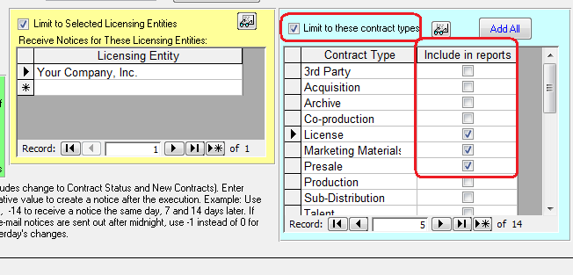

* The automatic conflict check reports are filtered to the above Licensing Entity and Contract Type filter.
* Title change log does not include SQLTimestamp changes
* In sales interest tracking, new titles added to interest can be either added as Pitched or To Pitch, except for bulk additions which are always “to Pitch”.
* In sales interest tracking, records set as “Sold” and linked to void contracts are removed.
* Comet supports Ukrainian language for the interface and reports
* New support for the following currencies:
  + MUR Mauritian rupee
  + MAD Moroccan dirham
  + UAH Ukrainian hryvnia
  + XOF West African CFA franc
  + QAR Qatari riyal

2012-07-23

New checkbox in company profile, Tax/VAT/GST tab, to always charge VAT/GST/HST overriding all other settings.

2012-07-16

Report #262 has an option to include/exclude materials invoices

Report #279 has separate report to show total program hours. Improved formatting as well.

Added log prompt for why a title is being marked as deleted from the title list.

The title has been added to the contract administration tasks

2012-07-04 Z9

Collection agent added to contract misc names tab

New warning message on deleting title from a contract. Previously, Comet would delete "included" titles before trying to delete the title from the contract, so the pulldowns would be blank. Now, the users get this message:

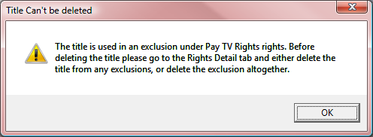

2012-06-26 Z6 Simplified producer receipt report #283

Avail report currency and language pulldown limited to list.

2012-06-12 Z4 Fix and improvements to hyperlink fields system-wide

2012-06-11 Z3 Fix to security popup when adding new titles to Comet

General improvements to the 64-bit version

2012-05-27

Fix to contract level security, where previously if users didn’t have edit permission on the open contract, they could not create a new contract. This has been fixed so security for new users is based on their SQL server security setting, not the contract level setting.

2012-05-05

The Comet “All invoices sent” tab workflow has been modified to accommodate new filtering options based on the “Invoice Type” setup. By default, the opening screen will show all “FEE/MG Invoice types” as set up (run report #56 to set up the invoice types).

Clicking on the re-applies the filter, so a user can switch from a multi-title invoice filter back to the invoice type filter easily.

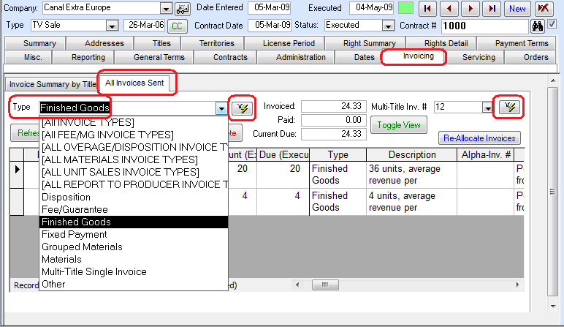

Report #229 totals column alignment fixed

**2012-04-24U**

* The Comet Email notification module has a new workflow for preparing and sending e-mails. If the setup variable “e-mail program” is set as “Batch Outlook”, the expiration notification module will prepare the e-mails in the log but not send them. By clicking on the “Use Outlook” button, Comet will send the e-mails directly into your Outlook outbox, bypassing the need to use the EMail Client. All e-mails with the Ready to Send =1 will be included.

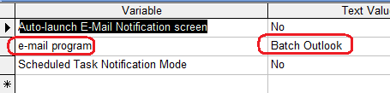

* The e-mail log list headings are much clearer.

2012-04-23 Added contact-level start date and end date to contract summary view

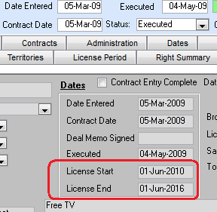

2012-04-18S

* Fix to title license fee refresh on changing the contract currency.
* Fix to multi-title invoice generation, with erroneous but harmless popup message indicating there was an invoice.

2012-04-18R

Comet has a feature to prevent users from editing contracts that are executed or at some other status as defined by the setup.

1. Each user has a contract security level between 0 and 255, although generally 1 through 10 will work well for most setups. The higher the level, the more edit privileges.
2. Each contract can be set at a certain level. Generally, it starts out as pending, which let's say is a level 1. This means that only users with a security level of 1 or higher can edit it as set up in the box shown below in the user setup under "Contract Security Level".
3. When it goes to legal for approval, it can be increased to a level 6. Finally, when executed, it can go to level 8.

Some notes:

* The contract security level is shown on the Contract screen, coded in color to indicate it the contract can be edited (Green) or not (yellow).
* You can edit the level directly on the screen, if your user level is set high enough. For example, if your user level

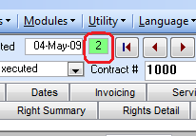

* A level 2 user can't edit a level 6 contract, but a level 6+ user can edit the contract.
* The levels for each contract status can be set in the Contract Status setup screen (Modules>Setup>Contract Status). When you change the contract status, the contract will be escalated to the level associated with the status.
* A level 2 user can't change the contract status to a level above his/her level. For example, if the level associated with Executed is 6, then a level 2 user can't change a contract to executed, only a level 6+ user can.
* Once a contract level is set, it won't go down, even if the status is lowered, unless the "Demote Contract Security Level on Change" is set to Yes in the contract status setup table. In the example below, if a contract is set from Awaiting Approval to Pending, the level will be reduced from 6 to 2.
* The level setup by status is 100% user definable.

|  |  |  |
| --- | --- | --- |
| Status | Set Contract Security Level to | Demote Contract Security Level on Change |
| Template | 1 | FALSE |
| Pending | 2 | FALSE |
| Deal Memo Signed | 3 | FALSE |
| Confirmed | 4 | FALSE |
| Awaiting approval | 6 | TRUE |
| Option | 8 | FALSE |
| Executed | 8 | FALSE |
| Do Not Show For Availability | 8 | FALSE |
| Deleted | 10 | FALSE |
| Cancelled | 10 | FALSE |

* To enable the security levels feature, you must set the Comet Server System setting "Enable Security Levels" to Yes and re-start Comet.
* There is a feature in Comet to update the contracts to the security levels as setup by status, which is in the updates and patches screen #47

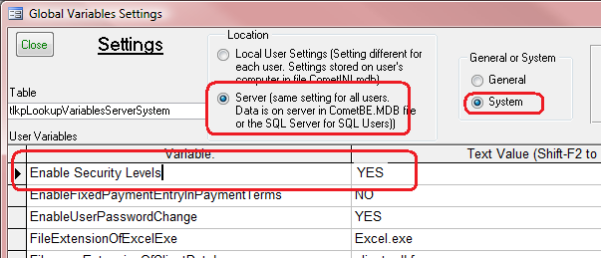

New report #282 shows allocated sales by title, territory and right with totals.

2012-04-13 There is a new Server/Sytem option “Show Restrictions on Title Entry” that will cause Comet to popup with any restrictions while titles are being entered.

2012-04-12 Numerous improvements to the Sales Interest Tracking reports, including an entirely new format designed to report to producers about sales interest to date, grouped by status.

2012-04-11 Sales interest tracking failed on “Sold to Other Broadcaster” during refresh, fixed.

Report #163, Incoming Royalty Report, has an option to include reports already received

2012-04-08L

* Problem fixed where, in the Word template NOD creator, Comet would not be able to process a title with a “:” in the title name.

2012-03-22

* The crosstab query in report #226 no longer pops up with an error
* Looking at the table of invoice types, it is possible to have many different invoice types that are offset against the MG or license fee. See report #56, “Invoice Types”, and make sure the column “set as Fee/Guarantee invoice type” is checked on for any invoice type that is used to invoice against the MG.

2012-03-13

* Problem fixed where, when copying a licensing entity, it was unclear that a new entity name had to be entered

Comet has an option in the payment terms to unlink a payment term to a multi-title invoice.

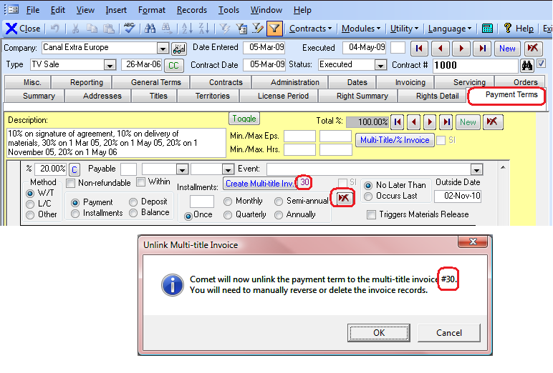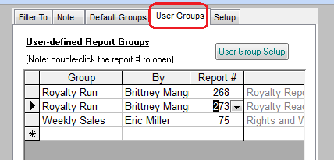

* New Report #282, Allocated Profitability report, shows title profitability on a producer, title and territory basis.
* There is a new screen to add titles to title groups. It is reached from the menu under Modules>Add to Title Groups
* It is possible to add log lines to the availability reports. If both the synopsis and log line is selected in the by title reports, the synopsis will take priority.

1. You can have your large avail reports processed on the IT computer overnight, so your computer is not slowed down. Check on the "Process Remotely" checkbox, and Comet will e-mail the report to you when it is finished.

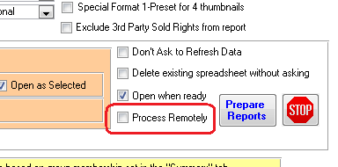

=============================================================================

2. You can have Comet prepare and send a daily avail reports to an e-mail distribution list. For each report you want to have sent, check on the "Send Daily" box and enter the e-mail address separated by a semicolon

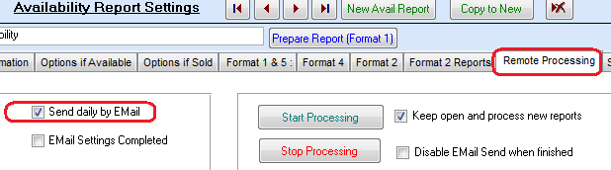

============================================================================

3. Comet will send a conflict check to you if any edits have been made to contracts that affect availability. This has not been enabled at ER, but can be by checking on the box shown in the Email Notification setup screen:

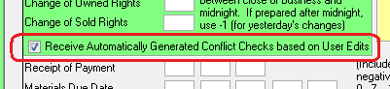

==============================================================================

4. In the same screen, at least one user should be set to "Receive Admin Notices" so Comet will send confirmation of what e-mails were sent, and of any problems.

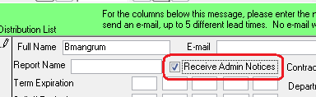

=============================================================================

5. For your foreign buyers, most Comet reports can be prepared in any of the following languages.  There is now a language pull-down in the avail report screen and also the general reports screen.  The Comet screens can also be changed to any of the languages as well.

Arabic

Chinese Simplified

Chinese Traditional

English

French

German

Hindi

Italian

Japanese

Korean

Malaysian

Portuguese

Russian

Spanish

Swedish

1. Comet can be set up to, each morning, e-mail out multiple availability reports to a distribution list. This is useful for users who are travelling or have limited access to Comet and want have a daily availability update delivered to their Smartphone or tablet computer.

2. Users can also be sent a daily summary of rights changes in Comet, such as deliveries, license term expirations, and option deadlines.

3. The availability reports or change in status reports can be automatically uploaded to a Microsoft SharePoint website.

4. If users make changes to the rights in a contract, an automatically generated conflict check can be sent out to a separate distribution list for review.

5. Comet warns the users upon adding rights to a contract if the rights may not be available to license.

6. Comet has an optional multi-level security feature, where users can't edit contracts unless their security level is at or higher than what is set for the contract. The level can be automatically set when the contract status changes from pending to executed.

7. The Comet availability reports can be set for delayed processing and e-mailed when completed, so a user can set up lots of reports to process, exit their computers, and receive the reports later processed on the server.

8. Most Comet reports and the availability reports may be printed in any one of the 15 popular languages listed below. This may be useful when providing reports to foreign buyers and producers. The Comet screens can also be changed to the languages if you have sales offices with access to Comet. More languages may be added upon request.

Arabic

Chinese Simplified

Chinese Traditional

English

French

German

Hindi

Italian

Japanese

Korean

Malaysian

Portuguese

Russian

Spanish

Swedish

* Office and Excel are not required to run Comet. However, the Excel reports and avail reports cannot be generated unless Excel is installed. Microsoft Access (the full version or the free Runtime version) is still required.
* The Comet interface can be displayed in any of the listed languages below. Also, for this release, most of the avail reports and general reports can be generated in any of the languages as well. The screen language setting is available on startup, and also on the main menu bar. The report language setting is in the report screen.
* Arabic
* Chinese Simplified
* Chinese Traditional
* English
* French
* German
* Hindi
* Italian
* Japanese
* Korean
* Malaysian
* Portuguese
* Russian
* Spanish
* Swedish
* The color coding and overall status of the conflict check has been improved to incorporate non-conflicting contracts for the same title, right and territory.
* Previously, when checking a contract for conflicts, Comet would only show information from conflicting contracts. Comet now has a checkbox to include information for the contract being checked. Shown is where the new setting is set so a user can carefully compare the conflicting contracts with the contract being evaluated.

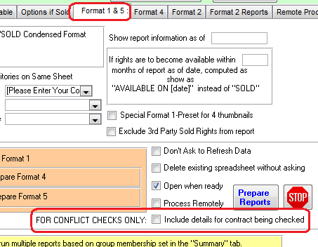

*Comet Changes in 2011:*

<http://www.saturnsoftwareinc.com/CometSupportFiles/CometChangeLog2011.doc>