# Comet™ Change Log for January 1, 2011 through Dec. 31, 2011

For 2012 changes:

<http://www.saturnsoftwareinc.com/CometSupportFiles/CometChangeLog2012.doc>

2011-11-09 04:42 H

Comet has an option which, if set to yes, warns users if they are adding rights and may not own the rights.

If user proceeds, a log entry is made.

* The random but harmless popup fixed with avails, where Comet would prompt for a value.
* The Comet Sales Interest tracking module has a new contact/customer search tab
* Contract Invoicing event based due date calculation sped up.
* “Square” character (due to line feed/carriage return) blocked from appearing in avail reports and contract summary
* Copy exclusions to all rights improved in the rights entry
* New title level security setup fields ready, code not implemented
* Report #83, Sales by Title by Year, updated to 2006-2012

**2011-09-29A**

* The  amount of system logging has been increased substantially, especially with respect to adding and deleting rights
* Comet has a new option to send conflict checks via e-mail when users make data entry changes that alter conflict status.
  + In the Expiration Notification module, there is a user checkbox to “Receive conflict check reports
  + The Server advanced setting “Enable Automatic Conflict Report” must be set to Yes
* By setting the Comet advanced Server setting “Enable detailed title setup logging to Yes, Comet will log all title setup changes. To view the changes for a particular title, click on the “View Log” button in the “System” tab in the title setup
* Comet has a new contract type, “Template”, which allows storage of contract templates that don’t interfere with live contracts
* Comet has a new contract type, “Archive”. In the Contract Misc tab, users can create an archive copy of any contract by clicking on the “Create Archive Copy” button. Or, a user can set a live contract as an Archive contract by selecting the contract type “Archive”
* When adding addresses, the address company name copies over from the group name. In this update, Comet retroactively copies the name if blank.
* Reusable territory groups may be created from any contract by clicking on the new “New Grp.” Button in the contract territory screen.
* New checkbox in Titles Setup screen and/or Contract Title Detail screen to block email notification of overdue royalty reports
* “Show” renamed as Studio and added as a new field in the Title Setup Misc, with a setup table button.
* Auto allocation priority added to right category setup
* Royalty statement due added to the e-mail notification module
* Fixed: ODBC error when adding duplicate languages to contract as “Add Default Languages”

**2011-08-30**

* Improvement to territory name change for Unicode databases
* Fix to looping issue with Avail report format 4 when Format 1 also selected
* Improved performance generating report format 4
* Sales interest “add titles” selection pull-downs sorted alphabetically.
* Problem fixed with report 202, Cash Flow Report, introduced in July 22 version.
* Date/timestamp and username created added to royalty expenses, including manually entered, imported, and created during run from execution expenses and negative calculations.
* Subtitled and dubbed language displays in all inventory list
* New “Awards” field in title setup.
* Option to show Awards column in availability reports
* Ability to create a new title group or add to an existing group from contract title lists

**2011-07-22D**

* Improvements to Format 5 availability report with respect to displaying owned rights holdbacks
* Significant improvement to the Conflict Check report, with improved determination of non-overlapping windows or non-exclusive no-conflict situations.
* Fix of colors with the Format 5 conflict check.
* Sales interest tracking report “unshipped screeners” report blocks inactive/obsolete titles by default with checkbox option to show them.
* Sales interest tracking blocks owned rights in producer report
* Sales interest report layout improvements

**2011-06-07D**

* Alternate company name not read-only
* Unicode companies get “Alternate company name” next to the company name in the contract list
* New Updates and Patches button #46, creates sales interest tracking log entries from the interest data.
* Global settings screen expanded
* New option to show rights information in license contracts in advanced settings, “Show Producer Tab in License Contracts”
* Changing a Company Name in the client profile updates the licensee name pulldown in an open contract.
* System wide performance increase in Comet event management, resulting in a 2-10x performance boost for
  + Availability Reports
  + Conflict Checks
  + Event Management screen
  + E-mail notification module
  + Report #75 Rights and Windows-with date calculation and range
  + Report #278 Contract Title Summary-Condensed with Date Filter
  + Report #208 Master Product List
  + Report #207 Sales Summary Report with Payments and Cash Flow
  + others requiring event calculations
  + Acquisition Source Payment screen
  + Servicing/Fulfillment on-screen date calculation
  + Fulfillment reports
  + System-wide invoice prompt list
  + Revenue recognition report
  + Report #202 Cash Flow Reports

**2011-05-24A**

* Sales interest tracking module Interest by Producer by Title report options clearer.
* System wide upgrade in Comet when browsing for Excel files to allow Excel 2007+ format XLSX files if running Comet for Office 2007 or 2010
* (MDB Version) Comet open data file defaults to *.mdb not CometBE.mdb
* Video orders screen looks to the Comet Title code in addition to the Version Catalog number and House Title #
* Report #278, Detailed format, now supports color coding and totals like the condensed version
* Report #278 has an option to show Right Category allocations as separate columns
* Company Profile setup-there is an alternate company name next to the regular company name. Also in the company list.
* In the Title Setup, the date/time edited does not change when moving between tabs unless the status (colors) changes.
* Report #83 is updated for 2005-2011, and also allows 3rd party contracts.
* Report #160 Sales by Title by Year has a checkbox option to include 3rd party contracts
* Comet warns if there is no default bank account ‘Default Account’ set up on update version.
* Comet creates the bank account “Default Account” if missing
* The Expiration Notification module has an option to disable the expiration date calculations for fast testing.

**2011-05-11C**

There is a new Advanced Server setting " Enable Contract Number Edit Block by User". If enabled, only users with the checkbox shown below ON in the User Setup screen will be able to change a contract number.

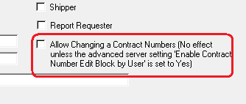

**2011-05-11B:**

* Report 278 has options to filter exclude titles with no NOD date and filter to an owned rights contract (for both owned and sold rights) or a single sold rights agreement.
  + If the "Owned Rights" checkbox is unchecked (to show sold rights in the report) and you filter the report to an owned rights contract, the report will be filtered to sales for the titles in the selected owned rights agreement.

**2011-05-10A:**

* Company name accounting approval export updated.
* Report #69, “Revenue Recognition, All Non-Series Titles” was filtered to include separate episode sales. This has been fixed.
* Contract summary screen more readable since data boxes lightened.
* Address tab has set/unset “show all addresses” checkbox. Previously it was a button only.
* Unicode problems fixed with Company Profile
* Royalty reports sales history territories only shows licensed territories no options or holdbacks based on license type setup “Include in Royalty Report Sales Territory list (See report #60 “License types”
* Agent checkbox added to Company Profile (under Vendor, Producer, Licensee etc. checkboxes)
* The Comet contract Title checkbox filters the list of titles to inactive/obsolete titles and allows adding to contract.

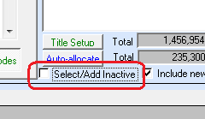

* The introduction of a Royalty Report batch reporting process, where an archive of all reports is created and users may work with smaller batches as well.

**2011-04-15H**

* Report #148, Company Profile List, updated with new columns. Name column frozen.
* Report #148 now available from company profile on Upper right hand corner of screen
* Company code widened
* Accounting Interface, rights, territories and languages columns to accounting interface receipt report by title
* Also, Report #195, “Allocated Receipts by Property”, has checkbox options to show the territories, rights and languages.

**2011-04-14**

* Populating Sales Interest Tracking “Informed” date now shows new “Pitched” status, previously showed “Interested”
* Change of headings from “Informed” to “Pitched”
* Removal of contact initials from Sales Interest Tracking reports
* Sales interest tracking, problem fixed where, for new companies, if adding titles before saving the company the titles were not saved.
* Company and title name search problem fixed for Unicode databases

**2011-04-11F**

* The Comet royalty report groups have a producer code range filter. (Blank=include all)
* The royalty report list is based on the server. All users share the same list.

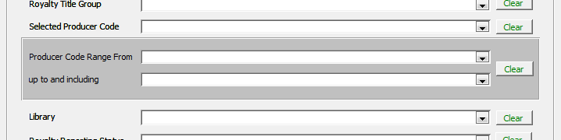

* In order that multiple desktops can be preparing reports from the same list, Comet has a processing reservation method implemented so that, if one workstation is processing a report or report group, the other workstation will skip ahead to the next report or grouped report. This is done by populating a new value in the royalty report record indicating the workstation and login name processing the report. This value is cleared when starting a new run, but only for the same computer/login.

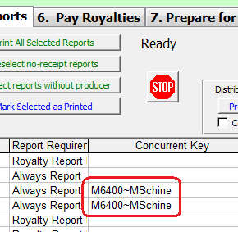

To start completely over again, a new button “Remove Multi-User Reservation” clears out the value for all users.

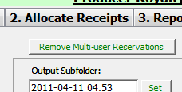

**2011-04-06E**

* For entities that “Don’t’ show any VAT information”, Non-Base (=foreign) currency multi-title invoices now prompt to display condensed format or detailed format. Previously, only the condensed format was available.

**2011-04-06 C**

* Ability to process royalty reports from server-based worksheet (SQL users only)
* Improved lookup tables format for Contract Types and Contract Status.
* New column in the Contract Type setup table (Report #132) to block contracts by contract type in the avail reports.
* Improved avail report performance during refresh, especially if blocking 3rd party contracts.
* The Royalty Expense Import performance improved

**2011-April-3 Release A** (Requires an SQL Update)

* New data fields in the Title Setup screen:
  + Log Line
  + Short Synopsis
  + Last Updated
  + Last Updated By
* New data fields in the Contract screen and Contract List:
  + Date Cancelled
  + Collection Agent
* New columns in Contract Status setup (as General Report #24):
  + Block from Availability Reports (blocks contract entirely from being used in availability reports)
  + Block from Pulldowns (to prevent the status from being entered again in the contract entry screen)
* Sales interest tracking, new column “[Screening] Format Sent” added to detail screen.
* Comet supports a default VAT/GST % by participant, which gets copied to the royalty share setup-party table. It can be modified for each royalty share setup. (note: the interface is operational, but the royalty report has not been updated in this release. To be completed soon.

(Open the participant setup from the owned rights agreement royalty terms setup)

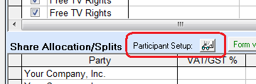

(Particpant Setup)

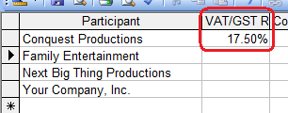

(From the owned rights agreement-royalty share terms)

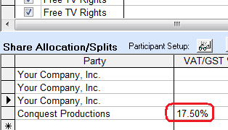

* Comet supports limiting what e-mail notices users receive to specific companies. The setup is at the bottom of the Expiration Notification setup screen.

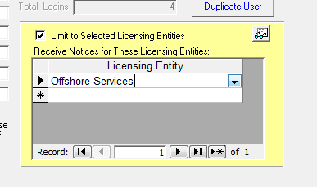

* Various Avail format settings are now saved with the report record, instead of requiring being set when the screen is opened. They include:
  + Prepare Format 5 with Format 1
  + Format 5 in color
  + The Format 4 condensed/all columns setting
  + The Format 4 Excel Output format (e.g. single sheet, 1 tab per territory, etc.)
  + Also, there is a new checkbox option to print the Format 4 report as set in the Format 4 tab.

**2011-03-29T**

* Improvements in QuickBooks export
* Improvements in multi-territory Format 1 avail by territory

**2011-03-18S**

* More improvements in the availability report interface
* When choosing format 4, there is no popup asking about changes the first time it opens up tab 4.

**2011-03-15R**

* The e-mail notification module is programmed to run at 8:00PM by default. Previously, it ran at 5:00 AM the next day.
* Email notification module Execution Event notification updated to show changes in contract status and changes in execution date and entry of new contracts.
* The EMail notification module shows newly entered contracts as well.
  + In the example below, a notification will be sent the same day the contract status is changed or the same day the execution date is entered, then a week later as the number is a -7 (negative)
  + The days before is not the date the contract is executed, but the date of entry/change.
  + If running the process the day after execution dates are entered, the number should be set to -1

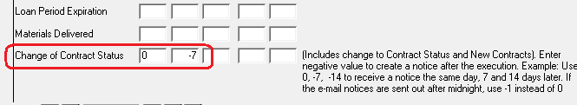

* Adding rights categories with no right category selected in Rights Summary screen has improved message with no screen refresh.
* In an avail by title report, Comet won’t disable the “Show restrictions next to title” if the “Show Restrictions in separate column” option is yes. The by-territory reports will keep this logic check in so the report does not have the restrictions in both a separate column and also next to the title being redundant.

**Version Q:**

* Avail report format 4 and 5 integrated with Format 1 report to speed up overall processing.
* Numerous improvements to report #278, “Contract Title Summary-Condensed with Date Filter”

**Version K:**

* New Advanced setting “OpenReport78OnLoad” opens a simple executive-level report screen:

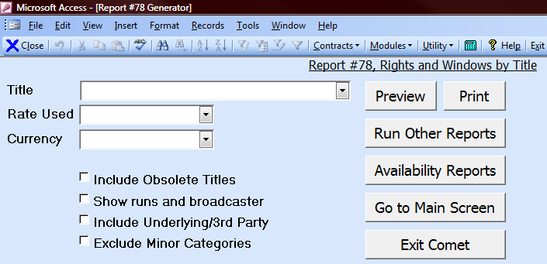

Creation of owned rights agreement from template in title setup screen.

Copy Contract now can copy the titles, episodes, and royalty information.

New report 278 “Contract Title Summary Report with Date Range” shows contract title details, expiry status with an end date filter. Has color coding based on expiry status.

Report 248, “Contract Title Summary Report” has an option to show owned rights (previously the report was sold rights only)

**2011-01-06A**

* There is a new checkbox option to block 3rd party contracts (Both Owned and Licensed) from the availability report Format 1.
* Many options in the Availability Report Screen have been moved to a single new tab called “Title Information”.
  + Some title information options appear next to the Title Name, other options are in a new column.
  + These options are supported in the Special Format 1 Thumbnail report.
  + The options circled below are new with this release.
    - Alias Title Name
    - Director’s Name
    - Inventory #
    - MPAA Rating
    - Restrictions

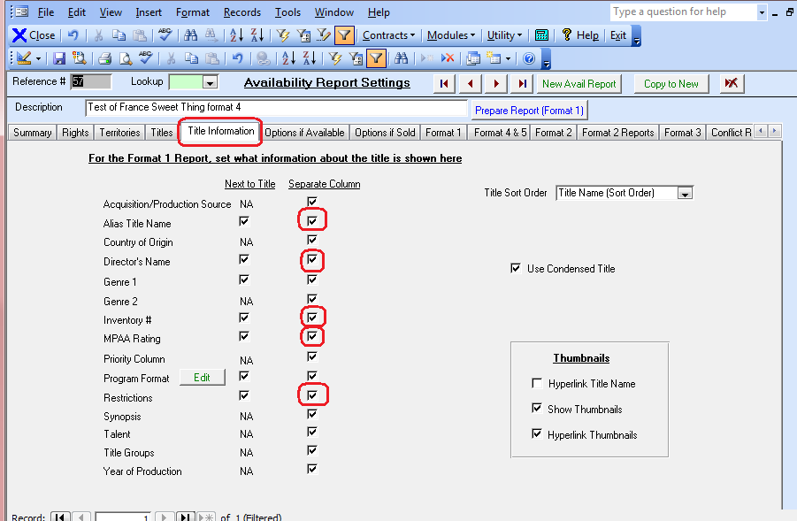

* Comments column on Contract Status setup screen added
* The Bank Account (Invoice Payment Account) setup screen includes a “Date Account Inactive” box.
* The Talent setup area includes an entered by and date entered column

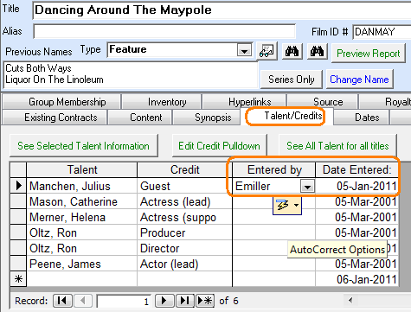

* In the Title Setup Royalty Expenses setup screen, there is an option to set a start and end date by expense.

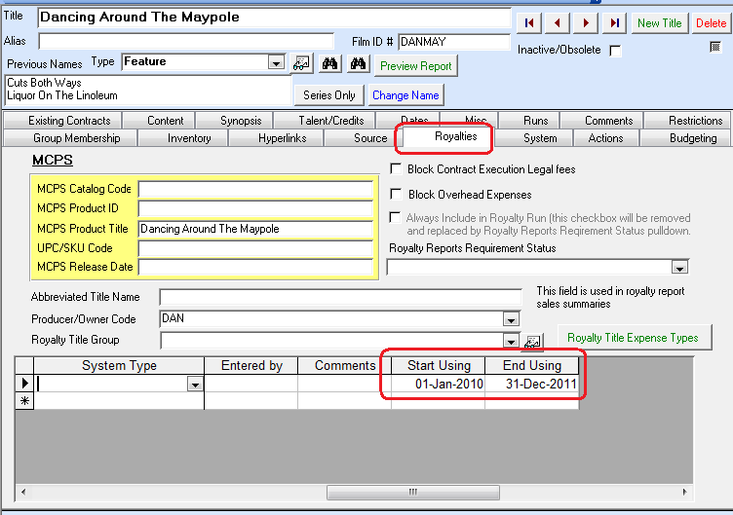

* Sales interest tracking, in the detail, a Last Changed, Changed by, Airway Bill # and Episodes fields are added.

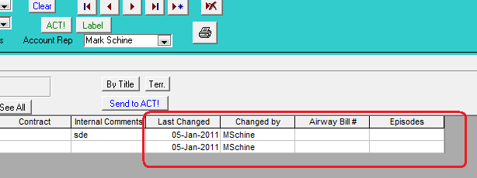

* Report #75, Rights Expiring in a Date Range, has some new report options as circled.

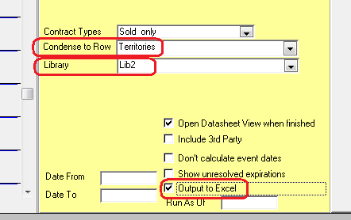

* When creating episodes in the Title Setup for a series, there is a new field for the total episodes in the series. Comet also used the default program time from the setup if available.

Report 277 lists contracts with no override end dates. There are 3 separate reports:

* Contract Level: List of contracts containing rights using a blank contract level term
* Contracts where there are right categories with no end date. (view the rights summary tab)
* This shows the right level details of the previous report

*Comet Changes in 2010:*

<http://www.saturnsoftwareinc.com/CometSupportFiles/CometChangeLog2010.doc>