# Comet™ Change Log for 2009

For 2010 Release notes: <http://www.saturnsoftwareinc.com/CometSupportFiles/CometChangeLog2010.doc>

**2009-12-31**

* New report 270, Owned Rights Implied Parent Territories” will list all owned rights agreements where a parent could be added.
* Owned rights parent territories for availabilities are automatically determined.
* Report 145, Invoices Due with Foreign Currency Amounts has a spreadsheet output format.
* In the general reports screen, there is an option to search for reports by report name.

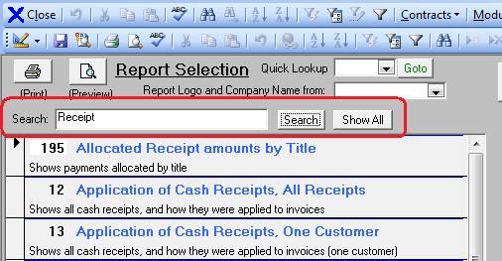

* Problem closing the rights detail entry screen where Comet would close the contract fixed

**2009-12-02**

* The Royalty Expense import table moved from a local table to a server table so that original import values and results are stored permanently. This also reduces the chance of importing the same expense twice since the unique ID values are stored on the server, preventing re-import.
* Comet has built-in support for moving to a new server without changing the user’s desktop configuration (Comet will do this automatically).
* The payment terms definitions have no length limit. Previously, they had a 255 character limit.
* The license term and holdback event widths were increased to 255 characters from 100 characters.
* Comet has a checkbox option in the availability report settings to show/hide resale window count value.
* Comet supports sending e-mail notices through SQL server, eliminating the need to use MAPI. To enable this,

1. In Comet advanced settings, set the variable “e-mail program” to “SQLDatabaseMail” without the quotes.
2. (This step is optional). If you have multiple SQL e-mail profiles, you can specify which one Comet uses to send e-mails by adding the variable “SQLDatabaseMailProfileName “to the Comet advanced settings, and setting the value to be one of the profiles. If this is not set, Comet will use the default profile. If you only have one profile, that is the default profile.

Example: SQLDatabaseMailProfileName = Comet SQL 2005 Database Mail Profile

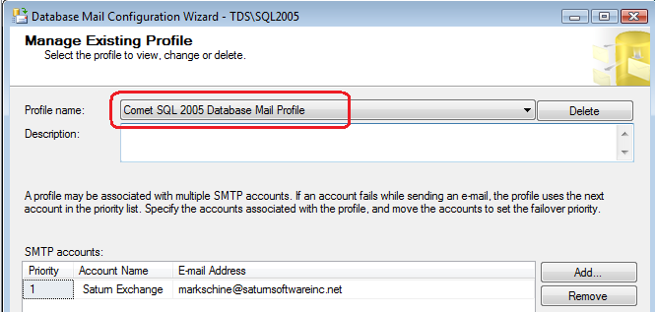

* As a new security feature to prevent users from editing different contract types, Comet supports limiting editing contract security by contract type and title type. By going to the User setup screen, you can add all types and block different types as shown:

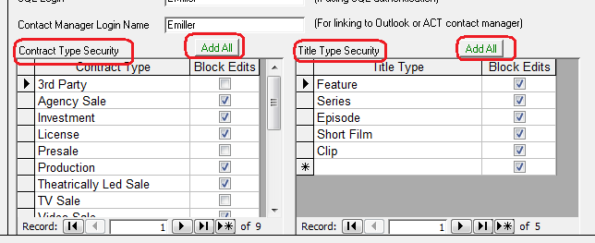

* Comet has a new option to automatically add titles that have owned rights for the territories selected (or the worldwide rights checkbox set on). Previously, it was necessary to select all titles and run the report. This option excludes all titles that are not acquired for the territories.

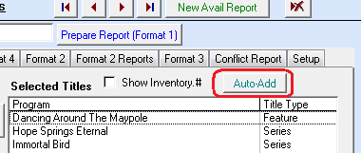

* Invoice pay-to bank account pull-down selection in new invoice popups must exist in the bank account setup table. Previously, a write-in was allowed.

**2009-10-14C**

* Report 248 shows Broadcaster, Library and Producer Code for all reports.

**2009-10-12B**

* A producer code field is available in the Participant setup screen
* Report #73 “Rights and Windows by Related Territory”, has checkbox option to group the rights and territories to one contract per record.
* Report #34 has two new checkbox options:

1. Show Foreign Currency shows the contract license fee and currency country, with the rights and license term windows. This report is oriented for portrait.
2. Show Receipts adds the invoiced, paid, current, uncollected columns in landscape orientation.

* New report #269, Compact Collection Report
* Report 262, Contracts by producer code:

1. New option to filter to one producer code
2. New checkbox option to include titles with no producer code (only applies if producer code pulldown is blank)
3. New checkbox option to open report 242 to show titles with no contracts.

**2009-10-05 Release K**

Adjustments added to report 256, with reportable receipts before and after adjustments.

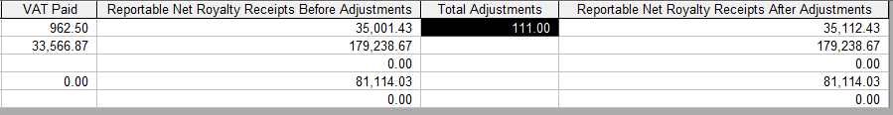

* Report 32 has a wider contract number

**2009-09-21J**

* Report 256 Allocated Receipts report has new options and columns:

Report #256 changes

1. New column based on existing columns for Net Credit Less VAT less WHT, less bank charges, less intermediary, less approved deductions, less currency gain/loss

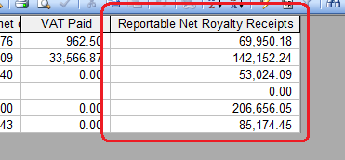

1. New report shows to provide title total version of the report (i.e. combined total by title of all contracts with receipts in date range). The new report is a condensed summary by title report showing new calculation column “Reportable Net Royalty Receipts” plus the title information columns (Producer Code, Title Code, Library)
2. Added a Producer Code column to the main query report by contract
3. Added a title code column to the main query report by contract
4. Added a Library column

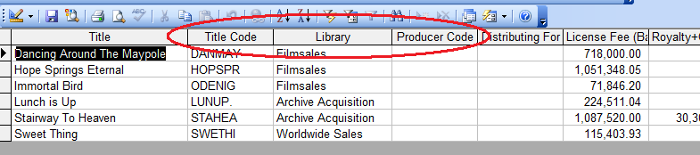

1. A new filter will filter by library. If left blank, all libraries are included.

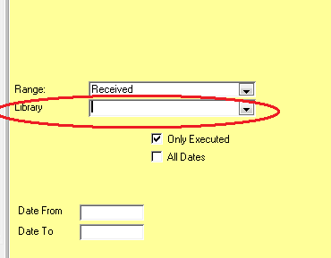

**2009-09-21F**

* Comet has a new path in Advanced Settings called “DrivePathOfPosterGraphicFiles”, intended for high resolution graphic images for the new Format 2 Word output report. It defaults to the same folder used for Thumbnails, but may be changed for each user.

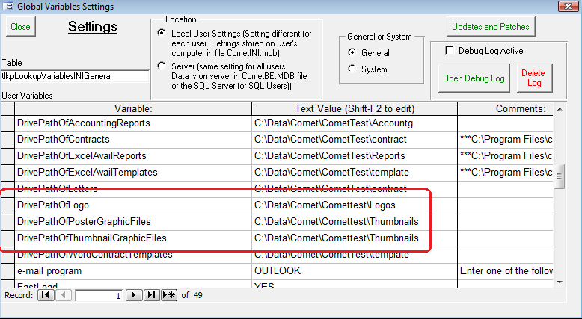

* Comet has a new availability report format, “Format 2 Word output” which creates a multi-page Word availability document with a high resolution “poster” image that may be exported to HTML directly. It uses the Format 2 report engine which requires that owned rights information be entered in Comet, or that the “Worldwide Rights” checkbox is on in the title setup screen.

To run the new format:

1. Open a word document and save it in the Comet shared server Template folder as AvailFormat2WordTemplate.dot. There is currently no way to change the name. Add your own company artwork and contact information in the header and footer.
2. Open a Comet availability report.
3. Select the titles, territories, rights, and other options for the report
4. Open the Format 2 tab in the availability reports
5. Click on the “Prepare Data” button

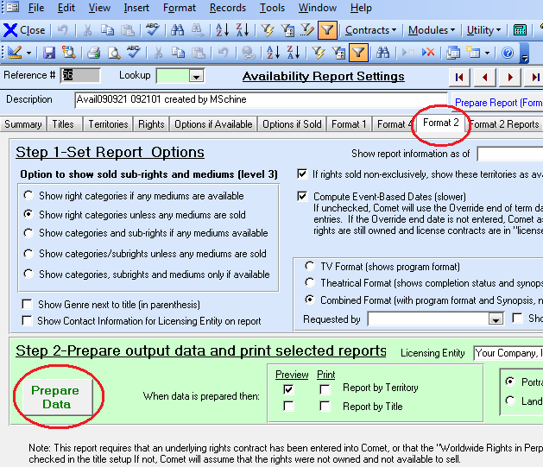

4. Wait until Comet brings you to the “Format 2 Reports” tab.

5. Click on the Create New button in the box circled:

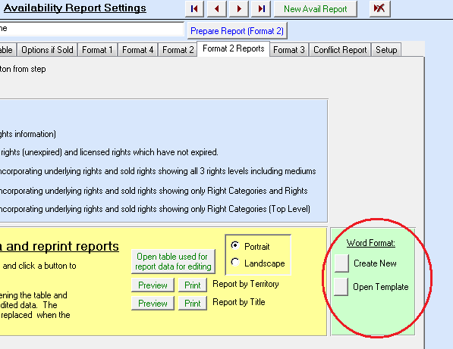

* 2009-09-21 New setting called “DrivePathOfPosterGraphicFiles”, defaults to Thumbnail folder. Allows high resolution poster images for new Format 2 Word output format and separate thumbnail output for format 1 avail formats.
* 2009-09-21 Comet Avail reports has checkbox option to include/exclude conflict checks
* “Excel Application Error” problem resolved
* Currency update points to Update folder on server instead of C:\CometRights, done for new all-version update procedure where update file 1998Exch.mdb is copied to the server Update folder.

Release E: Producer Code pulldown added to title list

Royalty “Adjustment Type”pulldown removed from share screen, only one type supported. (Contract Title, no longer all title)

New royalty exception report #267 “List of Royalty Receipt adjustments with no date”

Comet has a new option to include obsolete/inactive titles in the “not included” title list.

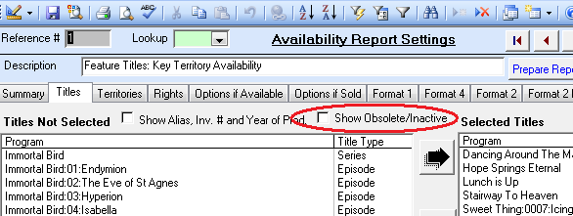

**2009-08-05**

* New “All version Combined” update file procedure, available on the Comet update web page, simplifying new Comet releases at multi-user installations. The simplified procedure is to download and unzip the files to the shared “..\Comet\Update” folder on the server. Comet will automatically update the clients.
* Extensive improvements to Royalty Reporting, documented elsewhere
* Fix and improvements to Notice of Delivery functionality
* Comet currency table updated for new currencies:
  + ARS Argentine peso
  + TRY Turkish lira
  + VEF Venezuelan bolivar fuerte
* Connection failure messages greatly improved
* Quickbooks accounting export functionality has new buttons to open up Receipt/Invoice export status table for re-exporting purposes
* Disabled the rights entry popup “Comet will use the start date override from the term tab, since one has been entered”
* Office 2007 users have new “X” at upper left corner of Title Setup screen to close the form due to reports of a slow close cycle.

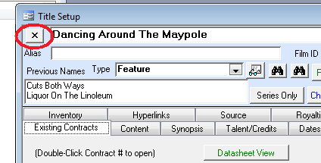

* New variable in Local System settings “Include Negative Invoice IDs” to include or block negative invoice numbers in receipt application screen. Set to No (block) by default.
* Report 141 has new checkbox option to allow invoices with negative ID.
* Improvements to company name change. Merge and name change combined.

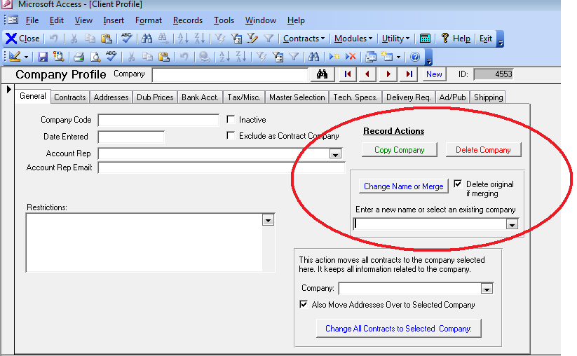

New tab in Company Profile screen to perform multi-company rename and/or merge. Values may be pasted in from an external spreadsheet.

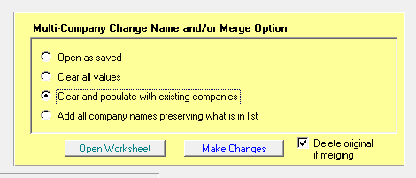

This is what the worksheet looks like:

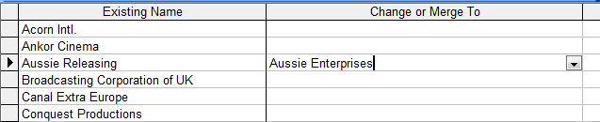

* In initial Receipt application view, negative receipts and negative invoices are blocked from view
* New options on Royalty Report application of receipts to royalty right categories to auto-link to Royalty Pass-through category.

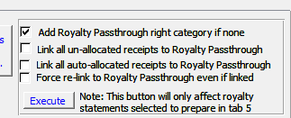

* Print/preview NOD shows updated NOD date on screen

|  |
| --- |
| Server Update Sequence #49770 |
| Frontend Update Release F on 2009-06-04 |

Incorporation of new terms in royalty reporting:

* Distribution Fee
* Distribution Commission
* Expense Recoupment
* Advance Recoupment
* Packaging Deduction
* Royalty
* Other
* Loan
* Investment
* Royalty Cap
* Reversioning Costs
* Advance
* Deficit
* Clearance Costs
* Advanced Costs
* Fees
* Numerous other royalty report improvements documented elsewhere. Improvements to the interface and output documents
* New count of available rights option on format 4 availability reports
* Territory group exclusion addition fixed
* All-address view available from splash screen left panel
* General reports screen re-designed
* New global variable filter option, “Library”, where entire system (screen views and reports) may be filtered to a single library.
* When generating a Word deal memo/long form, Comet checks destination path to make sure it exists to prevent Word freeze trying to create file into non-existent folder.

|  |
| --- |
| Server Update Sequence #49490 (first released 2008-12-07 04:20) |
| Frontend Update Release H on 2009-02-12 |

* Prevent importing royalty expenses unless either the period date override is entered, or the checkbox “Use expense date” is checked on. This is to prevent importing records to the wrong period.
* Improved linking of receipts to the owned rights agreement’s right categories in the royalty setup
* Additional Royalty report improvements.

|  |
| --- |
| Server Update Sequence #49490 (first released 2008-12-07 04:20) |
| Frontend Update Release F on 2009-01-15 |

* Fix to royalty expense import where Comet could attach expense to 3rd party contract

|  |
| --- |
| Server Update Sequence #49490 (first released 2008-12-07 04:20) |
| Frontend Update Release D on 2009-01-07 |

* Further Royalty module updates. Please contact Saturn for current documentation.

|  |
| --- |
| Server Update Sequence |
| Frontend Update Release |

Updates and Patches new button #43 updates contract-level start and end dates from rights category start and end dates.

Options 1 and 2 will overwrite existing dates

Options 3 and 4 will only update if the contract level date is blank, so existing dates will not be replaced.

An existing date will not be replaced by a blank.

|  |
| --- |
| Server Update Sequence |
| Frontend Update Release |

New Library filter capability in reports and system filter

General reports screen enlarged

*Comet Changes in 2008:*

<http://www.saturnsoftwareinc.com/CometSupportFiles/CometChangeLog2008.doc>