# Comet™ Change Log for January 1, 2007 to December 31, 2007

*Comet Changes in 2008:*

<http://www.saturnsoftwareinc.com/CometSupportFiles/CometChangeLog2008.doc>

**2007-12-11 23:07**

* Pops up SQL Script in SQL 2005 and/or SQL 2000 during update
* Popup error message fixed in contract Payment Terms tab
* Contract buttons set back to tabs

**2007-12-11 04:02**

* New subrights entry screen loads faster
* ACT import process improved
* Address screen has pull down in company name to easily switch address to a different company
* Button added to open all-address full screen view in Company Profile addresses (same as Modules>Setup>Addresses)
* Comet e-mail notification screen will launch automatically if the Advanced Settings option “Auto-launch E-Mail Notification screen” is set to “Yes”
* New long form mail merge fields

| **Mail Merge Fieldname** | **Description** |
| --- | --- |
| <<Subtitled/Dubbed Text>> | Shows "Subtitled", "Dubbed", "Subtitled and Dubbed", or "Original Language only, not subtitled and not dubbed" |

| **Mail Merge Fieldname** | **Description** |
| --- | --- |
| <<Payment Terms Text No Description>> | Shows the payment terms without the free-form description |

<<Titles+Duration+Term+Fee>>

|  |  |  |  |
| --- | --- | --- | --- |
| Titles | Duration (Minutes) | License Period  (inclusive) | License Fee(s) |
| <<Titles+Duration+Term+Fee>> |  |  |  |

**2007-22-20**

* New support for Brand Advertising
  + New tab in Contract Misc. called Brand Advertising
  + New long form merge fields supporting new data entry fields related to brand advertising as shown:

| **Mail Merge Fieldname** |
| --- |
| <<Brand>> |
| <<Brand Titles and Credits>> |
| <<Brand Adverts>> |
| <<Competitive Advertising Categories>> |
| <<Competitive Advertising Block>> |
| <<Proscribed Hours>> |
| <<Brand Advert Spots>> |

* Exclusions added to report 75 datasheet output
* Date/time right category added now available for reference purposes
* Additional reports in Sales Interest Tracking
* Accounting export prompts to close period after preparing export data
* New information checkboxes on Contract summary form (Amendment, closed)

**2007-11-02**

* Extensive changes to Sales Interest Tracking screen, to be documented later.
  + Interest tracking has feature to update Pending Deal and Sale Closed status from Comet contract area.
  + Interest tracking app close problem when searching for company fixed
* Comet Word Long Form Merge changes:
  + Fix to Comet deal memo showing “Success” for some fields
  + New checkbox added to company profile screen Certificate of Residency, next to original Certificate of Residency text box.
    - <<Certificate of Residency>> will show “Yes” or “No” on mail merge deal memo
    - <<Certificate of Residency With Notes>> will show yes or no, and also show text from box.
  + Blank lines removed from payment terms text (except one blank line after overall description)
* On Overage Entry screen, caption “Amount Due (Foreign)” changed to “Period Royalty (Foreign)”
* In Company Profile, Addresses tab, New query added to Addresses tab in company profile, “Show All Addresses in Datasheet View”

**2007-09-28**

* Fix to new rights entry screen and retroactive fix to data

**2007-09-25**

* Contract input>Overages>Financial Terms pull down widened to view more information
* New address fields in internal address module under company profile
* New screen for viewing internal addresses, available from Modules>Setup>Addresses
* New screen in Rights Summary tab of contract input listing all rights groups. Reached by clicking on “Show” button. List details
  + Included titles
  + Included territories
  + Excluded territories
  + Runs
  + Playdates
  + License period start and end dates
  + Holdbacks
  + Included sub-rights and mediums details

**2007-08-30 Patch F**

* Fix to rights remapping screen
* Territory setup, language tab has “Add All” setting

**2007-08-30 Patch E**

* Comet Word Long Form/Deal Memo: If no special terms or additional terms, the contract will show “None”
* When changing the contract currency, Comet will refresh the currency shown in the included title summary to the new currency
* Word deal memo “boxes” removed

**2007-08-30**

* Improved format 4 user interface
* Title setup-episode tab visibility was based on title type, not on title type setup
* Right Category Rename feature added in rights setup, changes all contracts and avail report selections.
* Royalty shares may only be added with the “New” button, not with the right record arrow causing a null error message
* If unrecouped, royalty payment summary due shows negative “Amount owed to producer” but shows 0 as amount to pay current period.
* Payment terms only allows adding new terms with “New” button instead of right scroll.

**2007-08-16 (Release C)**

* Release C has new report #257, “Title Catalog List” with output to Excel.
* Patch release B: Fixes problem with updating delivery dates when closing commercial invoices

**2007-08-16**

* Significant improvements to the new rights entry screen
* Improvements to the Royalty/producer reporting module
* Comet will refresh the deliveries tab in the title input screen after adding new titles
* Comet defaults to hide episodes on title selection screen

**2007-08-10**

* All-new easy screen to enter rights. It will open when clicking on Rights Summary tab with no rights in contract, or by clicking on the new Screen button in the Rights summary screen.
* Improved performance entering rights in new screen and original rights summary screen
* Improvements to Rights re-mapping module
* Word Long Form merge document has additional merge fields:
  + <<Default Runs>>
  + <<Default Playdates>>
  + <<Default Runs in Playdates>> (combines runs and playdates in single field)
  + <<Inbound Shipping Costs>>
  + <<Outbound Shipping Costs>>
  + <<Default Loan Period Days>>
  + <<Certificate of Residency>> (new field in Company Profile, Tax Misc. tab)
  + <<Withholding Tax Form Y/N>> (new field in Company Profile, tax Misc. tab)

**2007-08-01 (early release dated 2007-07-25 as Release B)**

* New built in rights re-mapping module
* All avail reports, general reports and royalty reports have border scroll lock set.
* Royalty report has Peachtree expense input format
* Royalty report shows unrecouped expense totals on the summary page.

**2007-07-25**

* Availability reports have significant improvement. When a right is available non-exclusively, Comet will show “Available Non-Exclusive” instead of “Sold (Non-exclusive). This change applied to format 4 as well. The Format 1 has a new color option for this status, set by default to be olive green. The status color can be changed to any other color in the Setup tab of the avail report. Shown is an example:

|  |  |  |
| --- | --- | --- |
| **Video Rights** | **Pay TV Rights** | **Free TV Rights** |
| AVAILABLE | AVAILABLE Non-Exclusive Acorn Intl. | SOLD Acorn Intl. |

* Multi-title invoice “% Invoiced” calculation in title list at bottom only shows fee/guarantee invoices instead of including materials and royalty invoices.
* Improvements to reports 202, “Cash Flow report” and report 207, “Sales Summary Report with Payments and Cash Flow” with respect to payments received and un-invoiced amounts.
* Materials invoices and payments excluded from report #207, “Sales Summary Report with Payments and Cash Flow” and report #265, “Contracts to Date with Receipts During Date Range”
* Improvements to report #256, clarification of headings and also addition of VAT amount column.
* Fixed “Can’t open Excel” popup with royalty report module
* Rights management setup interface improvements, including new button for report showing list of all rights in any non-void contracts useful for re-mapping of rights.
* IBAN# added to Bank Accounts setup as a new field.
* Size of setup text values in advanced settings for pull downs and invoice descriptions increased from 256 characters to unlimited (SQL users only)
* Comet availability reports now have option to add title type (Feature, Series, Special, etc.)
* Additional fields added to Invoice Log (Title, Company, Contract#) for report 252 when deleting invoices.
* The Current Exchange Rate (used as the invoice rate) on the multi-title invoice (both the invoice by payment term and invoice for all payment terms) and the System Invoice Creation invoice may now be edited prior to invoice creation.

**2007-07-03**

* Producer royalty report improvements, including performance optimization
* Unit sales import improvements
* New report #256, “Contracts to Date with Receipts During Date Range” similar to report 244 and 32, lists all contracts to date with receipts for a period, including allocated amounts for bank charges, currency gain/loss, withholding, and other deductions.
* Format 4 Avail Report improvements to formats

**2007-06-14**

* Servicing module has full support for shipping, loaning, and bicycling “sets” of tapes.
* Report 207, “Sales Summary Report with Payments and Cash Flow” has the following improvements:
  1. Withholding tax, Intermediary, Other deduction, and Currency gain/loss broken out into separate columns.
  2. Bank charges and currency gain/loss shown separately in summary calculation at bottom.
  3. Contract currency MG shown with contract currency.
  4. Headings improved
  5. Gross payment and net payment received shown
* Improvements to the producer royalty reporting module

**2007-06-05:**

* Reports 73 and 74 (Rights and Windows by Territory) has option to export report data to Excel
* Availability reports Format 1 no longer require template. Also, “scratch” or extra tab will not be shown in the report. Comet uses the first page of a multi-sheet template as the avail template and deletes the rest, including the “scratch” sheet.
* Improved support for Excel reports generated in Excel 2007/Office 2007
* Royalty report improvements
  + Better representation of receipt detail, showing detailed allocation to rights
  + Receipt allocation does not require allocation to a right category. Comet will allocate receipts to all rights categories using rights category allocation weights pro-rated.
  + Interface upgrades for selecting which receipts are to be automatically allocated or manually allocated.
* Invoice address send-to description may include the   
  auto-fill field <<Invoice Title>>
* All Comet “Output to Excel” reports and documents have improved numeric formatting and cell alignment

**2007-05-08 Re-release**

* Avail format 1 sometimes showed a “file not found” message, fixed as a patch release.

**2007-05-08**

* New availability format, “Format 4” with options for output to multiple Excel files and tabs.
* New option in Availability format 1, condensed version, Comet will show “available since” date for resale status now available if checkbox “Show available date for resale status” is checked on.

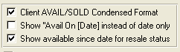

* Royalty reporting improvements to interface and reports
* Report #73, “Rights and Windows by Territory” has an option to output report details to Excel
* Problem fixed in report 202, Cash flow reports, where company name not coming through for titles not linked to a payment term, or contracts with no payment terms.
* Report #57 has checkbox option to show new query “Bank Account by Title”
* New report #255 “Producer Royalty Reports Schedule” shows all undelivered producer royalty reports.
* Cosmetic only bug fix during multi-title invoice creation, where Comet would indicate that some titles contract was over/under invoiced when they were not due to materials invoices being included in the total amount invoiced.

**2007-04-10**

***Improvements to Comet bar code label printing***

* New button next to bar code description will create description based on AA-BBB-NNN where
  + AA is category code from category setup table (program, trailer, etc)
  + BBB is title accounting code
  + NNN is internal system ID number
* New “mini-label” format combines Bar Code Number or System # as the bar code with the Label Description. Label too small to print alpha-numeric values, so numeric range limited to 999,999. Label will print to Dymo 30330 return address labels to a printer named Dymo 400 LabelWriter 400.
* Preview checkbox allows direct print or preview.

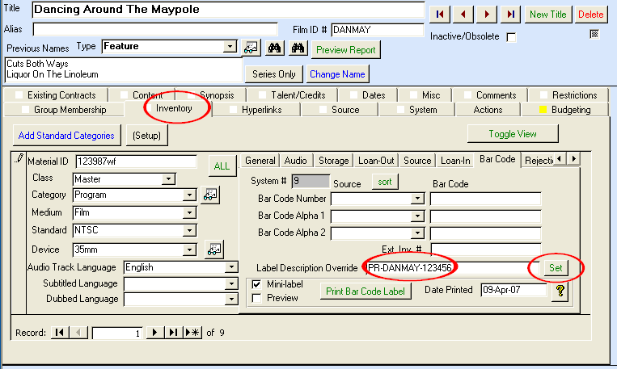

**2007-04-02**

* Report 142, “Invoice Tax Report at Invoice Rate” intended for VAT reporting purposes shows contract currency and contract currency invoice amount with improved headings. Sample:

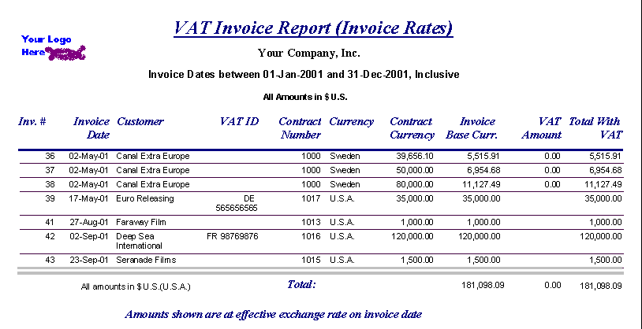

* Improvements to servicing bar code scanning lookup of data and auto-populate of loan returns.

**2007-03-26**

* When adding all titles in the Contract Servicing screen, if the fulfillment type and method are set as a “Loan Out” type in the Contract Fulfillment screen, Comet will check on the “Loan Item’ checkbox in the servicing record and also include the default loan period.
* **Bank Account information on report #57**  
  Comet shows bank account information with an option of sorting it by Bank Account, by Distributor or by Title.
* There is a new pull down for the sorting/grouping on the report 57 options, with a checkbox to show bank account information which opens up the new condensed report format.

Report 57 Options:

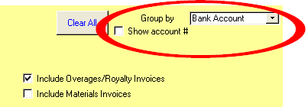

* There is also a new Condensed Bank Account Name in the bank Account setup screen. If this is blank, Comet will use the main account number.

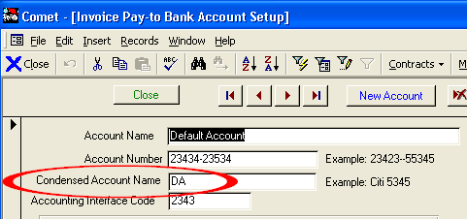

**Aging Reports**

* Modification of report #186:Invoices are aged monthly for the first year, quarterly for the next two years and then annually (with report option to show extended aging)
* Aging reports switched from “0-30, 31-60, 61-90 days” to “0-29, 30-59, 60-89”

* **Contracts By Customer report 158, o**ption to show 3rd party contracts. 3rd party MG’s and balances excluded from report.
* Report 202, Cash Flow Reports, has option to select Report by Distributor.
* Report 202, Cash flow report, will automatically run step 1 and/or 2 if skipped.

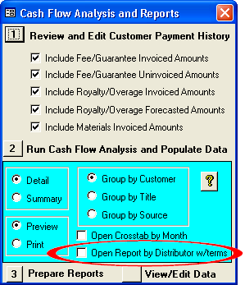

Comet title inventory and servicing module has these changes:

* In the Title Setup, Inventory tab, the Audio information was moved to a separate tab and combined with 8 audio channel description boxes
* There is a new “Class” to identify each inventory item as a master, dub, or loan tape.

**OVERVIEW OF NEW TITLE “VERSION” SCREENS in COMET**

At the high level, both for features and series

titles

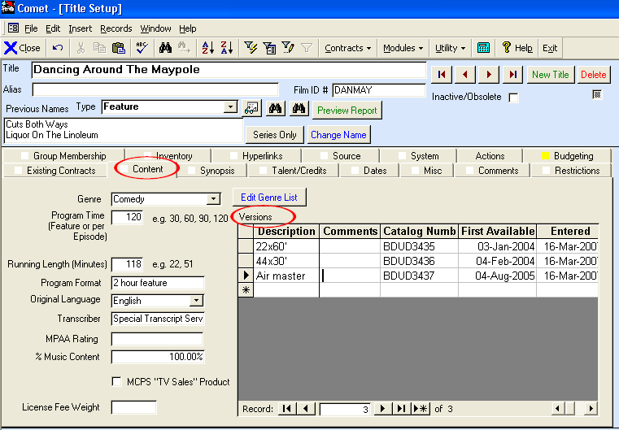

Episode set up for series versions

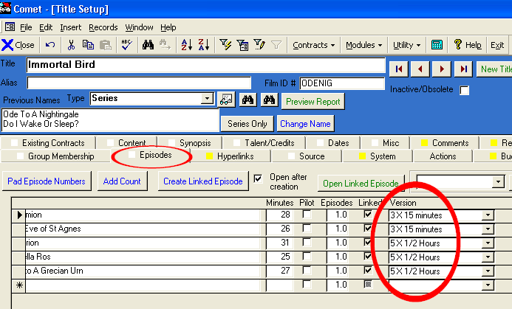

In the sales contract, select the version to limit to associated episodes.

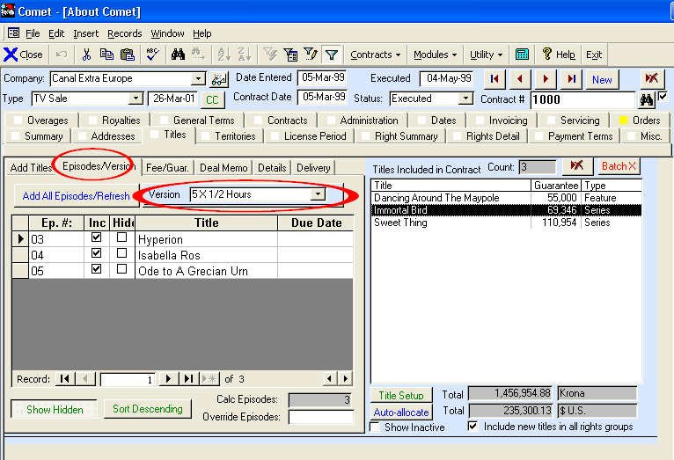

Comet will only add episodes for the version selected. If no version is selected, Comet will add all episodes as before.

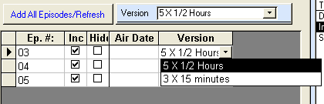

Also in Details sub-tab for features or on the series level.

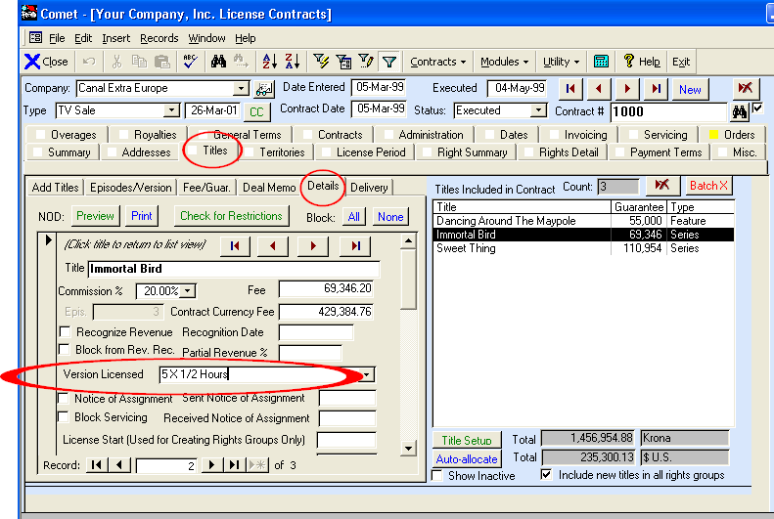

When servicing, episodes are also limited to the version sold in the contract

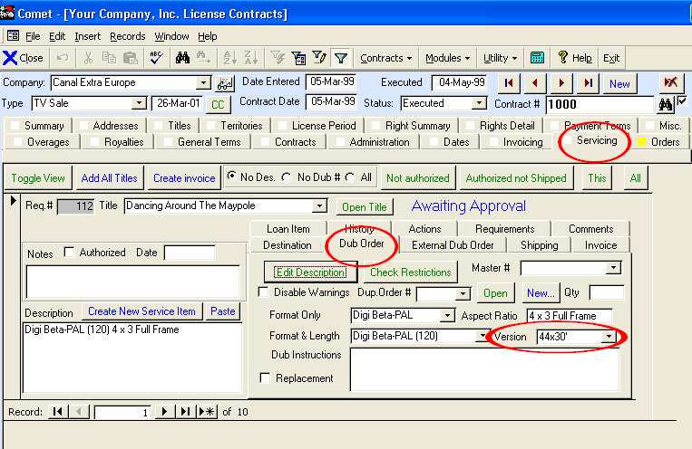

Availability report has option to show what version was sold

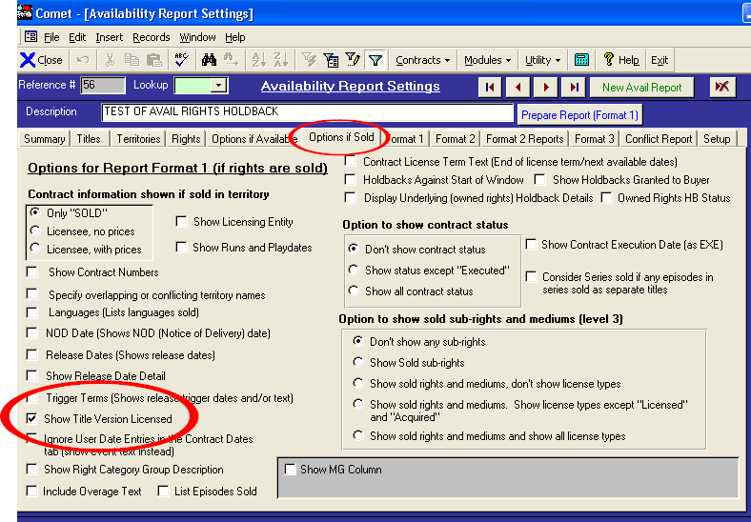

**2007-03-16**

* Full support for multiple title versions in title setup, episode setup, contract title entry, contract episode entry, and servicing. The availability reports will show what title version was sold if new checkbox option selected.
* Report 156 “System Activity Log” has improved formatting with more data columns
* Format 2 avail reports will detail available rights, but hide sub rights and/or mediums for a more condensed report.

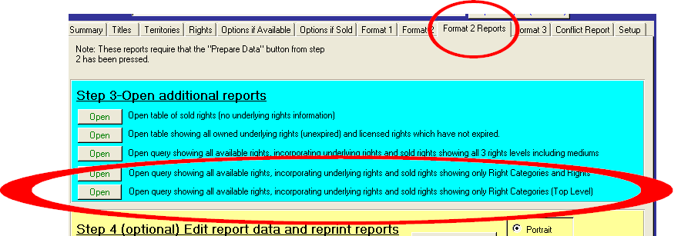

* Report 131, Title Catalog Reports, sorts by title sort order instead of title name
* AFTRA report 159 uses license fee per episode instead of the entered AFTRA rate. The detail report shows contract currency and contract currency amount.

**2007-03-02**

* System filter includes producer code with pulldown
* New exception report 253 “Invoices with Invoice Rate Different from Contract” for special purposes only.
* Rights and Windows by Title Reports 30, 33, 77, 77, 78, 78, 116, 161, 211, 224, 244 sort by sort order instead of title name
* Report 131, “Title Catalog Reports”, has checkbox option to
  + Exclude episodes
  + Exclude obsolete titles
  + Exclude titles where the owned rights have expired
* Contract summary territories on front of contracts shows territory exclusions
* Office 2007 avail reports saved as Office 97-2003 format since 2007 format cannot be opened in 2003 or earlier
* New long form mail merge fields added “<<Distributor Code>> and <<Salesperson>>
* New report 254, “Contracts with Execution Dates with Incorrect Status” lists contracts with an execution date, but the status is not executed. Also shows contracts with Executed status and no execution date.
* Producer reports show clearer error messages if no royalty terms are entered
* Royalty reports setup for account groups shows account description instead of just the account number
* Report 4 has new option to exclude expired contracts, where the override end date on the contract level is in the past or the contract status is “Expired”
* Avail reports show a new status “Owned Rights Holdback” with a color of orange to show where the owned rights start date or holdback expiration is in the future. Status enabled by checking on the “Owned Rights HB Status:

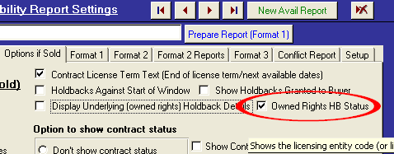

|  |  |  |  |  |  |
| --- | --- | --- | --- | --- | --- |
| |  | | --- | | **Free TV Rights** | | AVAILABLE Underlying Rights: Perpetuity | | *No Rights* | | *Owned Rights Holdback Underlying Rights:  Starts:01-May-2007 | |  |

2007-02

* Bulgaria and Romania added to EC countries when determining VAT status
* Title list view shows obsolete/inactive titles at bottom of list
* In title setup, when changing from Feature/Series Only to All title types, Comet will return back to title visible upon switching.

2007-02-05

* Improvements to Producer Royalty Reporting
  + New expense account grouping screen, available from tab 1 of the Producer Reporting screen.
  + Automatic batching of producer report payments to new tab in Producer Reporting screen, with preview list before payments issued
  + Producer Royalty payments are shown as sub-tab of “Producer Reports” tab in owned rights contract

2007-01-25

* Office 2007 Comet version released. Comet loader looks for Office 2007 installation automatically and launches the new Comet for Office 2007 frontend, “Comet07.accde”

* We have updated the Comet loader file CometRun.exe to be more compatible with Windows Terminal Server.  The new loader file is now bundled with our current Comet release.

Each WTS client needs to have a different Comet front-end because the front-end file uses internal tables when formatting some reports.  If two users run the same report on the same frontend file, the table data will conflict and the report can fail.

The new Comet loader file CometRun.exe will launch a different front-end file based on the user name, and automatically install and or update users.

Shown is a complete procedure on setting up a Windows Terminal Server with full automatic installation for new users and automatic updating:

1. On the WTS server, create a DSN connection to the SQL server using the standard procedure, naming it Comet. With SQL2005 running locally, use “Shared Memory” as the connection protocol for improved performance.
2. Install a standard Comet client in any folder on the WTS server that will be accessible to all WTS clients. For reference, the required Comet client files are:
3. CometRun.exe
4. CometRun.ini
5. COMICON.ICO
6. CometINI.MDB
7. CometWG.mdw
8. TabBlu.bmp
9. TabGrn.bmp
10. TabGry.bmp
11. TabRed.bmp
12. TabYel.bmp

Note that the Comet frontend files are not required here since Comet will automatically copy these files as necessary from the “Update” folder.

1. Manually copy the file “3925 1. ttf” into the folder “C:\Windows\Fonts\”. This is a bar code font file that is used for inventory and shipping labels and is also bundled with Comet releases.
2. Make sure the file “CometRun.exe” is version 5.0.21 or greater. This file is bundled and unzipped with Comet updates and also located at <http://www.saturnsoftwareinc.com/cometrun.zip>
3. Open the file CometRun.ini and make sure the “CometPath” value is the local path to the Comet support files, not a network path or UNC path. Also make sure the value “Use Comet Automatic Update Process” is set to “YES”
4. Rename CometRun.ini to Comet.ini, so all users will share this file (if this step is skipped, Comet will create an INI file for each user)
5. Launch Comet and press the “Advanced Settings” button immediately. Change all of the paths to Comet support folders to the local paths instead of network or UNC paths.
6. Close Advanced Settings, then click on “continue with new settings” to launch Comet.
7. Close Comet after it has finished loading successfully.
8. Copy the file “CometRun.exe” to “WTSDirector.exe”
9. Create a shortcut to for all WTS users to the file “WTSDirector.exe”. This can be done most easily by right clicking the Start button, select Open All Users, then creating the shortcut in the folder. This icon will be visible to all users.

**** END OF INSTALLATION PROCEDURE ******

**OPTIONAL:**

If users are logging in under the same user account, you can manually create files for each user that can run concurrently. For each user, copy the 3 files as shown (assuming an example user of “mschine”)

“CometRun.exe” copy to “mschine.exe”

“CometRun.ini” copy to “mschine.ini”

“CometINI.mdb” copy to “mschine_INI.mdb”

Then, create a shortcut to “mschine.exe” and put on the users profile in C:\Documents and Settings\mschine\Desktop

* Fix to servicing when adding base currency dub priced charged into satellite price charged in datasheet view, invoice currency price not updated. This version retroactively fixes this issue for existing dub requests and fixes problem.
* When adding new servicing items manually, when using Internal address book (not ACT), Comet had popup error when use accepted option to add address to company profile.

2007-01-12

* Improved syntax in avail reports for holdbacks granted.
  + Now showing “Holdback Ends” instead of “Next Avail” for holdbacks.
  + Holdback-only rights now show “HOLDBACK” status.

|  |  |  |  |
| --- | --- | --- | --- |
|  |  | ***UNITED KINGDOM*** | |
|  | Avail070105 125529 created by EMiller | | |
|  |  |  |  |
| **Title** | **Video Rights** |  |  |
| **Exonerated** | HOLDBACK #70059 Holdback Ends:02-Oct-2009 |  | Holdback granted, no license |
|  |  |  |  |
|  |  |  |  |
|  |  |  |  |
| **Title** | **Video Rights** |  |  |
| **Exonerated** | SOLD #70059 Next Avail:01-Jul-2010 |  | License only, no holdback |
|  |  |  |  |
|  |  |  |  |
| **Title** | **Video Rights** |  |  |
| **Exonerated** | SOLD #70059 Next Avail:01-Jul-2010 ----------- HOLDBACK #70059 Holdback Ends:04-Dec-2009 |  | Holdback granted and license |

2007-01-08

* New report #251, “License Fees Allocated by Territory” shows all contracts with title license fees allocated by territory for all rights
* Problem fixed showing all invoice types in contract invoice tab where Comet would move off contract and return.
* Problem fixed for foreign currency servicing multi-title materials invoice, where foreign currency amount would not populate during auto-pricing causing blank values to appear on invoice

*Comet Changes in 2006:*

<http://www.saturnsoftwareinc.com/CometSupportFiles/CometChangeLog2006.doc>