# Comet™ Change Log for 2006

(Click for 2007: <http://www.saturnsoftwareinc.com/CometSupportFiles/CometChangeLog2007.doc> )

2006-12-28

* Various improvements to Producer Reporting, Fulfillment, Servicing modules.

2006-12-20

* New report #250 “Uninvoiced Amounts by Title” shows titles that have been under-invoiced or over-invoiced.

2006-12-18

* Improvements to the Budgeting module, including new “Actual” report
* Direct QuickBooks export format incorporated into menu.

2006-12-11

* Report 83, “Sales by Title by Year” updated to include contract dates from 2001-2007
* Comet servicing popup does not ask to output restrictions to notepad if the message will fit in the warning popup box.
* Producer Royalty reporting improvements

2006-11-17

* Producer Royalty Reporting improvements
* Incoming Royalty reporting auditing improvements

2006-11-03

* Title list upgraded to include MCPS columns and other recent columns
* Reports #186 and #187, “Itemized Invoice Aging Report” have checkbox to total by title instead of by customer
* Royalty improvements

2006-10-30

* Additional Report #248, “Contract Title Detail” improvements

2006-10-20

* Report #248, “Contract Title Detail” improvements

2006-10-17

* (Non-SQL version only) Problem fixed when reversing a materials invoice created by allocating a materials invoice to individual titles.
* Problem fixed showing restrictions in avail by title format 1 and conflict check

2006-10-12

* More royalty report improvements
* Report #248, “Contract Title Detail”, has an option to show exclusivity and comments, and export to Excel with contract payment terms and payment history
* Availability report format 2 will not show linked individual episodes as available if also sold in series.

2006-09-29

* Additional Royalty report improvements
* New report 248, “Contract Title Summary Report” shows information of all contract titles
* Fix to Conflict Check

2006-09-27

* Improvements to MCPS report
* Improvements to unit sales screen and data import

2006-09-21 14:45

* Extensive improvements to the Producer Royalty Reporting module, to be documented elsewhere
* Extensive improvements to the video unit sales module, to be documented elsewhere
* Availability reports have an option to only include first run rights
* Availability reports have another option to show the status of owned rights only by ignoring all sold rights. The report format 1 will show “Owned” or “No Rights” or “Rights Expired”

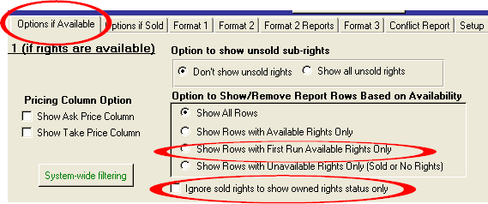

* Comet allows all availability options on multi-territory multi-title layout. It is not necessary to be in “Client AVAIL/SOLD” only mode.

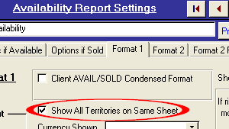

* We have updated and improved our Long Form Word Merge template to include new fields, and have grouped the fields into functional areas. It is located at

<http://www.saturnsoftwareinc.com/all_mailmerge_fields_a4_or_letter.doc>

Comet has a direct hyperlink to open this reference directly from the interface as shown below:

This document may be added to the template list in Comet for testing purposes.

A spacing problem was fixed with respect to the right margin on the rights sold table.

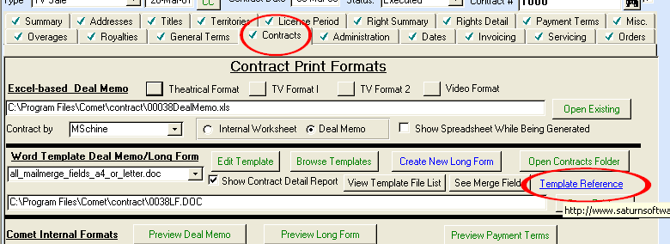

**2006-09-05**

* Full support for servicing invoices in any currency.

Company profile allows customer price list to be in any currency.

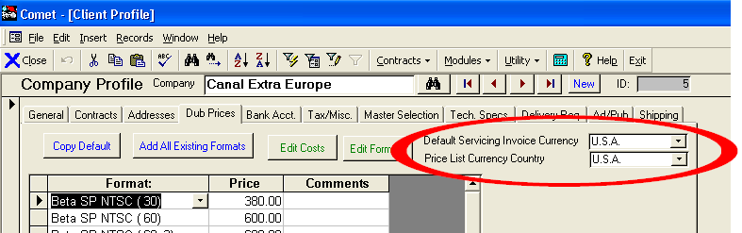

* Each contract can have a different servicing invoice country

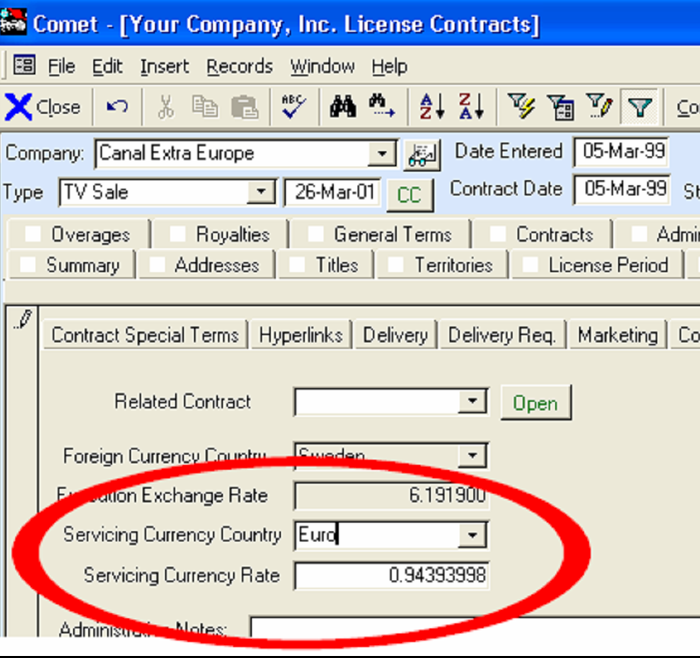

* Hourly recharge price overrides customer price list.

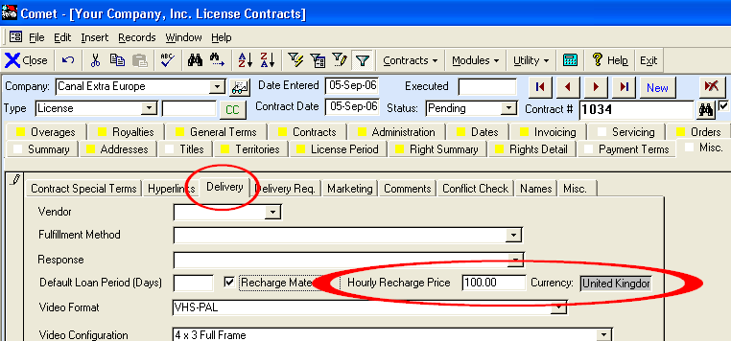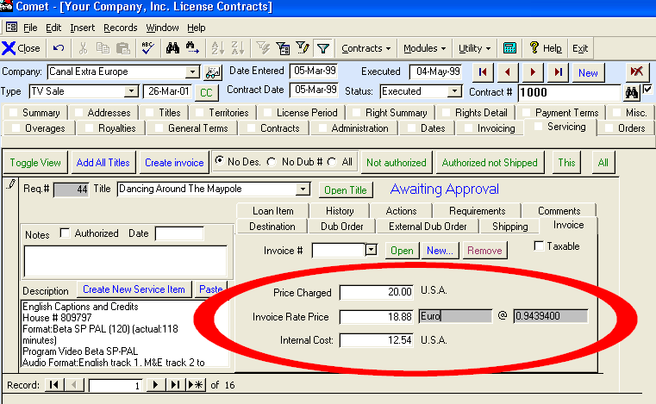

Materials Invoice shows both base currency and servicing invoice currency amounts. If there are different currencies in the same invoice, Comet will print them separately.

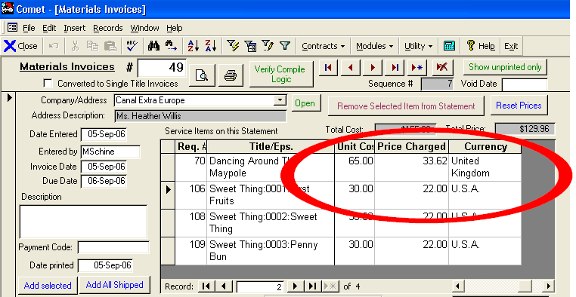

* Dub order construction popup allows direct entry of either base currency amounts or invoice currency amounts

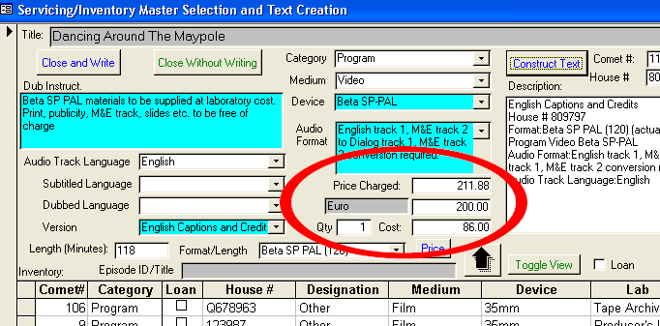

* Creating an invoice from the servicing screen allows entry of any currency at any rate, but will default to the contract servicing invoice currency and current rate.

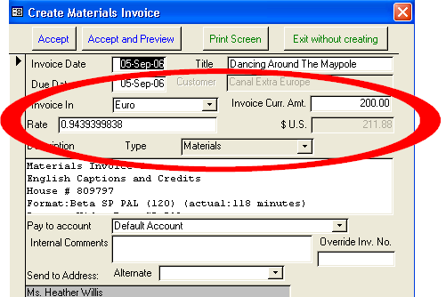

**2006-09-01**

* Other changes to be documented soon
* Manual entry of partial revenue recognition now available, with new filter option and partial revenue % column. Entry available in “Notices and Delivery” screen.

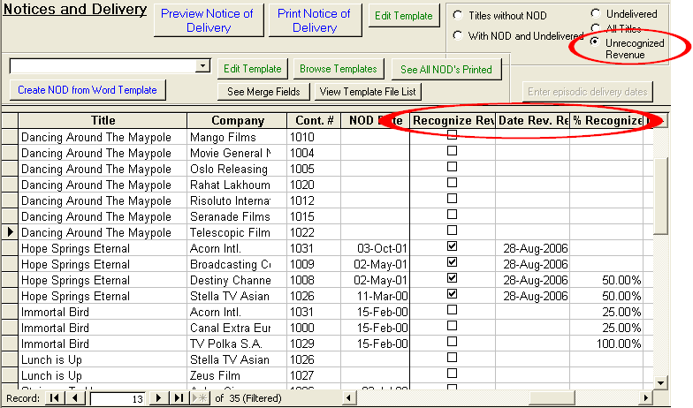

**2006-08-11**

Comet system filtering for Agent value has 2 new options on the top of the list

1. (Blank), filtering the contracts to all contracts with no Agent entered
2. (NonBlank) showing all contracts with any agent

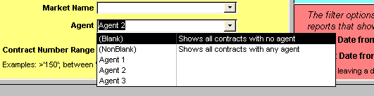

The Comet long form deal memo has a new table format, which is the same as <<Lic. Per. Tbl.>> except the release trigger column is replaced by Exclusivity.

**<<Lic. Per. Tbl.2>>**

|  |  |  |  |
| --- | --- | --- | --- |
| **Licensed Rights** | License Period | **Exclusivity** | Exclusions |
| Pay TV Rights | The License Term starts 15-December-2004 and ends 13-December-2007 | Exclusive |  |
| Free TV Rights | The License Term starts 15-December-2004 and ends 13-December-2007 | Exclusive |  |
|  |  |  |  |

**<<Contract Exclusivity>>**

Exclusive

**2006-08-02**

Additional improvements to Producer Royalty Reporting Module

**2006-07-31**

* New Producer Report Royalty module added. Documentation to be provided elsewhere.
* Application of Receipts screen now shows title name next to invoice

**2006-07-18**

* New Finished Goods Orders module in place and operational. Module located in Contract under Orders tab. Additional development in progress.
* Comet invoice creation popup now supports entering base currency invoice rate or base currency execution rate or contract currency amount as shown:

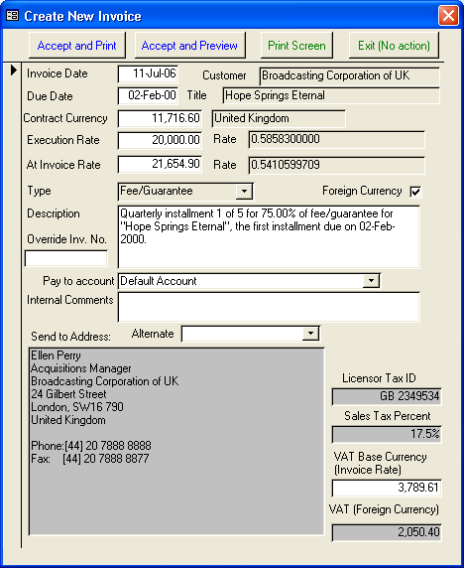

* Payments for Report 186 and 197, Invoice Aging Reports, are filtered to the receipt criteria when the global filter is on.

**2006-06-30**

Various changes to be detailed:

* Sales interest tracking
* Word Contract Merge

**2006-06-20**

* When selecting the contract customer and there are customer restrictions, Comet will prompt user before adding the restriction to additional terms.
* Various budget and forecasting module changes documented elsewhere

**2006-06-05**

* During updates, if a contract has only one right category, the right category allocation is set to 100% . If there is only one territory, the territory allocation is set to 100%. This may be done manually in updates and patches using procedure 23 and 24.
* When adding titles to a contract, if there is only one commission for the title in the owned rights commission setup, Comet will link that commission rate to the contract.

**2006-05-29**

* Comet updates internal territory relationships tables. This will not affect the contracts or territory setup.

**2006-05-23 05:58**

* (Availability reports) Significant improvement to the way holdbacks are computed and displayed. Availability windows that have active holdbacks but otherwise available to sell have a new status (HOLDBACK) and color code option. The color code can be set to the same color as “available”, but any setting is possible.   
    
  This option relates to rights entered in Comet with a license type of “Holdback”. This is generally not related to the holdbacks entered in the holdback tab, which are designed to delay exploitation of the rights licensed.
* New Availability Report option “Show Holdbacks Granted…” will show the holdbacks granted, along with the holdback license term information, if checked on. If this checkbox is clear, Comet will only show AVAIL without showing the holdback information.

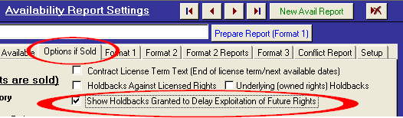

* Shown is an example of how the “Holdback” status is depicted in a Comet avail report:

|  |  |  |  |  |  |  |  |  |  |
| --- | --- | --- | --- | --- | --- | --- | --- | --- | --- |
| Feature Titles: Key Territory Availability | | |  |  |  |  |  |  |  |
|  | **UNITED KINGDOM** | **France** | **BENELUX** | **Germany** | **Sweden** | **Spain** | **EASTERN EUROPE** | **Poland** | **Japan** |
| **Title** | **Free TV** | **Free TV** | **Free TV** | **Free TV** | **Free TV** | **Free TV** | **Free TV** | **Free TV** | **Free TV** |
| **Dancing Around The Maypole** | HOLDBACK | HOLDBACK | HOLDBACK | SOLD | SOLD | 12-Jan-2014 | SOLD | SOLD | AVAIL |
| **Hope Springs Eternal** | SOLD | SOLD | SOLD | SOLD | SOLD | SOLD | RESALE1 | RESALE1 | RESALE1 |
| **Immortal Bird** | AVAIL | HOLDBACK | HOLDBACK | AVAIL | HOLDBACK | HOLDBACK | HOLDBACK & RESALE1 | HOLDBACK & RESALE1 | RESALE1 |
| **The Long Age** | *No Rights* | *No Rights* | *No Rights* | *No Rights* | *No Rights* | *No Rights* | *No Rights* | *No Rights* | *No Rights* |
| **Lunch is Up** | AVAIL | AVAIL | AVAIL | AVAIL | RESALE1 | AVAIL | RESALE2 | AVAIL | 20-Mar-2009 |
| **Stairway To Heaven** | AVAIL | 14-Sep-2011 | AVAIL | AVAIL | SOLD | AVAIL | RESALE1 | RESALE1 | AVAIL |
| **Sweet Thing** | AVAIL | HOLDBACK | HOLDBACK | AVAIL | HOLDBACK | HOLDBACK | HOLDBACK & RESALE1 | HOLDBACK & RESALE1 | RESALE1 |

Shown is the color code setting for the new availability status “Holdback”. It will be set by Comet during the upgrade to 35, which is the light green shown above. It may be set to any number from the Excel color code table shown here:

<http://www.saturnsoftwareinc.com/ColorSummary.xls>

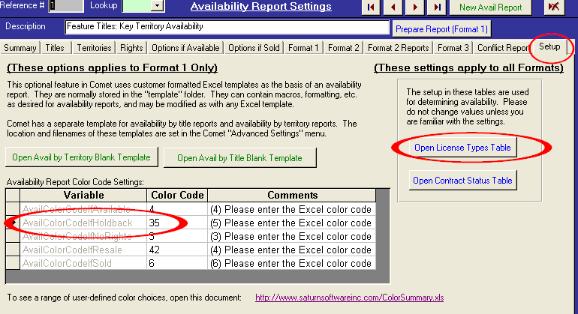

The following circled settings are made automatically during the upgrade. Holdbacks should no longer be set as “Licensed for Avails”. This was done previously so that the holdbacks would show up in the avail reports. However, any holdback rights must be set to “-1” or “1” in the holdback column shown.

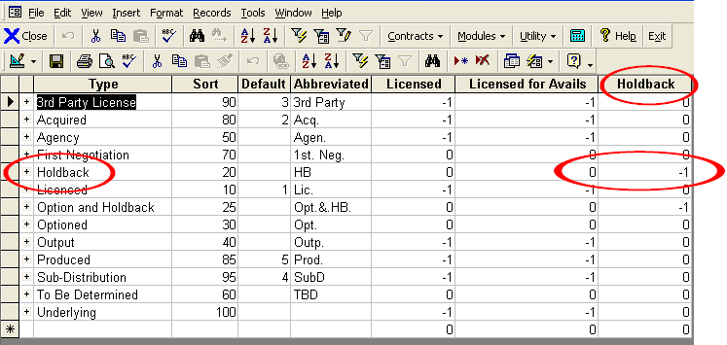

* Report #158, “Contracts by Customer, all Customers with Contract” has checkbox option to only show contracts with balance owed.
* New report #244, “Contracts by Title with Receipt Date Range” shows all titles where there are title receipts during date range, showing cumulative receipt totals to end of date range. Similar to layout of report 32.
* Receipt screen has a search button next to the receipt number
* Availability report layout is improved:
  + Avail reports starts at column A instead of column B
  + The Page Setup is set as follows:
    - LeftMargin = (0.3 inches)
    - RightMargin = (0.3 inches)
    - TopMargin = (0.5 inches)
    - BottomMargin = (0.5 inches)
    - HeaderMargin = (0.3 inches)
    - FooterMargin = (0.3 inches)
  + Synopsis has a column width of 45 points
  + Avail/Sold condensed version will print in portrait or landscape as selected. Previously, it printed only in portrait
* Event management screen has Title Inventory # and Salesperson as new columns
* (Office 2003 only) Fix to situation where, in Accounting Interface Receipt screen, moving to last record caused popup error problem

**2006-05-05**

* Performance optimization for new report #242

**2006-05-04**

* System filter now includes year of production (range) and Distributing For (from Title Setup)

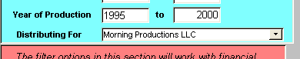

* New report #243, “Contracts by Customer with Receipt Date Range” shows all titles where there are customer receipts during date range, showing cumulative receipt totals to end of date range. Similar to layout of report 158.
* New report #242, “Titles Without Sales Contracts” lists titles and title information that are not in any license contracts or third party contracts. Episode Titles linked to episodes in contracts are not shown. Excludes void contracts.

**2006-05-03**

* Invoice and license fee re-allocation has option to condense the adjusting invoices and allocations into one record whenever possible. Individual records are totaled. Recommended for contracts with over 5 titles.



* Invoice and license fee re-allocation screen has option to save and recall contract selections. This feature is useful if re-allocating numerous titles and a change is needed to the weighting,



* Invoice re-allocation has option to stop processing



* Report 32 “Contracts by Title, excluding materials” has two new checkbox options to show detailed spreadsheet view of data behind report, and summary report showing totals by title.

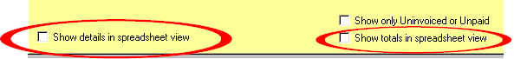

**2006-04-21**

* Performance optimization of invoice re-allocation

**2006-04-20**

* Due to base data setup problem for specific customers, the language English was added but not included (checked on) for Canada English deals. This version retroactively fixes this.
* Comet has standardized the Comet installation to “C:\Program Files\CometRights” instead of the previous “C:\Program Files\Comet” The Comet update extractor copies the necessary download files from the Comet folder to the CometRights folder.

**2006-04-18**

* Multi-contract re-allocation has new option to select if license fees are re-allocated based on title weights, or if the invoices are to be re-allocated with existing license fees, or both.

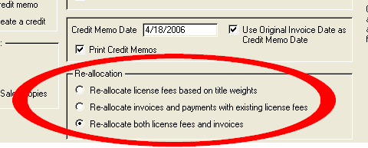

**2006-04-15**

* Comet allows selecting multiple contracts for invoice/license fee re-allocation. Feature can be reached from Comet menu under “Modules->Accounting->Multi-contract re-allocation”

**2006-04-10**

* Retroactive conversion of “Grouped Materials” invoices and “Single Record Multi-Title Invoices (Only applies to specific Comet customers)

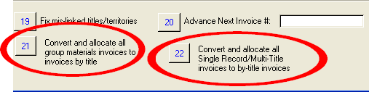

**2006-04-04**

* Comet report 75 has new options and features:
  + Filter by right category now active (shown below)
  + “Datasheet View” option provides the following additional fields:
    - Contract Status
    - Contract Execution Date
    - Holdback Text
    - Computed Start Date, based on holdback events entered
    - Runs
    - Playdates
    - Number of Days until Expiration of license period
    - Number of Days until End of sell-off period
    - Number of Days until End of Blackout Period
    - Number of Days until End of release trigger window
  + Report may be run as of any date (past and future) shown below. If blank, current date is used. Normally, the dates will be the same if run as of the current date or a future date, with the exception that if outside dates are exceed in the calculation, the expiration date may be different. However, the “days until end” calculation will be different.

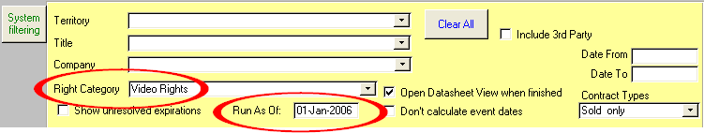

* + Open Datasheet View defaults to true
  + Internal Title Billing Comments appear in the “Datasheet View”. The source is from the box shown:

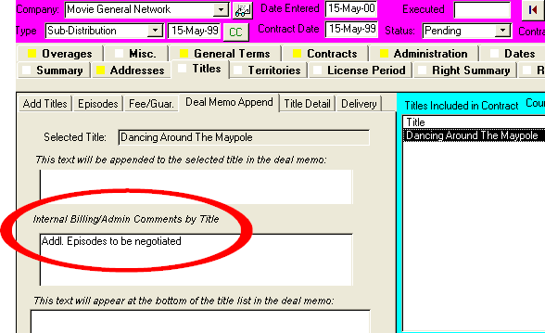

* Comet Expiration Notification may be re-run with full e-mail functionality as of any date in the event a report was missed.

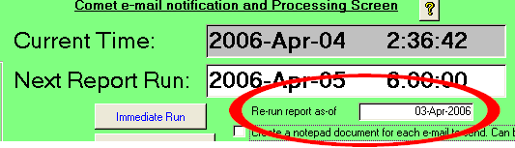

* Report #57, “Invoices Due” has options to include/exclude Overage/Royalty/Disposition invoices and/or Materials invoices.

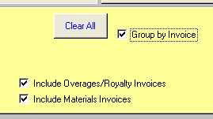

* Additional options for Report #4 “Acquisition/Production Contract List”
  + New option to show territory exclusions, combined from the included/excluded territories and from the exclusions entry.
  + New option to exclude obsolete/inactive titles from the title list.

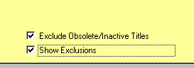

**2006-04-03**

* (patch only to 2006-03-30) Popup message when creating a new Availability report, “You tried to assign a null value”

**2006-03-30**

* Comet availability reports has new option to show the Program Format in a separate column.

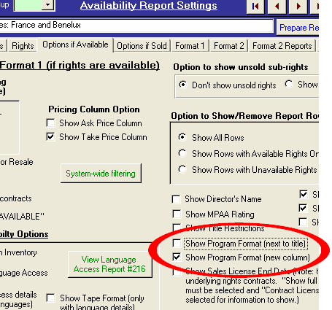

Comet availability Report has new option to show the talent information in a separate column (just to the right of synopsis).

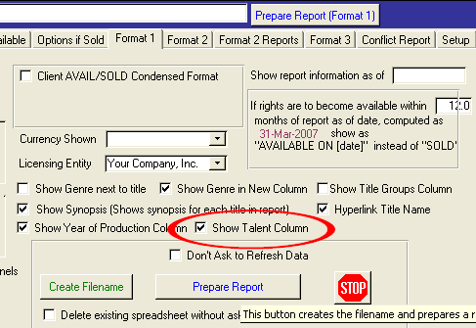

Source of talent information is from Title Setup, Talent/Credit, Comments box.

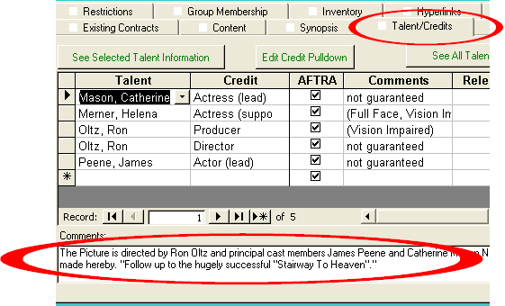

**2006-03-29**

* Comet has option to show availability report condensed format either as date “23-Nov-2008” or “Available On “23-Nov-2008” using checkbox “Show “Avail On [Date] instead of date only

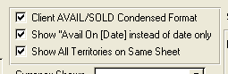

* Numerous Budget/forecasting module changes and improvements documented separately

**2006-03-22b release**

* If the "Split into left/Right Panels" option is set on, Comet will sort down the left, then pick up on the top of the right (on the same page), and insert a page break in Excel for the number of rows per page, which is set as shown:

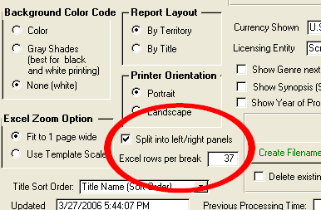

**2006-03-22**

* Previously, Comet would show Ask/Take pricing columns when selecting the “Show MG Columns”. Comet now lets user select if ask or take or both columns shown, independent of “Show MG Columns”.

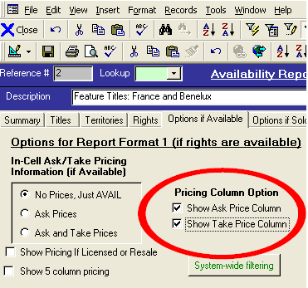

* Bug fix to show synopsis in format 1 availability reports

**2006-03-20**

* Comet avail reports have option to show year of production (Avail by territory only)

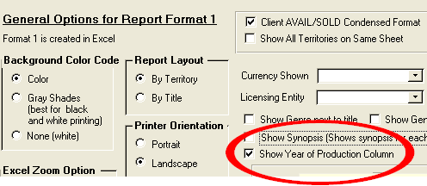

* The Show Genre column option has been re-located to the next column after the titles.
* Comet avail reports has option to take bottom half of avail report and move it to the right side, creating a split left/right column (Avail by territory only)

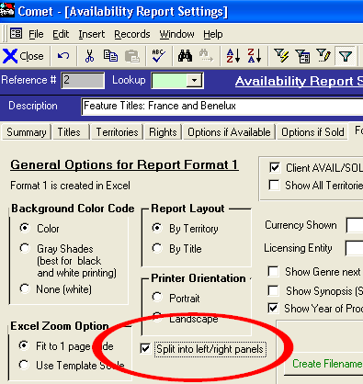

Shown is an example of a split Availability Report:

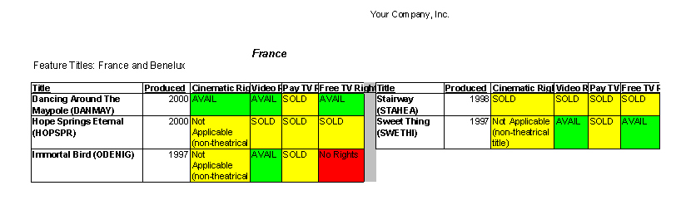

* Comet avail by Territory report will pre-set the print area
* The Comet Title Setup holds the “Date Created” and “Created By’ for new titles in the “System” tab.
* The Comet User Setup screen has option to re-assign all contracts to another salesperson.

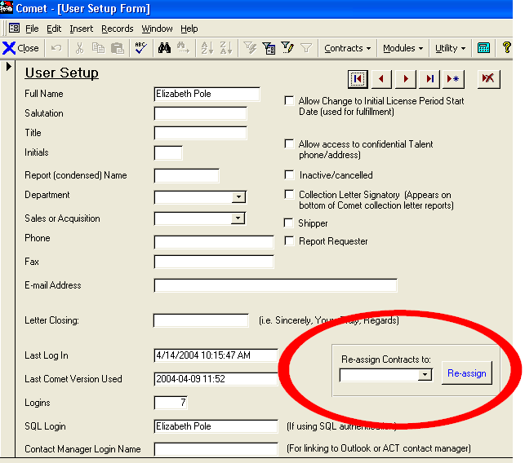

**2006-03-01**

* Comet has new option to hyperlink the title name in the Excel avail reports by checking on the option shown below:

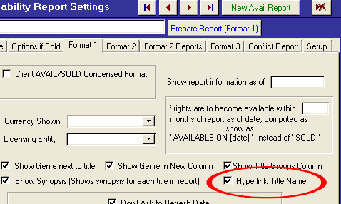

* The column heading will show “(click to open website)”.

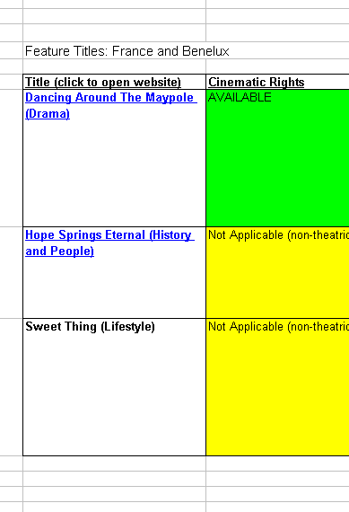

* The source of the hyperlink is from the Title Setup, Hyperlinks tab where the Avail Report Hyperlink checkbox set on. If more than one link has the checkbox on, Comet will use the most recent entered.

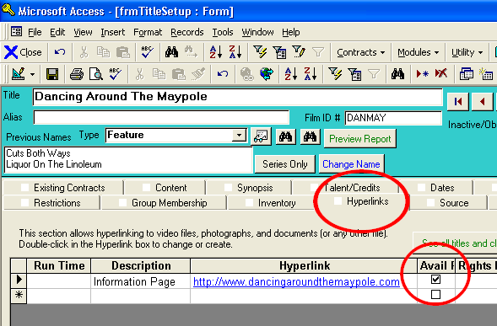

* Comet has a new Group Administration screen, where the titles belonging to a group are shown, and the group members may be added to or deleted. The screen can be opened from the Title Setup screen, Group membership tab.

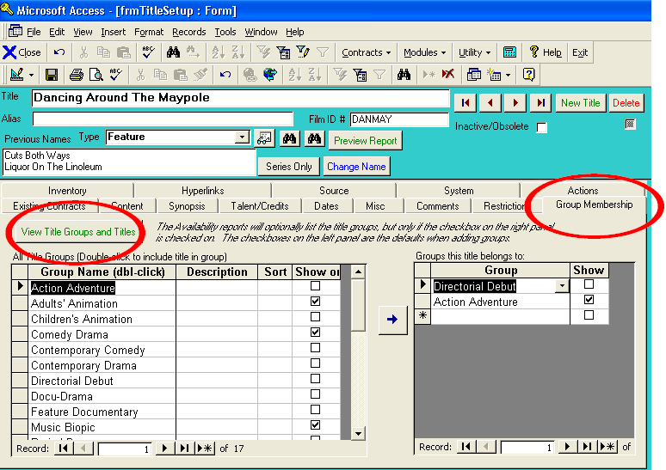

**2006-02-28**

* Comet Availability reports have a setting to prevent edits users other than the report creator:

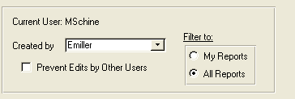

* When running an avail report, Comet will warn if obsolete titles are included in the report.
* 3 new options added to system filter as shown below.
  + Contract Execution Date range (blank includes all)
  + Genre (in the Title setup)
  + Delivery date range (Blank includes all)

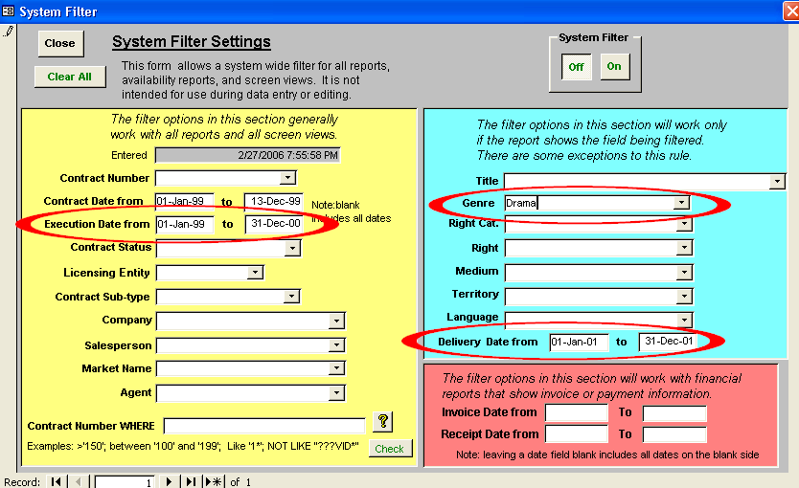

* Column heading alignment problem fixed with avail report using 5-column pricing with realistic price column.
* Possible month calculation error on contract level event-only based license term for the second event fixed. Problem could occur with a rare combination of circumstances.
* Comet has two new availability report options, available on the Format 1 tab.
  + Show Genre in New Column
  + Show Title Groups column (this shows the title groups in a separate column on the availability report)

These options are only shown on the Avail by Territory report, excluding the condensed Client version and excluding the multi-territory and the 5 column pricing avail report.

Users can select what groups are shown on the avail report by checking on the checkboxes shown. The checkboxes on the left side will be the default setting when adding groups to the title.

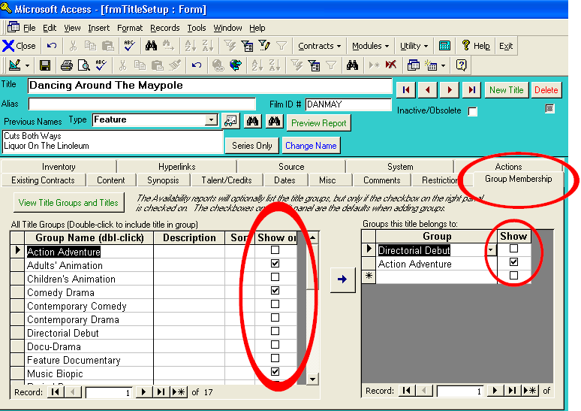

**2006-02-12**

* Various improvements to the Budget and forecasting module and the Long Form module, to be documented at a later date.

**2006-02-02**

* Avail report 2 report by territory, portrait, shows territory on top of each page
* Avail report, format 2 allows changing rights shown information on “Format 2” tab section and re-print or preview on the “Format 2 Reports” tab without re-computing all report information.
* Avail report format 2 contact information footer does not show “*success*” when no address is entered.
* The detailed license fee invoice footer shown at the end of the invoice is now a user-definable value, which can be set (or deleted) in “Advanced Settings”, Server, System as the “Invoice Footer” value. It will default to *“Invoices are due for payment not later than 30 days from invoice date unless otherwise stated. Interest will be charged at 1.5% per month on late payments.”*
* Comet has new feature to automatically assign license fees based on pre-entered weights for a weighted average. The weights are entered in the title setup as shown. The pricing will be proportional to the weight. The weights may be in a user-defined range, e.g. 1-10.

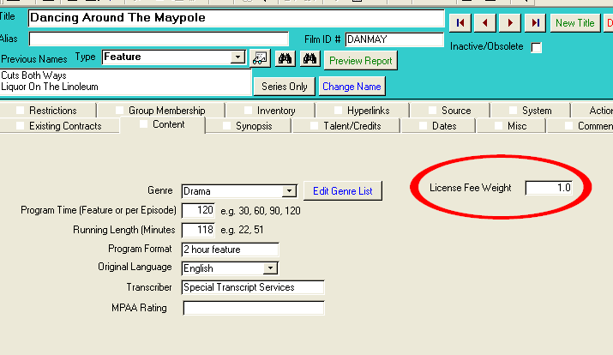

To use the pricing feature, click on the auto-allocate button as shown.

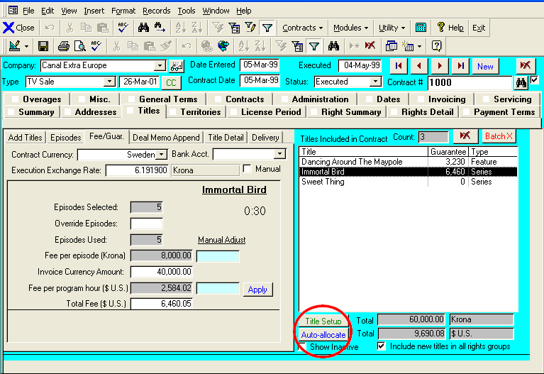

Comet will prompt you for the total license fee in the contract currency.

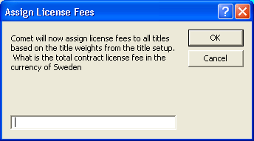

**2006-01-25**

* Further improvements to format 2 availability reports
  + New option for user to decide how sub-right sales determine available/sold status. If a right category is partially sold, a user may decide to show this status as “Available” or “Sold”.
  + New option to select if non-exclusive sales are shown as sold (unavailable status) or available.

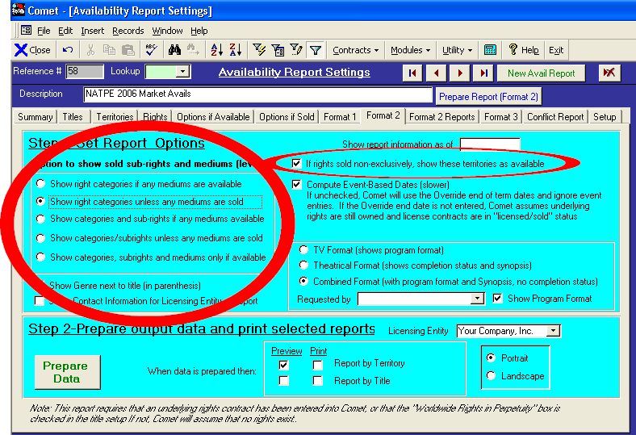

**2006-01-19**

* Problem fixed with application of cash to grouped materials invoice, retroactively fixed for all existing (and future) grouped materials invoices.
* Avail report format 2-has option to show/not show program format
* Appearance improvements to Avail report format 2.
* Problem fixed re-printing multi-title invoice where previous description used.

**2006-01-17**

* When running availability reports, option to show genre next to title not disabled when running Client-only condensed version.
* When deleting a contract, Comet prompts to delete linked producer reports or distribution statements.
* When starting up Comet, Comet will display a popup box containing the contents of the global system variable “InitialTextMessage”, set in Advanced Settings. If the setting is blank, no startup popup box will be displayed. The “InitialTextMessage” also appears on the title bar of the contract display and the title bar of the Title Setup screen. This option is useful to set in report-only copies of Comet so the user is warned that any data changes will be lost.
* “Report Requestor” added to availability report screen, shown on Avail reports format 2
* Fields added to Report 131, “Title Catalog reports”
  + Cast/Talent
  + Program Format
  + Title Type
* Avail Report, Format1 no longer truncates the synopsis at 512 bytes
* New Word Merge field, “<<Distributor Contact>>” looks up customer contact name for Word long form agreements
* New field “Report Requester” on availability report settings (shown below). Appears in Avail Report Format 2. Also shown on Summary page of settings.
* New Availability Report Format 2 layout, “Combined” TV and theatrical.

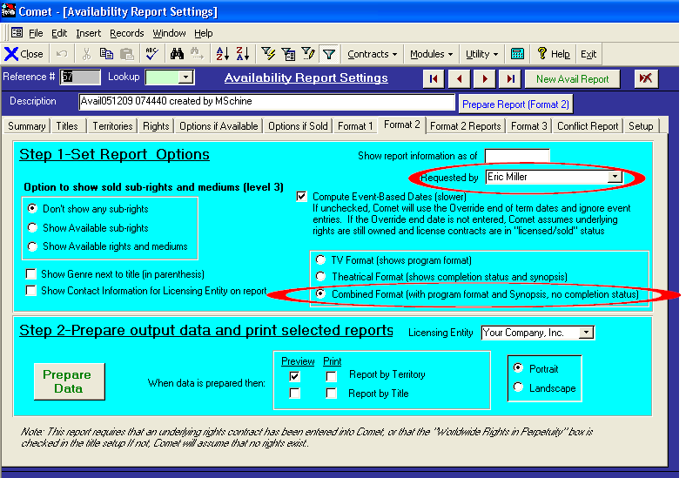

**2006-01-03**

* When creating a rights-owned agreement from the title setup, source tab, Comet will check to see if there is an underlying agreement already in place for the title and prompt to open that agreement.
* Problem fixed on source payments, where no payment terms entered resulting in error message of no description.
* Report #75, “Rights and Windows Expiring in a Date Range” has new contract type filter option: Sold rights, Owned Rights, or both.

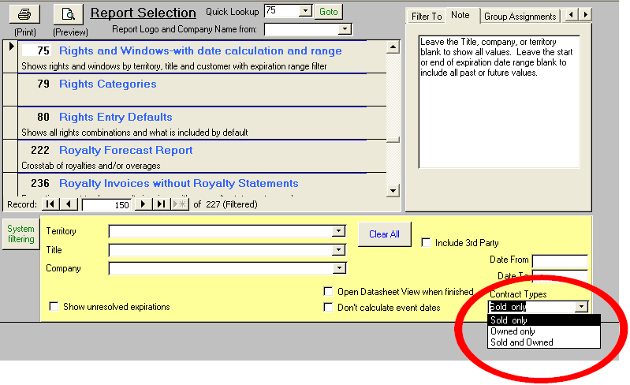

* When deleting a contract, Comet will prompt user to remove related contract administration tasks from the contract (if there are any) or fulfillment module, and delete them prior to deleting the contract to prevent referential integrity error message.
* Availability report title selection screen improvements:
  + 1. When the Individual Episodes/Clips radio button is set to “Hide”, Comet will only add “Features” and “Series” titles when the Add All button (shown with a “1.”) is clicked, as designated in the second column of the setup table “Title Types”, which may be reached by clicking on the drill button shown below in the title setup:

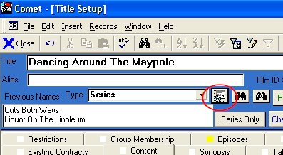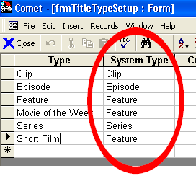

* + 2. New Genre capability feature allows addition of a single Genre
  + 3. New “Remove Episodes/Clips” button removes all title types except for “Features” and “Series”, as defined in item 1 above.
  + 4. When adding a title group, obsolete/inactive titles are not added.

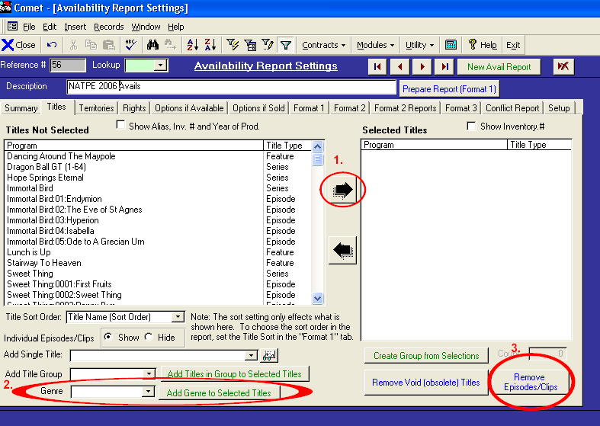

**Comet Changes in 2005:**

<http://www.saturnsoftwareinc.com/CometSupportFiles/CometChangeLog2005.doc>