# Comet™ Change Log for January 1, 2004 to December 31, 2004

**2004-12-12 B Release**

* Report #57, Unpaid Invoices, has checkbox option to limit report to Fee/Guarantee invoices, and to group and subtotal by invoice payment accounts
* Invoice Re-allocation functionality reverses original invoice receipt applications by applying reversing amounts to credit memo.

**2004-12-12**

*[Extensive servicing changes to be documented]*

**2004-11-24**

* Problem fixed where Comet would, when creating Excel report, including Avail report or invoice balance reports, “ in fncOutputToExcel”. Problem was invalid output folder setting. Comet will provide clear resolution message, and checks for valid location prior to loading.
* Problem fixed where, for Office 2003 users, Comet would exit without message when clicking on the “Text Terms” tab in a contract.
* Problem fixed where, when adding a new feature or episode title with the “Series Only” filter on, Comet would not move to new title since titles shown were limited.
* When creating a new availability report, Comet will set the way the underlying rights are shown based on new advanced setting “Default Avail Underlying Rights Setting”. A setting of
  + 1=Ignore Underlying Rights;
  + 2=Show if entered;
  + 3=Show 'Not Entered' if no agreement entered

corresponds to the availability report setting shown below, using an example setting of “2”

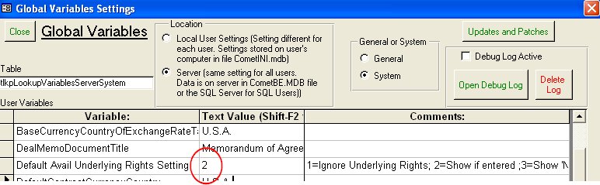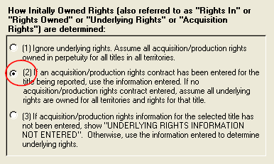

* Problem fixed in the Word long form contract where, if there is no rights setup, Comet would print “All rights not reserved….etc. “ in the middle of the contract.

**2004-10-28**

* Comet has an on-screen view to add airbill numbers, which may be accessed from the Comet menu, select Modules->Servicing->Enter Airbill Numbers
* New feature added to create “tape sets” based on a new lookup table.

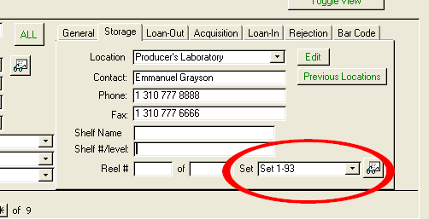

* Comet will report expiring options in the e-mail notification module. Any action item added to the administration module with “option” in the task name will be included in the report.
* Comet has a new feature to change the company name of contracts to a new name, and move all of the addresses to the new name, preserving all contracts and other records linked to those addresses. Helpful for merging companies together.

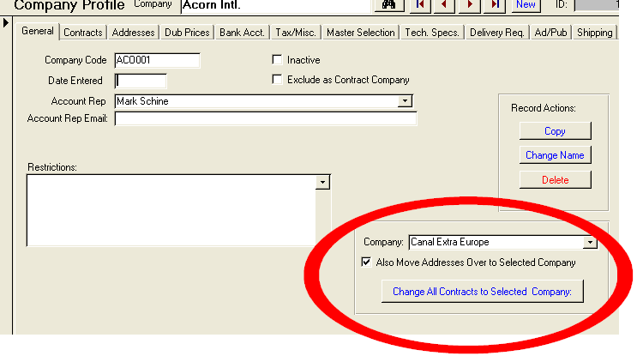

* New report #231 “Delivered but Un-Invoiced Materials” shows all un-invoiced but delivered materials
* If selecting a source loan tape already on loan, Comet will provide the warning shown:

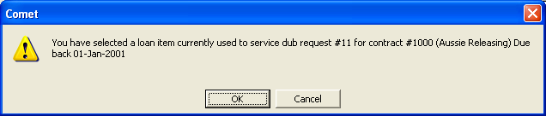

* Comet has bar code scanning feature where, when loan items are returned, Comet will automatically update status, location, loan return status and open up the Title and Contract record when label scanned. The label number may be typed in if bar code reader unavailable. The screen is accessed from the Comet menu, select Modules->Servicing->Bar Code Label Scan. Shown is the bar code screen, which pulls up the title inventory record, plus all tapes duplicated from that master.

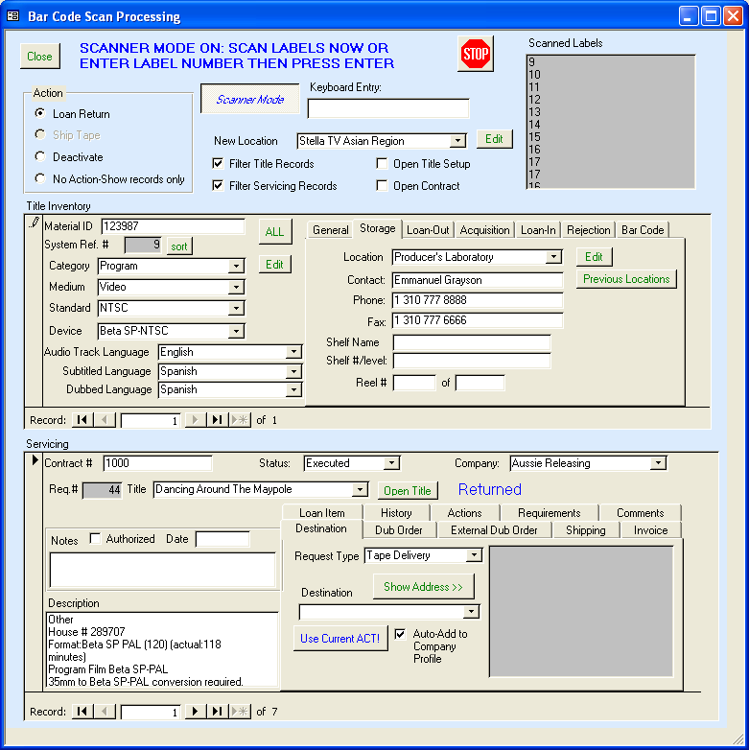

**2004-10-26**

* A potentially problem where Comet would compute slightly incorrect VAT amounts was fixed. This problem occurred only when printing foreign currency VAT invoices from the Comet “Invoicing” tab in the contract “Create New Invoice” button, and changing the invoice date. Comet has provided new report #230, “VAT Amounts”, listing all invoices with VAT as a percent of the value to determine if any invoices were affected. Any incorrect VAT amounts can be fixed by opening up the Comet “Advanced Settings” window, clicking “updates and Patches button, then button 11, Invoice View.
* The Comet Inventory module prints bar code labels for each master/tape/element directly to dedicated bar code printer, including title information. Shown is a sample:

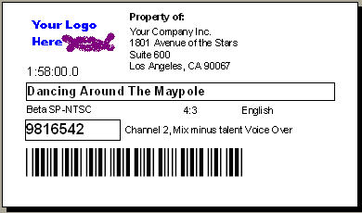

* Pressing the ''Print Label'' button will print an inventory bar code label to a dedicated label printer. It is sized to work with Dymo 30256 labels (2-5/16'' x 4'') on a Dymo 320,330, 330 Turbo printer or Seiko pro, 220, and 200 printers. The printer name must be ''Comet_Label_Printer''. Add a printer with this exact name using the label printer driver, or rename your existing label printer.

**2004-10-19**

* Report 88, “Due” caption above invoice date changed to “Invoice Date”
* The listed reports here have an option to show Runs. They also have an option to exclude minor right categories, as set up by checking a new box in the Rights setup.
  + 181 Rights and Windows by Customer
  + 77 Rights and Windows by Title
  + 78 Rights and Windows by Title-One title per page
  + 211 Rights and Windows by Title (Sorted by Territory)
  + 161 Rights and Windows by Title Showing Gross Profit
  + 116 Underlying Rights Summary by Title (only underlying, no exclusions)
* New option in Rights Setup to set mediums as Non-Exclusive by default. When adding right categories to a contract, Comet will add these sub-rights as non-exclusive if setup this way.
* New Report #228, Overdue loan items by Company lists all overdue loan items grouped by company.
* Commercial invoice licensor address is now the invoice address instead of the general address. This changed so that return address is finance department, and licensor VAT number is shown as required by EC rules.
* New report #229, Recognized Revenue by Title, All Titles with datasheet output
* In the Servicing section of the Comet menu, Comet has a query to enter airbill numbers directly from dub requests.
* Users may be designated as “shippers” in the User Setup screen.. If so, Comet will limit the pull-down selection in the “shipped by” field of the Commercial Invoice to these users, instead of showing all users.
* Comet has a new event available for computing license periods and payment terms, “Delivery of the first N Episodes”. Comet will recognize any number substituted for N, and will lookup the last delivery date for the episodes using the episodic delivery date.
* The expiration of the materials loan period has been included in the Comet automatic e-mail notification module.

**2004-10-08**

* (Contract Fulfillment Title Filter Screen) For the selected Distributors/channels, Comet will show next to the relevant titles:

* + A blank checkbox if no action items are populated, generally because the fulfillment method has not been selected
  + A gray checkbox if the "Negotiation of the Fulfillment Method" or "Receive Deal Memo from Acquisition" action items have been created, but no delivery type action items exist
  + A full checkbox if the title is fully populated with delivery type action items.
* Override invoice number on multi-title invoices now prints on invoice for reprints and original invoice.
* All formats of Multi-title invoice show the episode numbers after a series title
* Avail report, if title “blocked” using title block checkbox, show “RESERVED” on avail report. This feature useful where a customer has option to choose from large number of titles than will be licensed.

**2004-09-20**

* Comet event date and release date lookup/match-up now resolves if all filter selections blank (except event name which is required)
* Contract Search is added to splash screen left selection bar
* Comet splash screen has new option “Quick contract open” pull down
* Comet has a new setting in Advanced Settings (Server/System), “Add restrictions to General Terms”. If set to YES, when adding titles to a contract, or selecting a customer, Comet will automatically add restrictions to the contract General Terms.
* "First Local Ancillary Release", "First Internet Release", "First Local Pay per View Release" added to Comet standard events. To handle variations in the way rights categories are spelled (e.g. “Theatric Rights” vs. “Cinematic Rights”), the following special checkboxes were added: (Note: a right category may be in two separate categories. Comet will use either one for computing release dates).

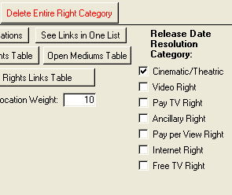

**2004-09-13**

* Report #168, “Contracts and Rights Group Information by Title” has option to filter to single territory with pull-down selection.
* Comet Royalty report entry (both incoming and for producer reporting) has Price per Unit entry cell. Comet will compute gross receipts when entered.

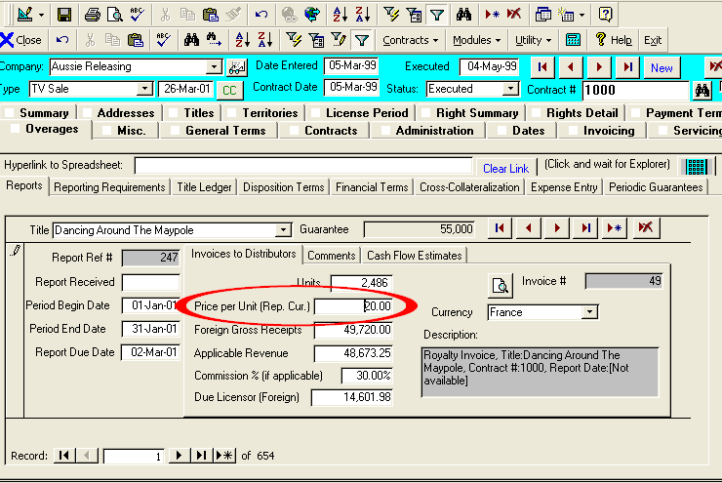

* Comet has new checkbox to reserve/block titles in Comet from being invoiced or serviced. As shown in the screen below, all titles in a contract may be set or cleared at once. Comet will prevent titles with checkbox from showing in Invoices by Title tab or in System Invoice tab. Titles will not be added to servicing module when pressing “Add All Titles” button. Additional blocks to be added in future release.

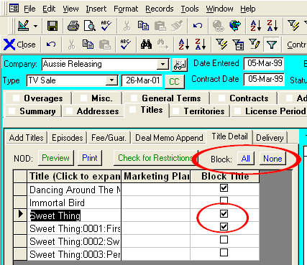

* Comet has new feature in Title Setup to combine titles into a single title. Useful when a duplicate title has been entered and contracts/invoices created. All records will be linked to new title, and duplicate title removed.

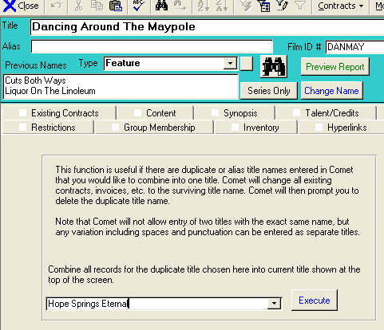

* Popup error message fixed in Availability Reports Format 2 (with underlying rights option)
* Comet Royalty Ledger has checkbox option to show amounts in Report Currency. Default is in Base Currency at Invoice Exchange Rates.

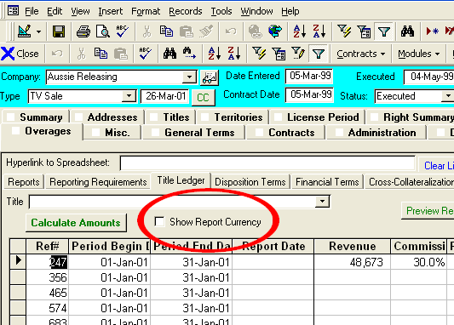

**2004-08-27**

* Comet has new Excel-based video deal memo format, available as a form of the Excel based deal memos in the Contract tab
* Comet has new delivery fields by contract, which are copied from the Company profile when selecting the licensee.

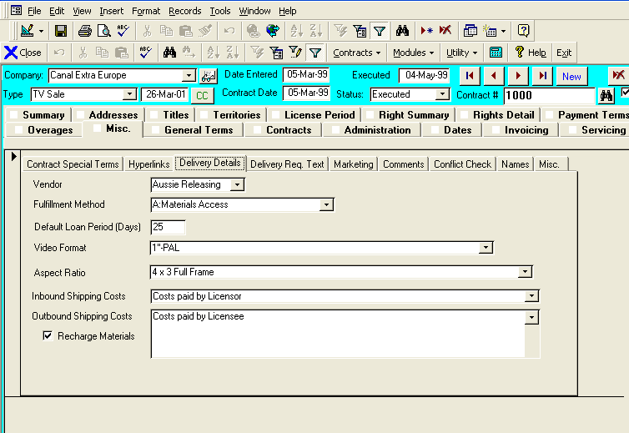

* When adding servicing items to a contract, Comet will prompt the user to automatically select the correct format and configuration. Comet will use the new Contract level delivery format fields if available, and otherwise look to the company profile.

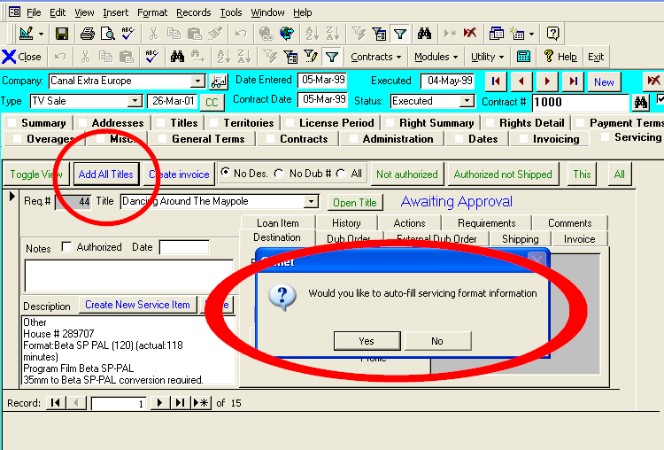

* Comet has a marketing spend entry screen (shown below). This information appears in the new Excel-based Video Deal memo.

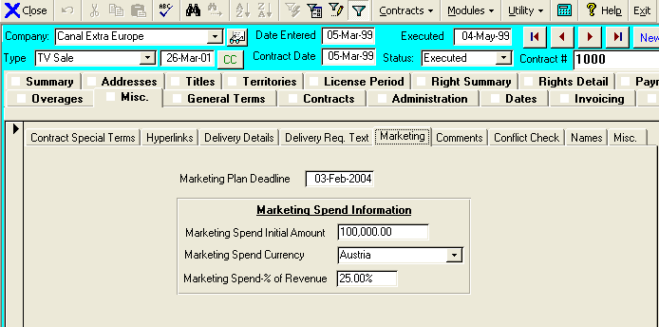

* Comet has a new event “Marketing Plan Deadline”, available on a contract level, but may also be input on a title by title basis which overrides the contract level. This field available to edit in the Marketing tab as shown above, or in the NOD date update screen. Comet adds this event to standard event table.
* New report #227 lists rights sold by territory for selected territory, with start and end dates and runs.
* Comet avail reports have new option to “Show Original Currency” in the “Show MG Columns” checkbox option under the “Options if Sold” tab.



|  |  |  |
| --- | --- | --- |
| **Free TV Rights** | **Total MG** | **Take** |
| AVAILABLE HoldbackAussie Releasing Avail Since 08-Feb-2002 ----------- Underlying Rights:Perpetuity | AUS001: Krona Kr340,554.50 | 10,269,298 |
| Rights Expired License Expired Pro-Plus Media AG ¥200.8K/ep. Avail Since 12-Jan-2002 ----------- License Expired (non-exclusive)Pro-Plus Media AG ¥200.8K/ep. Avail Since 10-Feb-2004 ----------- Underlying Rights:Rights expired 29-Jan-2002 | PRO001: $ U.S. $600,000.00 |  |

* Format improvements/fixes to this report format:
  + Number format consistent
  + Repeat of contracts fixed
  + No empty columns with outline to right of MG column
  + When choosing to see prices in selected foreign currency, Comet will show in all forms of MG listing, unless Show Original Currency is checked off. Previously, only Comet would show selected currency when amount was allocated
  + The ask and take prices are a total of all of the ask and take prices for the rights used in the report, instead of just Cinematic rights.

**2004-08-16**

* When adding titles to a contract, Comet will automatically create the fulfillment items, but only if the response method has been selected. If the response method is not selected, then the action items have not been created yet anyway.
* Proactive Servicing Report no longer has percentages based on record count. Values now based on quantity.
* When opening the title setup from the menu, Comet does not close the fulfillment screen
* All fulfillment action items where the task starts with "Ship" updated to be as shipment types so they show up in the proactive servicing report
* When rejecting a shipment type item, Comet makes sure the replacement shipment is also a shipment type.
* To easily drill to a contract from the Title filter list, a new Open Contract button on the fulfillment screen has been added. If there is more than one contract for the title and channel combination, Comet will ask which one to open.

**2004-08-05**

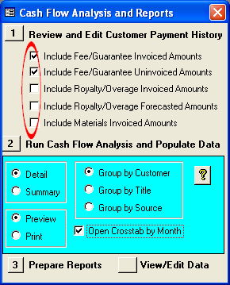

**2004-07-30 08:06**

* Completed new report #226, "Receipt Cross tabulation by Month", showing a cross-tab query of payments by month and title. You may select Royalties or Fee/Guarantee or both in the report, as well as filtering to a title or company and a payment date range.

* Report #202, Cash Flow Reports, to allow selection of MG or Royalty forecasts only.  It will still show invoiced but unpaid amounts for both Fee/Guarantee and Royalty amounts, although typically the Royalty invoices are paid upon receiving the report, so the report will typically be limited to unpaid MG invoices only.

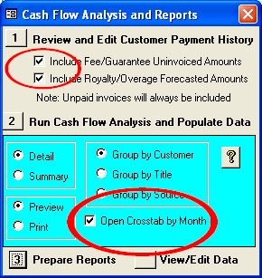

**2004-07-22**

* Contract tab re-organized. Printing of Comet standard deal memo formats added to screen.

* Report 223, Royalties Due Report, additional columns added to report including unrecouped advance and earliest release date. New summary by contract also provided.

* New report #225, Un-submitted Royalty Statements, lists all overdue Royalty statements by customer, showing the title, territories, contract # and the period start, end and due dates.

* Fix to month/day switch bug with invoices causing incorrect currency rate lookup, also causing blank contract exchange rates. Problem occurred only on UK desktops with US SQL server settings.
* Universal Invoice has slightly more spacing between sections so that border is not hidden by expanding text boxes
* Problem fixed on availability report settings, Language Availability settings, where pressing button "View Language Access Report #216" had popup error message

**2004-07-16 13:25**

* New report 224, Revenue by Title
* Fix of Output to Excel reversal of Boolean to “YES” or “NO”

**2004-07-09**

New reports 222 and 223

**2004-07-06**

* Comet warns against creating 0 amount servicing invoices
* Report 88, Statement of Unpaid Invoices-All Customers
  + Top section borders extended to far right
  + Line break added after invoices before invoice payment section
* Problem fixed with Comet long form contract: when clicking on “Open Existing”, popup error message occurred due to extra delay in opening Word document. (Office 2000, XP, 2003 only)
* In title Input batch delete, “Keep or Delete” scratch checkbox was not enabled (SQL backend only)
* Receipt Screen captions modified to be clearer as shown:

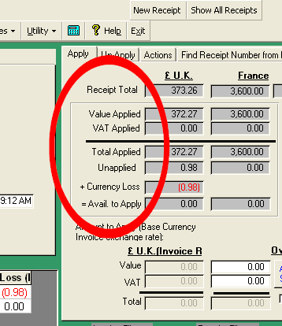

**2004-06-25**

* Bank account selection pull downs are sorted by account name.
* Licensing entity pull down selections sorted by name
* New Report #220, Company Addresses lists all internal Comet companies and addresses.
* New report #221, Use of Company Names in Contracts
* When using shortcut master selection in servicing tab, loan information column has increased size.
* Invoice/receipt balance entry screen programmed for foreign currency contracts. ‘
* Comet holdbacks allow adding holdback days, either with years and/or months or independently.

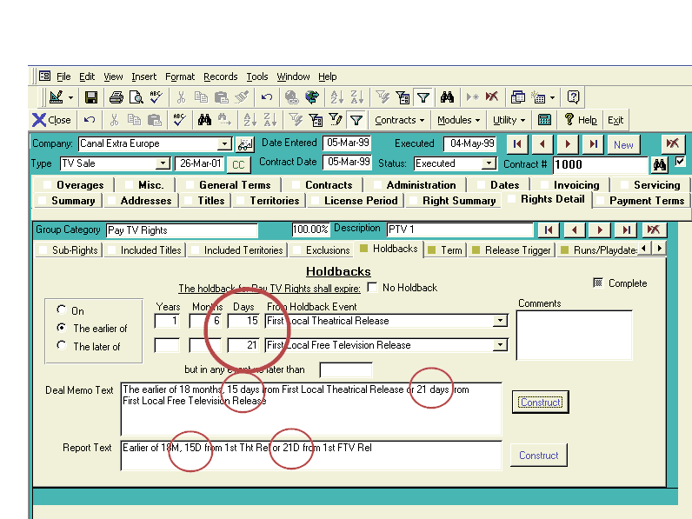

**2004-06-16**

* New Comet user setup screen, including new fields necessary for Comet generated letters such as salutation, closing, and fax.
* When Comet checks for restrictions, it looks up the Company Profile restrictions.
* Improved performance of availability report selection of titles and opening the screen.
* Comet invoice popup preview screen allows entering an override invoice number
* Report #88, Unpaid Invoice Statement by customer (with automatically generated collection letter), has improved formatting of the collection letters and report. Also, produces list of addresses in Excel for direct use as a data document in Word mail-merge.
* The NOD generator uses the contract licensing entity information as the licensor information on the document.
* AFMA or User defined Word long form mail-merge agreement popup-message bug with Office 2000/XP/03 fixed.

**2004-05-29**

* The condensed version of the Comet Materials Invoice does not group by shipment date.
* The Comet revenue accounting interface includes NOD date and delivery date

**2004-05-05**

* The Event Setup screen cosmetically improved by showing more informative headings and removing unimportant columns
* Users may enter any user-defined title level event by adding the event to the event setup list and checking on the column “Title Level Event”.
* When creating invoices from the contract invoice tab, Comet will requery the invoices created so it is not necessary to press the “refresh data” button.
* New license period event added to system, “Rolling”, for contracts where distributor can continue licensing until producer cancels sales agreement. Event calculations and availability reports programmed to show rolling status.
* Report #208 changes:
* Report #208 performance improved
* Report #208 uses Arial Narrow font for more condensed format
* Report 208 has choice of using Contract Comments or Contract Special Terms
* Contract Fulfillment Module changes:
* Contract fulfillment will ignore all filter settings when on “Single Contract” view mode. List filtered to selected contract.
* Proactive Servicing Report uses the “Description” column instead of the “Comments” column for the report column “Comments”
* For Comet Fulfillment reports, the “Underlying Data” is a much improved format.
* When adding a new Title to a contract after the fulfillment items for the contract have been created, Comet will create the initial two items automatically, so they are included in the list of undelivered titles to choose from. A new pull down in the "Actions" tab allows a user to manually add the remaining items.
* When moving to "Limit to Contract", Comet shows all items for that contract and ignores all filters, so that items don't appear hidden.
* The fulfillment loading performance has been significantly improved after a full re-design of some of the data preparation steps.
* New Availability Report quick find pull down now available on first tab of availability report.
* Expiration Notification report now includes underlying rights and shows the contract type in the report.

**2004-04-09**

* Popup error box on running conflict check fixed
* Change in design of adding titles to contracts to increase speed and reduce server load
* Checkbox added to title inventory to block titles from being serviced. Comet will provide warning before adding dub request to purchase order or shipment. Invoicing not effected.
* Performance of servicing reports 123,126,113 improved

**2004-04-06**

* Comet has option in title entry area to delete all titles for contract by clicking on “BatchX” button

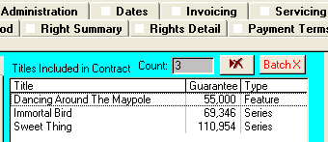

* With Contract Territory entry, deletion of territories options clearer with “Remove Selected” and “Remove All” buttons

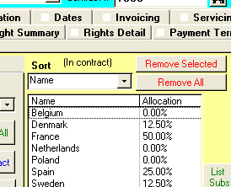

* In language entry screen, new “Set” button will set all language “Subtitled” and “Dubbed” to the contract defaults:

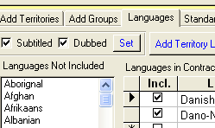

* DVD Regions added to contract territory entry in Standards section.

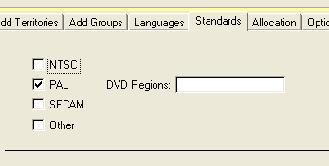

* New “Hyperlink” column added to talent setup in title setup screen
* Foreign title name added under main title name in title setup
* Title Territory pricing screen shows Title Inventory number
* Comet e-mail notification of expiration dates includes underlying rights contracts. Previously filtered to license contracts.
* The following changes made to the Contract Fulfillment module:
  + “Any Open” button re-labeled “Any Open Items”
  + Uncompleted predecessor warning message logic and clarity improved
  + Problem fixed with popup when company exceeded 32 characters
  + Improved message handling when creating documents for invalid file paths
  + “Merge Fields” button moved into Setup tab
* Availability reports have new options:

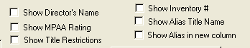

* With availability reports, new options for sorting titles and showing new columns of information. Shown is an example:

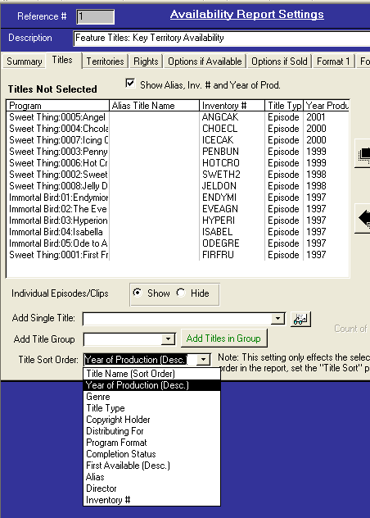

* Comet availability reports have an option to show the underlying rights holdback text
* Title restrictions show on the Availability Report as an option. Set by default in the Conflict Check
* “Reissue” checkbox added to Comet contract on Contract Summary screen

**2004-02-24**

* DVD Zone added to territory setup
* Sales rep and Servicing Rep added to Territory Setup screen
* Report #75 shows expiration of sell off period, release trigger end, blackout period, expiration of sales information in addition to expiration of rights previously included. (This included in 2004-02-18 version, not in notes)
* The following events are now computed by Comet and will automatically be added to the event setup table:
  + Deal Memo Sent to Customer
  + Deal Memo Received from Customer
  + Long Form Sent to Customer
  + Long Form Received from Customer
  + Notice of Availability to Deliver
  + Notice of Initial Delivery
  + Insurance Documentation Delivered
  + Ad/Pub Materials Delivered
  + Chain of Title Documentation Delivered
  + Materials Order Form Received"
  + Comet will lookup the event “Acceptance” as an alias for “Technical Acceptance”, but this event was not automatically added to the event lookup table.
* Swedish Currency name “Krone” changed to “Krona”. Does not impact contracts.
* Comet splash background replaced with updated design.

**2004-02-18**

* Report format #2 does not require a filename, although it would not prepare the data without one. Problem fixed.
* Country of Origin added as fieldname to Title Setup
* DVD Region added to territory setup screen
* In Contract Fulfillment, description changed from “memo” field to “text” field for fast searching and sorting. Length limited to 255 characters.
* Browsing in, and drilling to the Company Profile should be much faster.
* Report #75, Rights and Windows by Territory-Expiring in Range, has option to include 3rd party contracts.

**2004-02-10**

* Problem fixed where, when adding a title group to a contract containing deleted titles, Comet would show a message “The title has not been entered into the title setup screen and cannot be added”.
* New report #219 added, “Distribution Report”, showing key information for titles without delivery or NOD or not fully paid. Detailed materials information included
* A new “Internal Billing/Admin” comments field by title is included in the title entry screen. Appears in the new report #219.

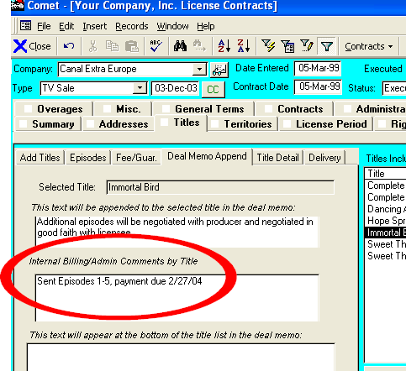

* Comet conflict checks gray out more area as “not applicable” when exclusions present.
* The following events are automatically added to the Event setup table. Perpetuity is a programmed event, and may be used for all term entries.

|  |
| --- |
| **Event Type** |
| Perpetuity |
| Chain of Title Documentation Delivered |
| Materials Order Form Received |
| Signature of Deal Memo |
| Receipt of Materials |

* The activity log includes the individual user session login time as a new column.
* (Comet availability reports) When entering an “expiring within n months” greater than 16,000 (i.e. 99999), Comet would produce an Overflow message. Comet will not overflow now.
* (Office XP only) In Company Profile, Toggle View button would show a popup error message. Problem fixed.
* The caption on the Acquisition Contract "Sales License End Date" was changed from "the date at which sales effort must stop based on the rights-in agreement" to "the date at which all sales contracts based on the rights-in agreement must expire"
* Interest by Title report-dates cut off in Interest and Tape columns should be fixed.
* Report 83, Sales by Title by Year extended to be 1999-2004
* Territories box in the Source Payments screen now populates
* On the Comet start-up popup window, SQL users will have the “data file location” grayed out. File not used to store data, but only as file location reference point.
* In the title inventory tab, “disposition” caption changed to “status”

**2004-02-09**

* When closing a commercial invoice, or entering the due date, Comet will

a. ask if the item is a loan item, and if so,

b. what the return due date is

c. update the servicing records with this date

d. check on the “loan item” checkbox in the servicing records.

* When clicking on “create New Service Item” button, Comet will look to see if there is a servicing address selected for the contract, and select this for the servicing record. If not, Comet will default to the selected contract address. If that was not selected, Comet will default to the servicing address in the company profile for the contract customer.
* The Notices and Delivery screen has 2 new filter options as shown: “With NOD and Undelivered”, and “Undelivered”.

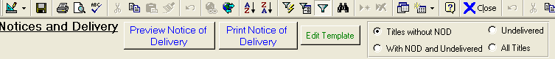

* For the title inventory, Mediums field, the pull-down list is now user-defined and set in the Advanced Settings, Server General as “Title Inventory Mediums”. The default choices are "Film;Video;Audiodisc;sound publicity;documentation".
* In Contract Servicing, the “Master #” field has a pull down option. When a master is selected, the description and format fields are filled.
* Comet computes a new event, “Materials Order Form Received”. It must be added to the event setup to be in the Event pull downs. It may be populated from the Contract Title Input-Delivery tab, or the Notices and Delivery update screen.
* Report #51 numeric formatting improved, negative numbers in red.
* Comet servicing statements may be converted to individual by title invoices. The original Grouped Materials invoice linked to the servicing record is reset to $0 amount, and each item in the invoice is converted into a “Materials” invoice at the base currency and linked to the servicing record. This is done by checking on a checkbox on the top of the screen in the Materials invoice screen.
* In the Comet servicing window, the Master ID # has a pull down option. If selected, Comet will populate the description and price charged based on the setup. For more complete data fill-in, click the “Edit Description” button.
* The “Medium” pull down box in the title inventory is now a list set from the Advanced Settings window, under Server General settings, variable name of “Title Inventory Mediums”
* When the Date Shipped is populated in the Commercial Invoice/Shipment screen, Comet will prompt the user for a loan item due date. If entered, Comet will identify all items in the shipment as loan items, and fill in the loan item return due date.
* The Materials Invoice may be printed in a continuous document, with the detail just below the header. The payment information appears at the end. User is prompted for choice of invoice.

**2004-02-06**

* Comet has a new module which will automatically e-mail selected users in advance of license periods expiring, release triggers occurring, sell off periods ending, and blackout periods ending. It is available from the main menu under Modules->Expiration Notification.

The process may be run manually at any time, but it is designed to be loaded to a designated desktop and left on, whereupon it will automatically send the reports via. E-mail once a day.

To set up the process:

1. Install Comet on a Windows 2000 or XP computer with at least 256MB of RAM and at least a PIII-800 processor.
2. Select from the Comet menu Modules->Expiration Notification.
3. As shown in the screen at the bottom, enter the number of days in advance prior to the critical date you would like each user to be notified. You may select up to 5 notice periods, i.e. 90 days, 60 days, 30 days, 5 days, etc. for each of the 4 events (Term Expiration, Sell off Period, Blackout Period, Release Trigger). Click on the red arrows to set up the next user.
4. Comet will send an administrative confirmation that the process was completed to designated users. To select this, check on the box “Receive Admin Notices”
5. Open the Comet advanced settings for each desktop, and set the variable “Client e-mail program”. Currently, Comet supports Outlook, Lotus Notes, Outlook Express, and Outlook with Exchange Server, or output the e-mail to Notepad. The choices are
   1. Outlook (all versions of Outlook and Exchange)
   2. Notes (Lotus Notes)
   3. Other (Comet will create a notepad output of each e-mail with the addresses, subject, and body).

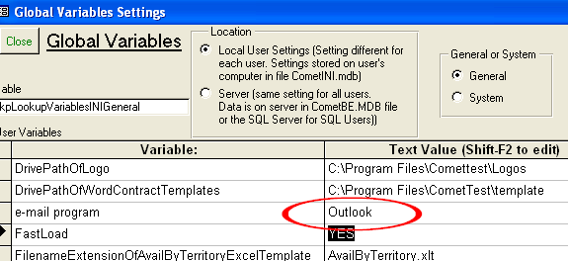

1. The next report run date/time may be set at any time.
   1. To stop the automatic processing, click on the Manual Stop radio button.
   2. To manually run, click on “Immediate Run”.
   3. If the computer runs low on available RAM, the processing will automatically stop and send an e-mail error report to the admin users. The admin users will also be notified if there are any errors.

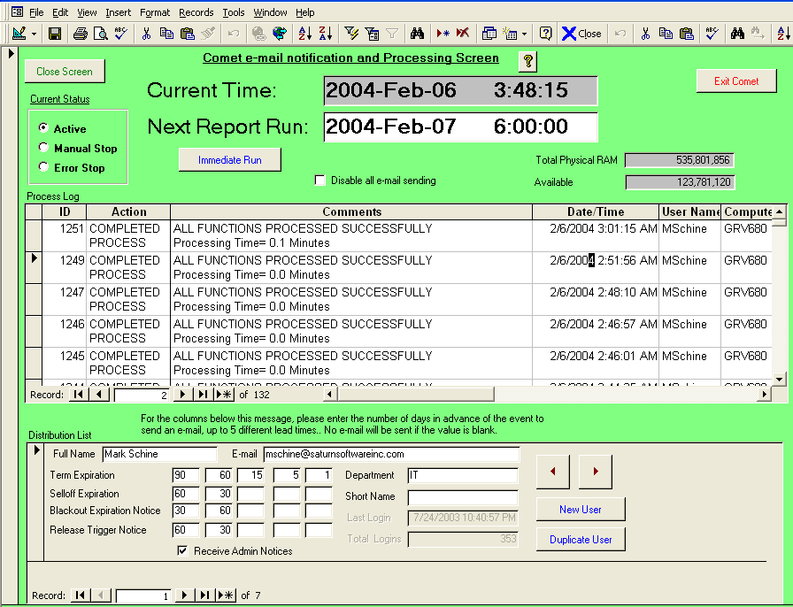

* Comet has an option with report 171 to show 3rd party contracts.
* The entry of Comet royalty statement periods is now clearer as shown:

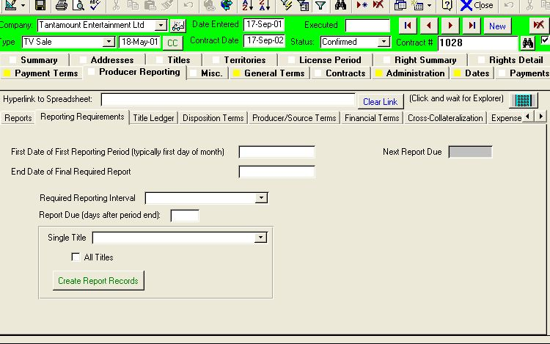

**2004-01-14b**

(Comet for Office 2003 Only) Office compatibility issue fixed with Output to Word

**2004-01-14**

The Comet availability reports has a new option to show multiple territories on the same sheet.

1. You can include multiple territories on the same spreadsheet in the same layout as your example provided.

2. The column width has been reduced to 9 points

3. The font has been changed to Arial Narrow

4. We have condensed the date formats so that available rights are "AVAIL" instead of "AVAILABLE" and the next available date is shown in "dd/mm/yy" format, instead of "Available on dd-mmm-yyyy". In order to see the next available date for rights to expire, you need to make an entry into the months box as shown below. In this example, all rights becoming available within the next 8 months will show the next available date instead of “sold”. If you would like the next available date for all sold rights to show, enter “9999” in the months box.

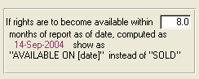

**Shown is a sample output from our sample database:**

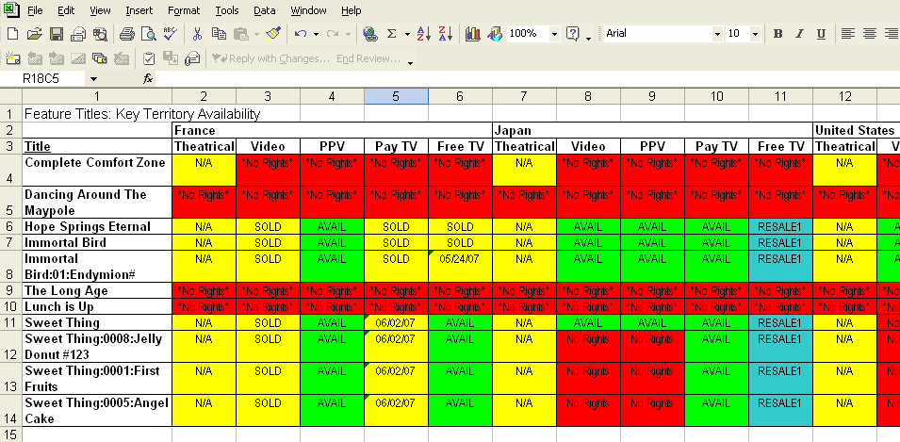

(Note that the "RESALE1" option will not show if you check on the box "Never Show Resale")

 It is necessary to check both checkboxes in order to see the new format

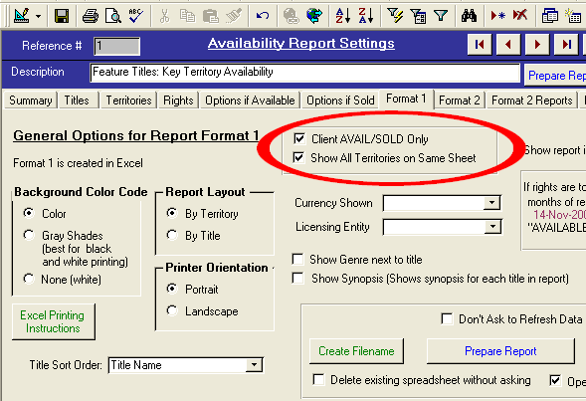

The Avail report column headings are set in the Comet rights setup screen, which can be reached by selecting from the Comet menu "Modules->Setup->Rights Setup.

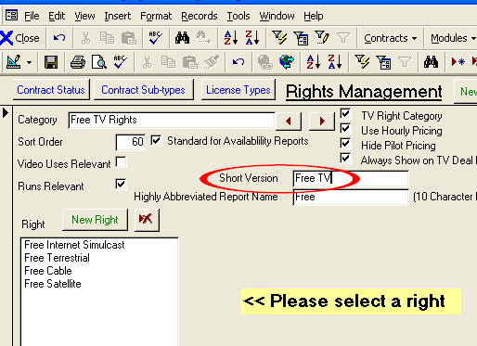

Use the red triangle arrows to scroll through the right categories.



**2004-01-09**

* Improved creation of underlying rights contract from the title setup. Comet will prompt to create all rights, all territory contract.

**2004-01-01**

* New report #217, Inventory List, shows spreadsheet view of all inventory items.
* New report #218, “Contracts with Incorrect Territory Allocation” lists all contracts with incorrect territory allocation and allows for single-button auto-allocation or drill to contract.
* Fulfillment reports have “All Channels” checkbox
* Fulfillment Reverse distribution report option to show open or all items operational
* Acquisition payments screen has option to show all payments or only payments due prior to and including current date (default). Report only shows payments due up to and including current date. If fully paid, Comet will not show computed due date even if known.

**Comet Change Log 2003**

<http://www.saturnsoftwareinc.com/CometSupportFiles/CometChangeLog2003.doc>

**Comet Change Log 2002**

<http://www.saturnsoftwareinc.com/CometSupportFiles/CometChangeLog2002.doc>

**Comet Change Log 1998-2001**

<http://www.saturnsoftwareinc.com/CometSupportFiles/CometChangeLog1998Through2001.doc>