**Comet Change Log 2004**

<http://www.saturnsoftwareinc.com/CometChangeLog2004.doc>

# Comet™ Change Log for 2003

**2003-12-04 13:45**

* The “Rights Summary” tab has a new checkbox on the right side showing if all sub rights are licensed (checked on), mixed (gray) or not licensed i.e. holdback only (unchecked).
* Avail reports: leading single quote removed from availability reports text
* Servicing caption “Designation” changed to “Version” in Company Profile, Servicing Text Construction Popup and Title Inventory setup.
* Full support for event “Perpetuity” and “In Perpetuity” in availabilities and date calculations.
* Reports #113,124,126
  + A ship date start and ship date end entry value is not required. If both left blank, Comet includes all records. If the start date is blank and the end date is entered, Comet includes all shipments up to and including the end date. If a start date is entered with no end date, Comet includes all records on or after the start date. The report title will show a descriptive title for any filter range combination. The same applies to the Title and Customer. Previously, it was necessary to enter a value for all filter criteria.
  + Report #113 now includes the title and customer filter option
  + Reports 124 and 126 include checkbox option to output data directly to Excel
  + Space inserted between date and “And” in date range title (“And” previously ran together with date)
  + Dub order #, shipment #, and invoice # are left aligned. Previously, the shipment number was right aligned causing it to be adjacent with the invoice number in the next column.
  + Comet will notify the user if there are no records given the filter provided. Previously, a blank report would be generated.
  + In the output queries, any of the columns may be searched, sorted, or filtered. Previously, this was not possible with some columns.
  + The filters will work with titles with “#” signs, double quotes, single quotes, or question marks or any Unicode character.
  + Reports #124 and #126 show “Page 92 of 182” format instead of just “Page 92”
  + Scrolling back and forth through the pages on-screen is considerably faster than before.
* Fulfillment Module improvements, including report layout improvements.
* Quarterly Acquisition Payment improvements, including check to verify that all territories with payments made are allocated correctly, as well as a new reconciliation report comparing the payments made to distributors with the payments made to channels.

**2003-11-11**

* Report #88 has popup option to show/hide invoice description text.
* Accounting interface currency values don’t have $ signs, also has new column filled with “Comet”, and has new column called “Account” which is the Nominal, Sub Account, and Level 3 combined together.
* Report #202, Cash Flow report, problem fixed with popup error message “The field is too small”, caused by long “contract status” entries (over 25 characters).
* “Language Access Description” from contract input added to all Excel deal memo formats.

**2003-11-07**

* When adding episodes to a title using the “Add Count” button, Comet prompts for the number of the first episode, and adds the total count starting there.
* When running availability reports for a single episode, Comet will look up delivery date in episode list for series for event calculations, both for acquisitions and sales.
* When adding rights categories, users may select if all mediums are non-exclusive, and select the license type prior to adding the sub-rights.

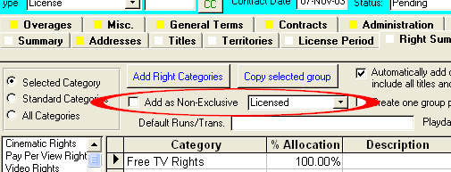

* Report #75 has the following changes:
* This report now calculates event dates to determine the license period expiration date, with an option to not perform the event calculation.
* The end of license period calculated date is now a new column on the report
* Users have the option to open a spreadsheet view of the report underlying data
* The report uses the territory hierarchy to provide sub and parent territories that are expiring in the date range.

**2003-11-06**

* In Comet avails reports, if caption had Asterisks, Comet would show heading and repeat for sold right. This has been changed so that the caption will not repeat.
* (availability report option) Sales license end date now appears in availability report if new checkbox option selected:



* (availability report option) New language version availability checkboxes now show in Comet availability reports format 1.

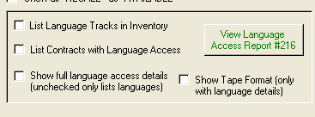

* + If “List Inventory for Languages” checkbox selected, Comet will show available inventory for the territory default languages.
  + If “Include Contracts with Language Access” is checked off, Comet will show availability for all contracts where the languages match the territory default languages.
  + If “Show full language access details” is checked, Comet will list the inventory numbers for language versions in inventory, and the contractual language access terms for contracts with the same languages licensed and the “language access” checkbox checked. Source of data is from contract territory input, under “special terms”.
  + If “Show Tape Format” is checked, Comet will show the tape format and length.
  + New report #216 may be opened from this screen which lists language availability

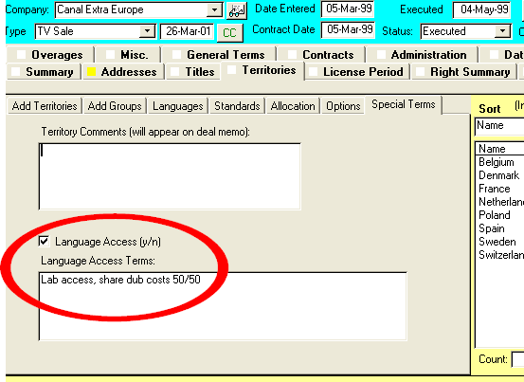

* The previous merger of Dutch or Flemish into the new language “Dutch/Flemish” did not delete “Dutch” from the language list. Consequently, contracts may have been entered with Dutch as a language. In this version, Comet checks to see if this is the case and prompts the update user to correct this by changing all uses of “Dutch” into “Dutch/Flemish” and remove Dutch from the language list.
  + Dutch and Flemish (a dialect of Dutch) are generally considered the same language for the purposes of theatrical and television licensing. Some reports and filters in Comet are language specific, and will not show the desired results if contracts are entered with only Dutch or Flemish. This version of Comet will, as a solution, create a new language called 'Dutch/Flemish' and modify all existing contracts so that entries of Dutch and/or Flemish and/or “Flemish or Dutch” will be converted to “Dutch/Flemish”. This conversion can be performed at any time in the 'Updates and Patches' screen of Comet as process 5. For more information on this issue, see

<http://www.bbc.co.uk/languages/european_languages/languages/flemish.shtml>

<http://www.bbc.co.uk/languages/european_languages/languages/dutch.shtml>

<http://www.bbc.co.uk/languages/yoursay/200506/594.shtml>

<https://www.cia.gov/library/publications/the-world-factbook/fields/2098.html>

* When creating a new conflict check, Comet will set the underlying rights option to show all term detail.
* Comet has a new option to remove rows from the Excel spreadsheet if they don’t contain any available rights. This is helpful for running conflict or sales reports. The checkbox “Show Available Rights” has been integrated with this new option.

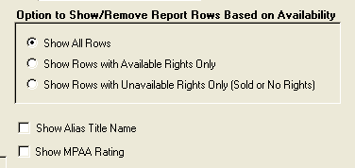

* (Availability Reports) Option to “Show MPAA Rating” now as checkbox option in availability reports. If selected, it will show the MPAA rating as entered in the title setup screen between the Genre and the Program Format
* (Availability Reports) Option to “Show Alias Title Name”, which, if one has been entered into Comet in the title setup screen, will show the alias title name instead of the main title name.
* Popup error message fixed with system wide conflict check report

**2003-10-02**

* Reports 12, “Application of Cash Receipts, All Receipts”, and 13 “Application of Cash Receipts, One Customer” re-formatted.
* With report #207, there is an option to use the contract comments or contract special terms as the report.
* The contract fulfillment screen initial filter is driven from the distributor name instead of the territory.

**Important availability report changes:**

* Multiple windows in Contracts in cell listed descending by contract number, instead of ascending. This makes the most recent deals at the top.
* When there is a value in “Available On” option, Comet previously ignored contracts with unresolved expiration dates in determining the next available date. Comet will show as “Sold”
* The dashes have been removed from the sides of cell headings
* Comet will not show a heading that is the same as the status of the next cell. For example, if the cell status is “SOLD”, comet would previously show

---SOLD—  
SOLD Dazio Films

Now, Comet will show:

SOLD Dazio Films

* When showing “Available On”, Comet will now add 1 day to end of expiration date.
* Comet checks, when adding new contract, that contract number not used. If it is, it will continue to increment the next number until it finds an unused one.
* Company profile address have copy button.
* Company profile has copy button. Delete and rename moved to section in “general” tab
* Problem fixed where Comet would not show license term for underlying rights contracts
* New fields added for language access rights in contract input languages.

**2003-09-11:**

* Under license from AFMA®, Comet has capability to create AFMA® long form agreements. This feature is only available for current AFMA® members only. A new button to create the AFMA® deal memos is shown in the contracts screen in the “Contract” tab. Users must obtain a Word template from Saturn, which must be copied into the comet Template folder.
* Can preview/print NOD from Delivery tab in contract title input
* Popup and blank column in report #187 “Itemized Invoice Aging Report in Foreign Currency” fixed.
* New fields in licensing entity setup for Phone, Fax and E-mail. Used in AFMA deal memo as separate address fields.
* Interest tracking reports date column width fixed
* New reports 213 and 214 summarize acquisition payments

**2003-08-25**

*[Note: numerous other changes to be documented, plus documentation to be provided on new Contract Fulfillment module]*

* When constructing license term text, Comet spells out the month in full text for the Deal Memo text.
* Entering new address in company profile has button at bottom to complete entry, and move to top of screen.
* New checkbox in company profile identifies address as e-mail recipient.
* New parameter in advanced settings, by user (local settings) of e-mail program in use. Choices are Outlook, Notes, ACT, Exchange, Outlook Express, Other. Parameter used for integrated e-mail and template functionality in Comet.
* Substantial re-arrangement of Company Profile screen.
  + Addition of new field, “Exclude as Contract Company” so name will not show up in company list. Color coded to cyan. When selecting a contract company, blocked companies will not show in pull down list.
  + Void companies show in red background.
  + Shipping information moved to new sub-tab
* Vendor screen layout improved.
  + New fields for company name and e-mail address.
  + Vendor name relabeled as “List value”
  + Additional fields for automatic document processing
* Date calculation for "U.S. Network Release", "U.S. Theatrical Release", "U.S. TV Release", "U.S. Video Release" events as entered in title events screen computes to date instead of returning event text.
* Comet Activity Log added to MDB Version

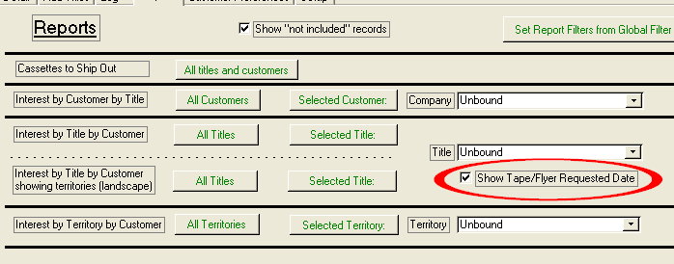

All interest tracking reports show dates in columns if they exist, otherwise they show the initials.

* New option to include 3rd party agreements in report #74
* New format of Excel based TV deal memo, TV Deal memo 2, available on contract deal memos as a second button.
* Comet has new module, Contract Fulfillment, which will organize all contract related tasks and generated related documentation, including mail-merge documents and purchase orders. Will send documents via Outlook, Notes, or Exchange to designated recipients. Included are 10 new reports in the Reports tab of contract fulfillment.

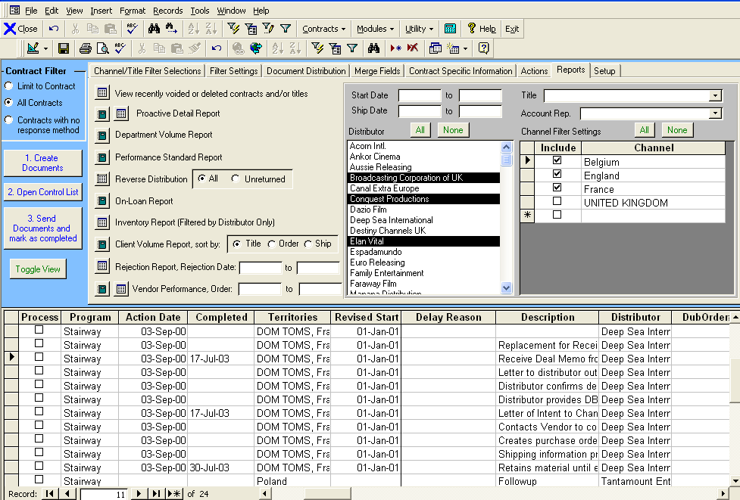

**2003-July-7**

* Potential problem fixed with contract exchange rate when changing contract currency.

**2003-July-2**

* Sales interest by Title report (from Sales interest “reports” tab) includes genre after title, instead of in column. Extra space used for Comments column.
* Comet message when invoice created changed from “use new invoice format” to “use detailed invoice format”. When selecting “cancel”, Comet shows message “If you created a new invoice, printing was cancelled, but the invoice may be re-printed from the ''All invoices Sent' tab. “
* Performance improved on SQL for report #23, “Contract Status”
* Performance improved for title setup screen over slow connections

**2003-June-23**

* Representation of languages in various deal memos shown as

“Spanish – Subtitled and Dubbed” instead of

“Spanish, Subtitled and Dubbed”

* Interest tracking module-customers cannot be deleted if they are used in contracts.
* When adding a new company name in the Interest Tracking module, Comet checks if the company already exists and will move to it.

**2003-June-19b**

* (SQL Users Only) Problem opening availability report settings screen with popup error message fixed.
* Problem selecting titles in availability report settings where clicking out of title selection box not possible fixed
* When creating a conflict check, Comet would not go directly to the conflict check record.

**2003-June-16b patch release**

* Comet prevents accidental loading of Office 2000 version of Comet in Office XP
* (SQL Users) Fix to report 211-ODBC Failure
* Popup message in availability reports setting screen, depending on Office configuration. Problem fixed.

**2003-June-16:**

* The “print screen” button on invoice popup forms should print normally.
* When applying system filter before printing Report #207, Comet would turn off the system filter since withholding taxes and bank charges are allocated among different invoices, some of which may have been filtered out causing incorrect allocation. Now, Comet will still perform the allocation correctly, with all invoices, but will only print contracts as filtered to the following fields in the yellow section of the system filter:
  + Contract Status
  + Licensee Name
  + Salesperson
  + Agent
  + Licensing Entity
  + Contract # (but not the SQL WHERE contract number)
  + Market
  + Contract date
* Availability reports-when printing the condensed client avail/sold report, users may see the MG columns, if checked off in the settings.
* Reports #186 Itemized Invoice Aging-Base Currency Invoice Rate and report #187 Itemized Invoice Aging Report in Foreign Currency have improved numeric formatting, where negative numbers are in parenthesis and red. Numeric values are right aligned.
  + Report #186, being converted to base currency, are rounded to the nearest whole number. Columns with zero values are blank instead of showing 0.
  + Report #186-Bug fixed when requesting to see the “Include Invoices Not Due” column, column was the same as the 0-30 day column. Problem fixed.
  + Report #187, in the contract currency, show 2 decimal places and show “0.00” where the values are 0.
* Availability 2 reports still have blank page at end, but are re-numbered so that total pages shown exclude the blank page. For example, if there are 5 pages of report data plus a blank page, Comet will show “Page 2 of 5” instead of “Page 2 of 6”
* A new advanced setting variable “DrivePathOfWordContractTemplates” will point to the location of the AFMA® and Word long form agreements. This upgrade will create the new variable and set it automatically to the same folder as the existing variable “DrivePathOfExcelAvailTemplates”, which is generally set to “..\Comet\Template” on the server.
* Expiration Warning message does not pop up frequently, and shows a date instead of “dddd dd-mmm” etc.
* When looking at invoice balances due on several screens, Comet would say “Paid” with any zero balance due, even if nothing was actually paid. Comet changed to show a green “0” for zero balance due situations.
* Availability Reports Format 1 and Format 2 has checkbox option to append title genre (from the title setup) to the title name in the availability report headings.
* Availability reports Format 2 has option to show contact information for the licensing entity selected for the report. A new field at the bottom of the licensing entity setup screen allows entry of the contact information which will be shown on the report.

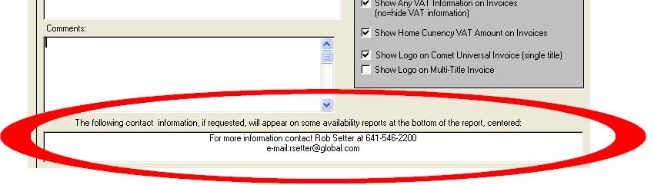

* Comet activity log includes network computer name and login name
* Comet when opening up Comet avail reports for a user with no saved report settings, Comet provides a message to either enter a new report, or show all reports.
* Comet defaults new avail reports to position 3-compute all underlying rights information.
* Comet interest tracking reports have on-screen filters as shown.
  + Interest tracking reports default to interest items “included”, with option to show all.
  + New interest tracking report by title in landscape format with the territory shown.

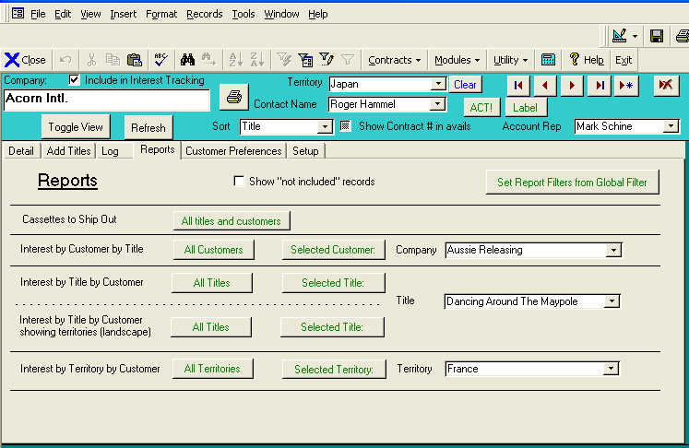

* Comet interest tracking reports have option to send log items to ACT!
* Availability report settings-when adding new titles to the report, Comet does not jump back to top of list. Comet will instead move the cursor to the next title on the list.
* Possible problem where, if using icon sort on existing contract list in the Title Setup screen or Company Profile screen, datasheet view would go blank. This version should fix problem, although unable to replicate it at Saturn.

**2003-05-19**

* Comet format 2 reports now include third party deals.
* When making an acquisition payment, Comet refreshes balances.
* New report #210 shows payments made to titles removed from the contract, and shows which titles were added back into the contract.
* Updates and patches has button 18b to re-link payments to the title as re-entered.

**2005-05-14**

* Bug fix: (Title setup for series title during episode move). When moving episodes from one series to another in the title setup, Comet would go into an endless loop if the episode had already been added to contracts. This problem was fixed. Additionally, Comet will:
  + Comet will prompt the user prior to making the move for confirmation, with the episode number and series name in the prompt.
  + Comet adds the episode move to the activity log
  + Comet will print out a list of all contracts without the destination series in Notepad. Previously, Comet would show the contracts in the popup prompt.
* (bug fix) In the “overages” tab, “financial terms” sub-tab, when adding in financial related terms not in the list of default terms, Comet will accept them without going into endless prompt box loop.
* New report #209 shows reconciliation of payments made to producers/distributors to acquire titles.
* When opening up the rights setup screen, Comet has a one-button drill to “Contract Status”, “Contract Sub-type”, and “License Type” setup tables, which affect rights and how they are utilized.
* When looking at Invoicing tab, in contract view, calculation speed improved. “Unpaid Fee” heading changed to “Uncollected” (this amount is total license fee less paid amounts).
* Improvements to the Quarterly Recharge invoice
* Improvements to report #209.

**2003-05-02**

* When deleting an invoice, for customers able to delete an invoice, a message box was erroneously indicating a reversing credit memo would be issued. This is not the case when deleting invoices, and the message box was corrected. Also subsequent harmless message fixed.
* Fix to materials invoice format, where the default currency country was the currency name.

* Various improvements to new acquisition source payment screen, including changing captions and adding new summary fields. Performance improvements in computing total amounts paid.
* In the Contract invoicing tab, the invoice amounts show 2 decimal places and are color coded so that fully paid invoices show “Fully Paid” in green instead of “0”.

**2003-04-25**

* When entering new exchange rates or selecting a new currency country, Comet will not allow option for user to stop adjustment process by clicking on “no” to question “Would you like Comet to modify the base currency amounts based on the new rates” and then ignoring next popup “Please re-enter the foreign currency amounts.
* When updating the contract exchange rate or selecting a new currency country, Comet will refresh the license fee values shown in the list of titles in the contract.
* In the Rights Detail tab, Rights sub-tab, Comet has a button labeled “Holdback” to set all sub-rights for the selected rights group to be holdback rights.

**2003-04-23**

* (Contract View) There is a new tab in Acquisition and Production type contracts showing all payments made.
* Various improvements to the new acquisition payment module.
* New Report #208 shows sales by territory broken down by title, with start and end dates.
* New report #207 is a spreadsheet report suitable for producer reporting which shows, on a title by title basis, a summary of sales, collections, uncollected and un-invoiced amounts, calculating the expected future due date by payment term for un-invoiced amounts. Bank charges and withholding taxes are allocated pro-rata to the titles paid.

**2003-04-17**

* Comet has a new module for tracking incoming materials, chain of title, ad/pub, and detailed servicing requirements, and authorizing payments based on deliveries as defined in the payment terms. A screen allows easy viewing, searching, and filtering of all titles in the system based on status, start date, licensee, and other criteria. [More documentation to follow]. To see this screen, go to Modules-> Servicing->Acquisition Approvals.

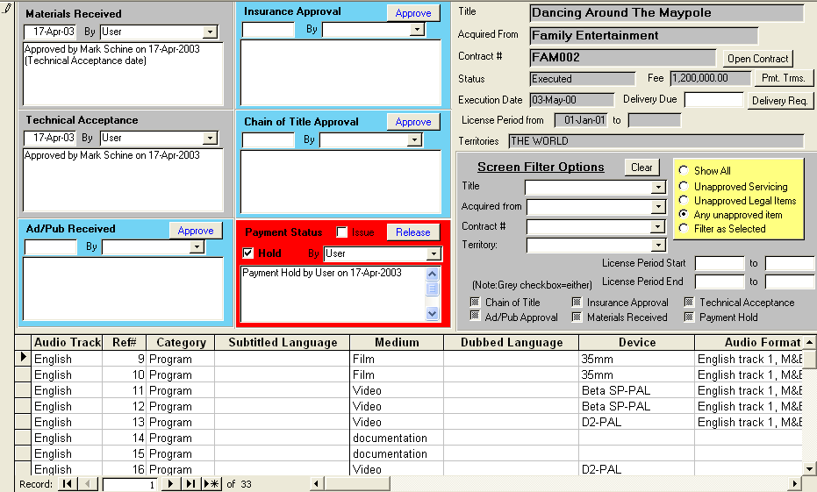

* Comet has a new module for paying producers for product. Screens and reports combine payment due dates with payment calculations. To see this screen, see Modules-Accounting->Producer payments. [more documentation to follow]

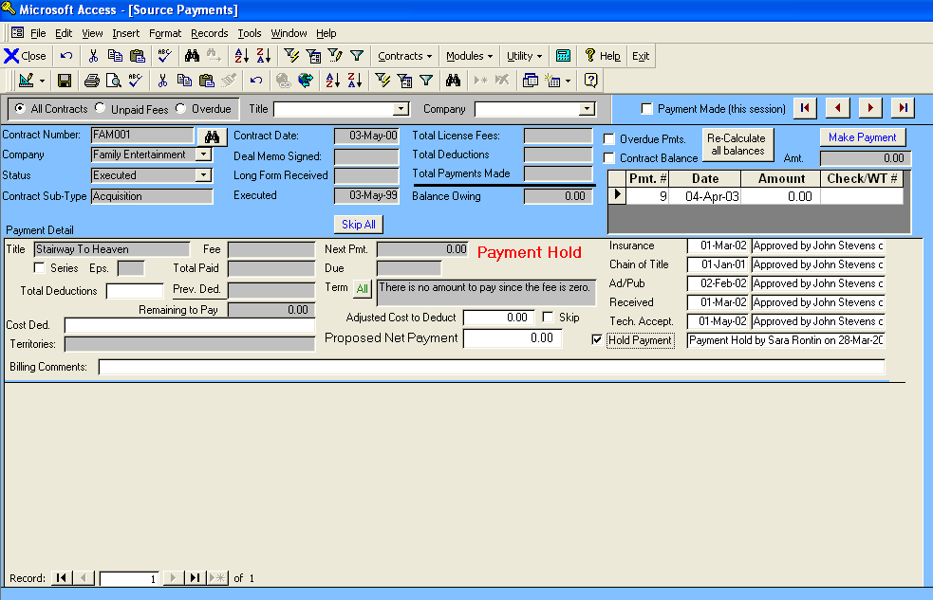

* Comet allows entry of currency amounts into the territory allocation screen, so that the percentage allocations are computed.
* (Contract input-titles) When clicking on a title, Comet will set focus to license fee amount (or price per episode for series) for easier screen navigation and entry
* Comet has a user-defined itemized standard list of required materials by title.. Upon adding a new title, Comet will prompt to add the items.
* Comet will create episodes based on the user-entered total number of episodes in the Title Setup tab.
* (Contract input-territories) In the Contract Territory input, Comet shows the total license fee, and allows entry of an allocation by Territory. Comet will compute the allocation percent.
* Comet allows adding new titles on the fly. If adding titles to a contract using the “Add single title” pull down, if a user enters a new title, Comet will prompt to add the title to the title setup database.
* (bug fix) Global filter-if set to title, would filter out receipts if did not have a title entry. Problem fixed.
* The following new events have been added to the Comet event setup list, and may be entered by title in each contract:
  + Ad/Pub. Materials Delivered
  + Chain of Title Documentation Delivered
  + Insurance Documentation Delivered

**2003-04-01**

* Comet no longer provides warning messages when entering override dates in right category summary screen

**2003-03-31**

* Comet has a default loan period by contract.

**2003-03-19 11:13**

* Cosmetic changes to Availability Report settings headers.
* If Comet availability report option in versions prior to March 9 2003 release was previously set to “Full determination but don’t show detail”, the option “If acquisition/production rights information for the selected title has not been entered, show "UNDERLYING RIGHTS INFORMATION NOT ENTERED". Otherwise, use the information entered to determine underlying rights.” Is selected.

**2003-March-14**

* In Comet Availability reports, better representation of “related” territories if the “Show Related Territories” checkbox is checked. In previous versions, Comet would not show the related territory name if it was included in the same contract as the Availability territory.

**2003-March-13**

* In Comet availability reports, when the “Client Avail/Sold only option” was checked off, Comet would show all Resale status as Available. Now, Comet will show Resale depending on the setting of the “Never Show Resale” checkbox.
* Problem in availability reports format 1 fixed where, if the checkbox “Don’t show expired contracts” checked, Comet would still show details for the most recent expired contract.
* Report 171, Contracts by Customer has checkbox option to include void/cancelled contracts.
* Improved integration of system filter with Availability Report sub-rights and mediums and refresh cycle. Pop-up messages to warn of potential undesired results.

**2003-March-09**

* New Report #206 shows undelivered titles by title and by customer, in both report and query view. The report uses the “Delivery Required” date from the contract entry screen, instead of the dub order due date as report #119 uses. This report also shows the delivery requirements information from the Contract Entry, Misc. tab, Delivery Requirements sub-tab.
* Comet Availability Reports underlying rights information options changed and moved to Rights sub-tab. Can now select determination and information shown separately.

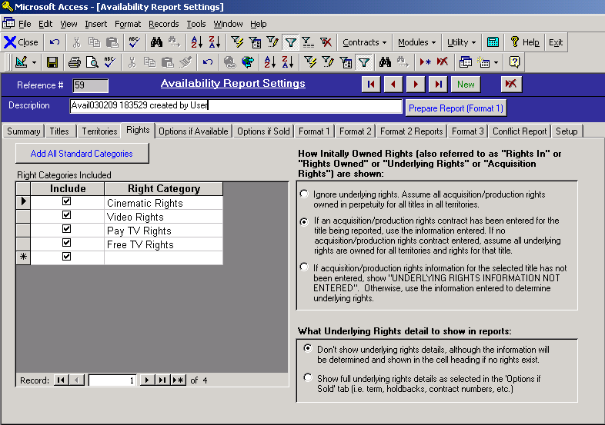

* Button to merge the languages "Dutch" and "Flemish" system wide to "Dutch/Flemish" is now available in the Updates and Patches window. To see this window, select "Modules->Setup->Advanced Settings" from the Comet menu, and click on the "Updates and Patches" button.
* New option in availability reports to show a different color if “RESALE”. Note that if the “Don’t show Resale” option is selected, Comet will use the “Available” color for this option.
* The Availability report colors may be changed directly from the “Setup” tab in the availability report screen as shown:

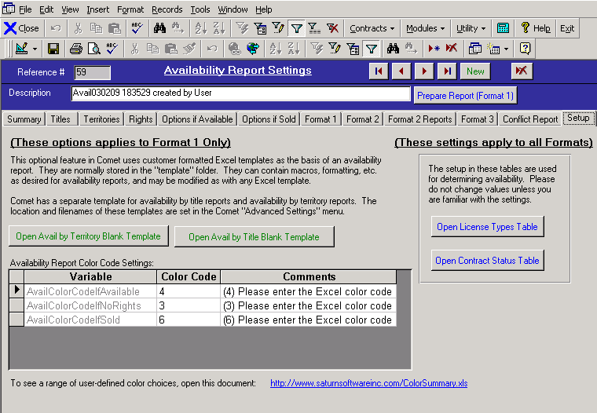

**2003-March-04**

* When clicking on “Open title” button in servicing area when on an episode, Comet will open linked episode (if one exists) instead of previous versions which just opened series.
* Extensive additional support for loan item servicing and bicycling added to Comet servicing module.
* Re-design of Comet Title Inventory screen.

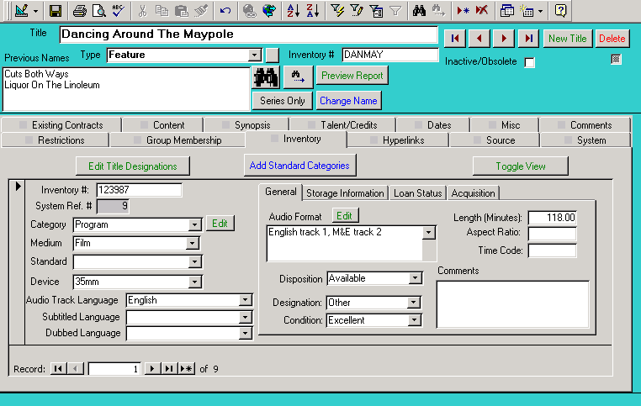

* Inventory information broken down into sections

This section contains audio format and length information as shown

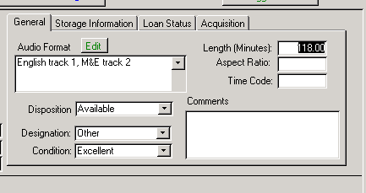

*The “Storage Information” tab shows the location of the title if it is in possession of the licensor. This section is not used if a tape is on loan.*

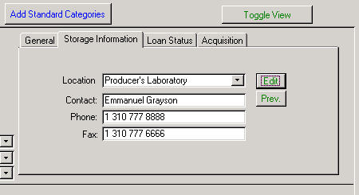

*The “Storage Information” tab shows the location of the title if it is in possession of the licensor. This section is not used if a tape is on loan.*

* *If a tape is on loan for a Comet dub order, the dub order number is added automatically when creating the dub order and selecting the dub*
* *The Loan Due date and loan information is shown as well, and automatically updated when either selected as a loan item, or returned.*
* *The “Mark as Returned” button will automatically update the loan information screen, and update the loan return information in the tape request order in the servicing screen.*
* *The Loan History will show a list of all instances the tape was loaned out, including contract numbers, customer names, and dates of loan.*

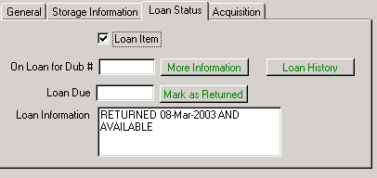

The Acquisition tab shows when the title version was expected from the producer, and a new “loan-in” function if it is on loan.

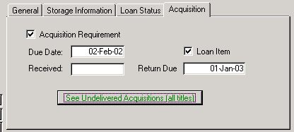

In Comet contract servicing module, selecting a master with a “Loan” checkbox will cause the automatic text creation to use the specs of the original loan item, not the format requested by the customer. Also, the description will show “LOAN ITEM” and set the price charged to be zero.

A loan tape can be used as a master to create dubs by un-checking the “Loan” checkbox next to the “toggle View” screen and re-constructing the text.

When pressing on the Close and Write button, if the “Loan” checkbox is checked, Comet will write “Loan Item-no dub required” into the Dub Instructions box in the servicing area. This note will appear in the lab order.

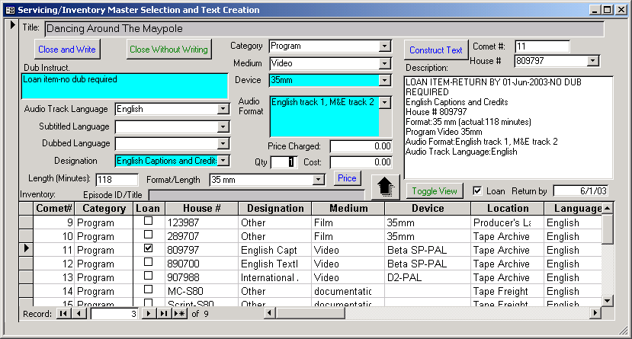

Scrolling to the right of the inventory selection screen, Comet shows the status of all loan items and the return dates.

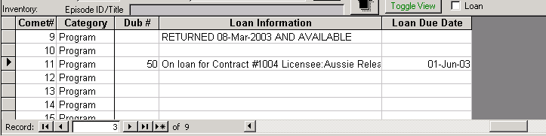

*When selecting a loan item, Comet will prompt the user for the loan date. This information is updated into the Title Inventory screen in the “Loan Item” tab*.

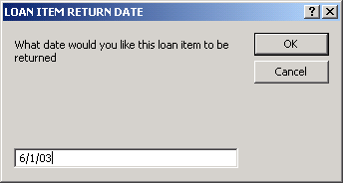

If entering a value in the “Date Returned” field, the title inventory loan information will be updated as well.

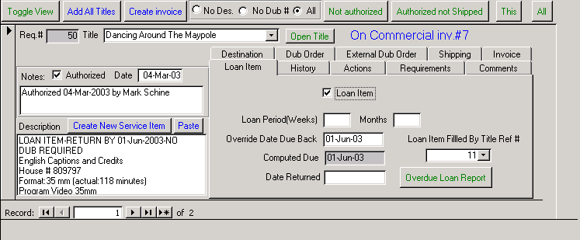

* (SQL Only) when deleting territories, Comet will delete all uses of territory in system. Some tables, including Sales Interest tracking and Licensing Entities, will cause the territory value to be deleted, instead of the record deleted. All related territory information deleted. Previous version required manual deletion.
* (SQL Only) Comet retroactively removes information related to deleted territories from all contracts in the SQL update script. To prevent this deletion, remove the DELETE queries in Sequence 14930 in the update script.

**2003-02-21 04:45**

* When Comet looks up the default licensing entity ID, if there was no entity checked off as the “default”, Comet would use the earliest entered ID. Comet has been modified to use the most recently entered ID instead.
* Availability report Format 2 reports have a “Licensing Entity” pull down box next to the “Prepare Data” button. The reports will show the selected licensing entity company name and logo on the report.
* Comet sets the licensing entity for the availability reports as the default licensing entity.
* The contract “Entry Complete” status checkbox in the contract summary not read-only
* (SQL users only) Cash Flow Report #202-problem running report causing popup box with ODBC message “This field too small” fixed.

**2003-02-18**

* New report #205, “Exchange Rates as of Date Entered”, shows an exchange rate table as of any date 1994-present.
* New Report #204, Key Contract Dates shows delivery requirements, execution dates, contract dates, delivery dates, etc.
* Contract Data entry complete checkbox moved to Summary tab in contract entry.
* Cash Flow report #202 now completed. For more information, including sample reports and a training guide, see

<http://www.saturnsoftwareinc.com/CometTrainingGuide/CashFlow/CometCashFlowForecasting.doc>

**2003-02-14 17:33**

* Format 2 availability reports showed a popup message. Problem fixed in this download.

**2003-02-13**

* Some availability reports did not show voided contracts. Problem resolved in this version.

**2003-02-12 07:19**

* Binocular buttons on pricing module search specifically for title.
* Availability reports have option to filter report settings to current user’s reports or show all reports. Comet will default to all user’s reports when opened.
* Report 77 does not show “$” prefix for report grand total
* Report #33 Contracts by Title has checkbox option to include third party contracts
* Report 65, “Overdue Loan Items” now available from servicing tab-loan items sub-tab
* Comet “Fast Load” advanced setting set to “true” due to improvements in code. This setting skips re-connection of tables during each load.
* Variable “AskToClearTabColors” set to “NO” to prevent asking uses to clear tab colors. Users may switch to “YES” if this method preferred.
* Variable “LaunchActUsingActEXE” set to “YES” for faster and more reliable launching of ACT (if using ACT).
* Availability reports have option to check all territories added, or uncheck all of them.
* System Filtering button added to interest tracking "Reports and Setup" tab
* Availability report tabs re-ordered so that “Format 1” tab is after format 1 settings.
* Comet will show “AVAILABLE” instead of “AVAIL”
* Comet will use 5 dashes in availability report cell heading instead of 2 (“-----SOLD-----“ instead of “—SOLD—“ except with simple client avail, where Comet will show “SOLD” without the dashes.
* If running an avail report for a high level territory, and some sub-territories are excluded, Comet will show “No Rights/Exclusions” and will be considered not available, since the entire territory is not available. Previous Comet version used to show “Available” under these circumstances, since some sub-territories were available. For example, if you have acquired The World excluding France, and run an availability report for “Western Europe”, Comet will show “No Rights/Exclusions” instead of “Available” since the entire Western Europe is not available for sale.
* Improved layout, accuracy, and readability of availability reports with respect to language rights acquired, sold and available.

**2003-02-03 13:46**

* Availability reports have an option to sort the titles by
  + Title Name
  + Year of Production
  + Genre
  + Title Type
  + Copyright Holder
  + Distributing For
  + Program Format
  + Completion Status
  + First Available

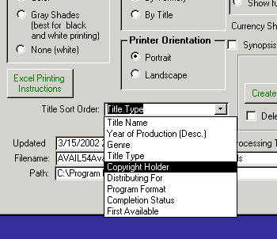

* (SQL only) Availability reports memorize NT login name of user in “Created By” field.
* The speed of availability reports has been increased, especially in less-than-optimum network or server environments.
* When requesting execution date to show in availability reports, Comet shows "EXE:" instead of "ED:
* When re-opening an existing report, Comet will check to see if the file exists before opening Excel. If not, Comet will prompt the user to create the report.
* After the Availability report data is refreshed, Comet will set the checkbox "Don't ask to refresh data" to true, so users will not keep getting asked. When availability report screen closed, Comet will uncheck the box, and users will be prompted again.
* The term of a copyright has been extended Congress and approved by the U.S. supreme court to 95 years for corporate-owned copyrighted material including films, and 70 years past the death of the creator for individual creative works such as books and music. Some reports will show license periods computed to be beyond 100 years as “perpetuity”. For more information see <http://www.guardian.co.uk/uslatest/story/0,1282,-2324588,00.html>
* Report #74 should have much improved speed.
* Preliminary version of Cash Flow report, with limited reporting capability, included as report #203. Does not include un-invoiced license fees.

**2003-01-27 02:53**

* Problem fixed where, if changing the contract exchange rate and immediately updating title license fees, the base currency license fee amount was incorrect. An exception report (#203-Execution Rate Discrepancy Report) shows contracts where this problem occurs. Solution is to go into contract and re-enter contract execution rate (no need to change rate). The execution rate invoice amounts for all related invoices will be corrected as well when the exchange rate is updated.
* Reports 73 and 74, “Rights and Windows by Territory”, should print faster and not freeze as reported by some users.
* Adding to interest tracking is faster due to improved interest tracking log speed.
* Screen update problem fixed with interest tracking, where screen would shimmer when scrolling from record to record.
* Problem fixed where, in interest tracking, when updating the “interested” column, the log entry would show “informed” action.
* Accounting interface tentative values rounded to closest penny.

**2003-01-14 09:09**

* Problem fixed when filtering contracts to a type with no records (i.e. selecting 3rd Party Contracts when there are none) and then adding a new contract, Comet would popup box “Expression has no value”.
* New option to show logo on Multi-title invoice in licensing entity setup



**2003-01-09 13:27**

* Problem fixed deleting receipts using the “Delete Receipt and Applications” button in the actions tab.
* New option to open contract while in Contract Invoicing by double-clicking on the contract number.
* New interest tracking report, available from the Interest Tracking Reports tab, “Interest by Territory by Customer” shows sales interest in each territory grouped by customer, listing each title of interest.
* When issuing a credit memo, Comet prompts the user for the credit memo date instead of using the original invoice date. The credit memo “due date” is still the original invoice due date.
* Comet supports two events and a date entry for determining the license period at the contract level or right category level. Shown is the modified entry screen:

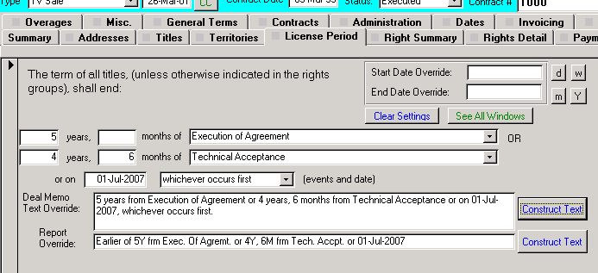

* Other modules of Comet modified to incorporate extra license term event, including availability date calculations, global event management, text construction.
* For underlying rights/production contracts, Comet has a new date that may be entered in the license term “Sales Period Expiration”, defined as the date by which sales contracts must be executed as per agreement with the underlying rights source. The licensed right term may extend beyond this date.



* Invoice aging reports #186 and #187 have option to show or hide invoices not yet due, which mean the due date is in the future, or blank. Invoice aging report #1 shows the “not due” column.
* Report #186, Invoice Aging in contract currency, shows 2 decimal places. Report #197, Invoice Aging at invoice rate is rounded to whole number since values are based on conversion to base currency using invoice exchange rate.
* When creating an invoice pay to address in bank account setup, Comet will fill in the following “merge” fields as shown.
  + <<Description>> Comet will fill in the first 40 characters of the invoice description in this field
  + <<Invoice Number>> Comet will replace this value with the invoice number
  + <<From>> Comet will fill in this value the customer company name for the contract being invoiced.

For example, you can set up an invoice pay to account in the bank account setup screen as:

City National

Account #324234

From:<<From>>

Invoice #:<<Invoice Number>>

Description:<<Description>>

When Comet prints the invoice, the values will be filled in based on the values for the invoice being printed.

**Comet Change Log 2002**

<http://www.saturnsoftwareinc.com/CometChangeLog2002.doc>

**Comet Change Log 1998-2001**

<http://www.saturnsoftwareinc.com/CometChangeLog1998Through2001.doc>