Comet Change Log 2002

**For 2003 Change log see**

<http://www.saturnsoftwareinc.com/CometSupportFiles/CometChangeLog2003.doc>

**2002-12-12 17:27**

* When entering address in the Company Profile area, after entering the e-mail address, Comet will fill in the pulldown address and move the focus to the top of the screen.
* New report #201, “Contracts with incorrect Right Allocation”, shows all contracts where rights allocation is blank, zero, or not 100%. Important for new revenue recognition reports, which depend on availability by right category.
* Report 194, Revenue, has option to show summary amounts by title and by quarter.
* Comet will show any logo file as entered into the advanced setting variable “FilenameExtensionOfSplashScreenGraphic” as the splash screen background. The variable “UseLicenseeLogoAsSplashBackground” must be set to “Yes” as well. This replaces the automatic use of any file named “Splash.bmp”. However, when the variable is initially set, Comet will look to see if “Splash.bmp” file exists, and make this entry when the variable is created. If not, Comet will use the default company logo file.
* Modules->Setup menu re-configured. New menu choice “Options” changes the following settings
  + Default method of searching for values (i.e. Start of field, Entire field, etc.)
  + ODBC timeout settings for extremely slow networks
  + Colors, fonts, and background of datasheet views
  + Print margins
  + Hyperlink colors
  + Text editing behavior, arrow key behavior editing text
* Popup-error message fixed adding items to the dub order from the dub order screen.

**2002-12-04 10:57**

* (SQL Only) when checking off or clearing the “recognize revenue” checkbox, Comet creates an entry into the audit trail.
* “Update Description” button in Comet renamed to “Import from ACT”.
* When adding new contracts, an empty payment term window is created to avoid problems caused by having a blank record in the window.
* Toggle view in system wide invoice creation has improved formatting
* Report #184, “Unrecognized Income by Title”, now available to non-SQL users
* Button to open report 184, “Unrecognized Income by Title” is on the accounting interface splash screen.
* (Accounting Interface) When posting items that lookup the Title Code, and the code has not been entered, Comet will prompt the user for the code and update the title setup screen for all future lookups. This avoids null title codes.
* Performance improvements to numerous Comet functions, due to improvement to generic Comet function.
  + Manual add to dub order
  + Adding compiled tape number
  + Adding items to commercial invoice, materials invoice, and dub order
  + Accounting Interface update of title code (if blank and prompted by Comet)
  + Adding all titles to the servicing area
* Comet allows creating and printing zero-value invoices from most screens (with warning and prompt to cancel)
* When looking at the contracts within an invoice, the Invoice date, Due date, and Invoice Description may be edited from this screen.
* Opening Contract Status setup table opens up formatted query instead of table for easier editing and viewing.
* Improved formatting in invoice and payment import screen (Column alignments, positioning, horizontal scrolling)
* If using ACT, Comet automatically sets the location of the ACT Exe file, and uses an improved method of launching ACT.
* The Company profile address screen has a new option to construct the address pulldown description from the data entry into the parsed fields on the bottom of the screen.
* In the Company profile, if ACT is not being used, the “Import from ACT” button is hidden.
* When entering a new address in the Company profile, tabbing improved. New record button sets focus to bottom portion of screen where parsed address information can be entered.
* Dutch and Flemish (a dialect of Dutch) are generally considered the same language for the purposes of theatrical and television licensing. Some reports and filters in Comet are language specific, and will not show the desired results if contracts are entered with only Dutch or Flemish. This version of Comet will, as a solution, create a new language called 'Dutch/Flemish' and modify all existing contracts so that entries of Dutch and/or Flemish and/or “Flemish or Dutch” will be converted to “Dutch/Flemish”. This conversion can be performed at any time in the 'Updates and Patches' screen of Comet. For more information on this issue, see

<http://www.bbc.co.uk/languages/european_languages/languages/flemish.shtml>

<http://www.bbc.co.uk/languages/european_languages/languages/dutch.shtml>

<http://www.bbc.co.uk/languages/yoursay/200506/594.shtml>

<https://www.cia.gov/library/publications/the-world-factbook/fields/2098.html>

* Comet has improved handling of single-language territories. It is now possible to designate territories as language territories, but specify their relationships as normal territories. For example, the territory “French-Speaking Europe” may be set up in this way, without the need to re-define the relationships or set up a “special language” territory.
  + The territory input screen allows entering a language filter without requiring that the territory is a language based territory.
  + An error message banner appears if the entry is incomplete
  + The availability reports will provide a detailed error message if running incorrectly entered availability reports.
  + Unneeded fields and objects are hidden when working with a special language territory.
* Report #116, “Underlying Rights Summary by Title”, has option to show detailed rights and exclusions
* There is a new option to enable or disable the capability of entering fixed payments in the payment terms screen. Option set by default to disable entry of fixed payments. May be re-enabled by setting the advanced server setting “EnableFixedPaymentEntryInPaymentTerms” to “YES”.
* This version contains numerous improvements to the entry of sales commissions. The total commission amount is now shown in the first column. There is improved ease of entry and scrolling.

The following text has been added to the commission entry screen:

**“The second column (retained commission) represents the commission you will receive as a percent of the total applicable sales. The first column (Total Commission) is the total of the retained commission plus the commission paid to participant 1 and participant 2. The Total Commission is the amount selected and entered in license contracts.“**

As an example, the first row shown in the screen below shows that you are entitled to receive a total 30% commission on sales, but have split the commission so that, of the gross sales you receive only 14%, and “Conquest Productions” receives 7%, and “Titan Video” receives 9%. The total commission amount adds up to 30%, which is the number entered into sales contracts and the amount shown in the first column.

**Shown is the upgraded screen:**

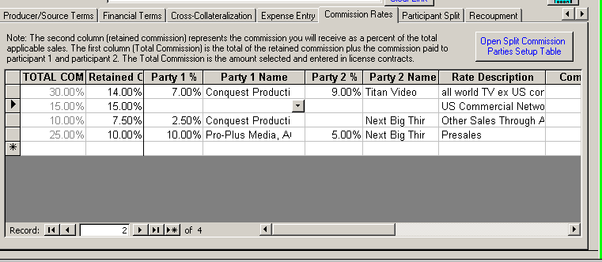

**When entering the commission in a new contract, the total amount will be available as shown:**

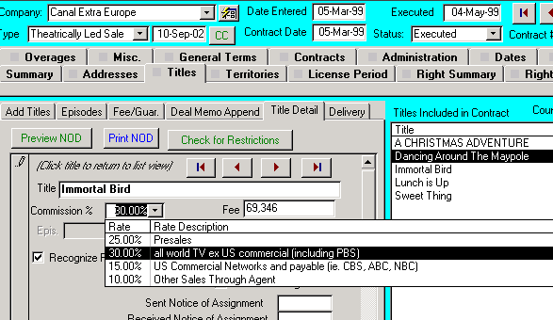

* In the Comet Territory setup screen, there is a territory search button available next to the territory name.
* Popup-message bug fixed when printing deal memos without a contract open after being prompted for the contract number
* The underlying rights contracts now show the disposition terms and cross-collateralization terms.
* When printing the territory report from the territory setup screen, Comet prompts to show a report with more relationship detail.

**2002-11-13 03:48**

* Report #103 has three variations
  + 103a is detailed title information. New fields have been added to this report, as well as a much more detailed underlying rights area
  + 103b is condensed acquisition report
  + 103c is condensed acquisition report with combined territories, rights, and exclusions
* Report 187, “Itemized Invoice Aging Report in Foreign Currency” has sub-totals by customer. Despite the amounts added up are in foreign currency values, the same customer typically uses the same contract currency, so there is a low probability of adding mixed currencies.
* Global filter screen is grouped to show which items will filter as expected.
  + Items in the yellow section will work for any report and screen
  + Items in the blue section will generally work if the field being filtered is visible in the report
  + Items in the magenta section are active only for financial reports showing invoices or payments.
* Report #33, Contracts by Title, Selected Title, will filter to any item in the blue (and yellow) section of the global filter.
* The invoice pay-to account setup screen is fitted to 800x600
* Fix to popup address message in servicing dub order, detailed version and materials invoice summary.

**2002-11-11 03:36**

* When using the internal address format, and adding all titles in the servicing area, and the contract servicing address is not one of the company profile addresses, Comet will prompt to add the address to the contract company profile address list, and then switch the contract servicing address to this new address ID link.

**2002-11-05 11:55**

* Territory allocation percent entry, insurance and handling percent entry now convert numbers entered greater than or equal to 1 as percentages by dividing entry by 100. Numbers entered below 1 are not adjusted.
* Report 158, “Contracts by Customer, all Customers with Contract” has option to include voided contracts
* Report 187, “Itemized Invoice Aging Report in Foreign Currency” has option to show invoices with no due date in the “No Date” aging column instead of in the “0-30” day column.
* Report 186, “Itemized Invoice Aging-Base Currency Invoice Rate” and 187, “Itemized Invoice Aging Report in Foreign Currency” when selecting query output has improved formatted output with user-friendly column headings and number/date formats.
* New report added #200 “Rights and Windows by Related Territory+Exclusions” is based on Report #73, with base currency, that also shows exclusions for the title and territory shown.

**2002-10-23 16:18 “b” release (XP only for this version, all versions for next release)**

* Availability report format 2, by territory portrait, synopsis does not carry over into the next column, and rights start at same level as title.

**2002-10-23 16:18**

* When not using ACT, Comet no longer confirms if ACT database files are present.
* Comet checks that availability report template exists prior to creating the report to avoid cryptic Excel error message if the template is missing or not in the location as set up in the advanced settings.
* Significant speed improvement for tab to tab movement in contracts.
* Improved speed in availability report ‘refresh” process, increasing speed by 30%
* In contract summary tab when looking at contract view, Comet will only show rights where there are sold rights as defined in the License Type table. Comet previously showed right categories where there were only holdbacks. Same change for the list of contracts for a title in the Title Setup screen.

**2002-10-11 08:48**

* Problem looking up addresses in internal format fixed.

**2002-10-08 03:22**

* Availability Report format #2 has an option to print in portrait for all variations.
* In territory group setup, Comet checks to see if territory exists before renaming. In SQL version, list of territories included in original name now copied to new name.
* When in full ACT mode (Using ACT and ACT is the primary address database), if when printing invoices for contracts where the addresses were not entered, Comet will look to the Company Profile invoice or contract address instead. This feature was already active when using the internal address feature.
* In report 172, Unpaid Invoice Summary, last column heading “Due” changed to “Balance”
* Reports 88 and 172 show full invoice description instead of being truncated at 255 characters.
* **On report 88, the invoice number field was widened and word wrap activated**
* Previously, Comet only showed the first 255 characters of the invoice description on reports 88 and 172. Comet now shows all of the invoice description text. It was previously truncating the text at 255 characters.
* ON reports 88 and 172, **The "Due" heading was changed to "Balance"**
* New to this version is the option to select the row and delete the application.   
  (SQL version only): Comet will make an entry to the change log for the contract. This option requires that you have permission to make edits to the application table. If you try to delete an application this way and do not have delete permission on the application table, you will receive an ODBC permission error message and nothing will be deleted.

**2002-10-01**

* In Title setup screen, under “Source” tab, new field added called “Title Completion Status”. Field shows up as an option in availability report #2.
* New report #199, “Contracts by Title with Payment Terms Excludes (materials invoices), similar to report #32 with payment terms. Requires 8.5’’x14’’ legal size paper.
* Availability report format #2 has option to show “theatrical” format, which includes the synopsis and title completion status in the reports. Default is TV format.

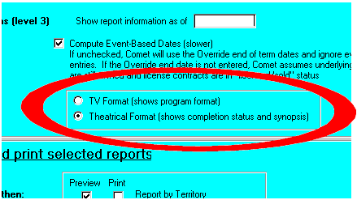

* Shown is where the “completion Status” is entered in the title setup.

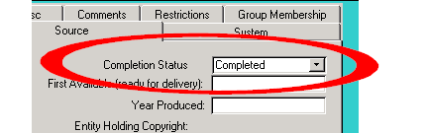

**2002-09-29**

* Comet Invoice and Payment Balance Adjustment screen shows the customer name.
* Improved logic in Report 88 and collection letter.

###### 2002-09-23 20:00b/c version (slip version may be used with 2002-09-23 20:00 version)

* When importing ACT addresses, truncates unusually long values to avoid “field size too large” error message.
* Heading in title setup “First Available Date (Product Complete) changed to “First Available Date (ready to deliver).
* Some customers interpret Notice of Availability as a notice when the rights are available by customer to exploit. Others interpret it as a Notice of Availability to Deliver title, which is synonymous with Notice of Delivery. A new event called "Notice of Availability to Deliver" may now be used which will be computed by Comet as the “Notice of Delivery”.
* C version fixes problem in SQL version only during one-time import of ACT database names when links cannot be found.

###### 2002-09-23 20:00

**I. Significant Change to Address Functions:**

This version of Comet has a new capability of using an internal address database, integrated with the main Comet data files, or ACT, or a both with automatic integration. It is entirely possible to perform functions which previously required ACT installed and no longer do, such as printing invoices, deal memos, and collection reports.

This update will import all ACT addresses into the Company Profile automatically, a process which will take between 10 minutes and 2 hours.

Comet has a new Advanced setting, “AddressStorageMethod”. It can either be set to “ACT”, “INTERNAL”, or OUTLOOK.

Comet has four basic configurations of address:

1. *ACT! Only*
2. *Internal Only*
3. *Mixed ACT and internal*
4. *Automatic fallback to the internal address book.*
5. *ACT Only*

In the ACT! Only setting, Comet will function as it has previously. When Comet needs to lookup an address, it will open ACT and request the address fields needed from ACT. In this mode, Comet will also look to the internal address record if the address cannot be obtained from ACT!

The “Using ACT” checkbox must be checked during the startup, and the “AddressStorageMethod” parameter must be set to “ACT”.

In this mode, the Internal Address storage is populated while ACT is being used as normal.

1. *Internal Only*

Comet has a new internal address functionality to store and hold unlimited addresses linked to each customer in the Company Profile. The Comet company profile holds:

* Contact Name
* Contact Title
* Customer Company Name
* Customer Address
* Customer Phone
* Customer Fax
* Customer E-mail.

These addresses are linked from the Contract Address section using pull-downs. However, if the addresses are not linked, Comet will look to the customer setup to determine if an address is set up there for the desired address. Therefore, it is not necessary to link addresses in a contract if the customer profile screen is populated.

The “Set to Default” functionality still works.

The “Using ACT” checkbox must be UN-checked during the startup, and the “AddressStorageMethod” parameter must be set to “INTERNAL”.

1. Mixed ACT and Internal

In this configuration, it is possible for some users to use ACT, and other users to lookup addresses from the internal address database without having ACT installed. This is because the internal addresses are maintained while using ACT functions.

This configuration allows printing deal memos, notices, invoices, and reports that require addresses without using ACT. This configuration is ideal for users who either don’t have ACT installed, or who are using Comet through TCP/IP or a slow VPN or dial-up without file server access. In

For the users using ACT in this configuration, the “Using ACT” checkbox may be checked or unchecked during the startup, and the “AddressStorageMethod” parameter must be set to “INTERNAL”.

1. Automatic fallback to the internal address book.

In the event a user does not have Access to ACT, ACT will set the address mode to use the internal address, even if the “AddressStorageMethod” is set to “ACT”. Users with ACT will have standard ACT integration, users without ACT will still be able to have access to addresses.

##### **II. New ACT! 6.0 Release**

* Comet has been tested with the just-released ACT! 6.0, and found to work without modification. There is no need to upgrade Comet for the same level of ACT! integration as with ACT! 2000 Release 5.04. For more information, see:
* <http://www.saturnsoftwareinc.com/documents/ACT_6.0_New_Features.pdf>
* <http://www.act.com/upgrade>
* <http://www.act.com/news/press/index.cfm>

**III. Other Address management changes:**

***Company Profile:***

* The Company Profile has a “Notices/NOD” default address checkbox. In the Contract Address section, when pressing the “Auto-set Addresses from Company Profile” button, the Notice/NOD address is set.

***Reports using Addresses:***

* If the invoice address is not linked in reports 172 88, 51 (Customer invoice statements) Comet will use the contract address instead.
* Report #51 “Invoice Statement By Customer” and report #172, “Invoice Statement By Customer-Foreign Amounts” typically had multiple invoices with potentially different addresses. These reports now lookup the address for the most recent invoice in the report.
* Report #51 “Invoice Statement By Customer” and report #172, “Invoice Statement By Customer-Foreign Amounts” lookup the addresses prior to printing the report, and store the values in a local table. The reports may be scrolled and printed much faster without the need to lookup the address for each page.
* Report #88 has an option to print collection cover letters based on a user-defined template.
* Reports 26 and 27, “Contracts by Customer with Rights”, do not include “All Customers” in the title due to filtering options. Also, possibility for situation where contract shown twice in same report fixed.
* The Comet standard deal memo’s only show, for the licensee address, the
  + Company name
  + Address
  + Phone number
  + Fax number
  + The contact name, title, and e-mail address does not appear.

IV. New feature to print payment reminder (collection) letters automatically for customers with unpaid invoices.

* When printing Report #88, “Statement of Unpaid Invoices-All Customers”, Comet has a checkbox option to print a user defined collection letter, addressed to the invoice address for each customer.
* The collection letters merge the date and address with user specified language based on the additional term “Collection_Letter_Body” as shown in the illustration below.
* Comet will prompt to provide for the customers all of the addresses of the customers with outstanding invoices in a datasheet view which can be exported to Excel or Word for printing the envelopes used to send the customer statements and collection letters, or for general mail-merge purposes.

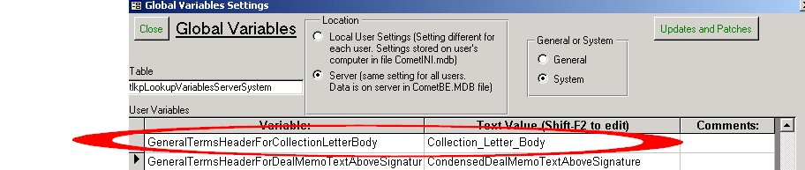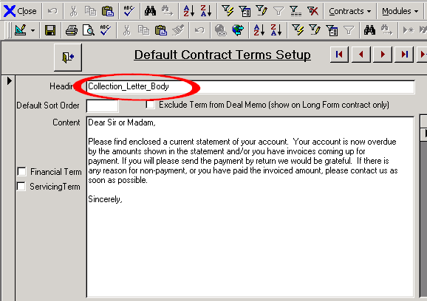

**V. Accounting Interface:**

* The Comet accounting interface checks to see if records exist before prompting to delete tentative postings and journal entries, reducing the number of popup boxes. Improvements in message clarity.
* Popup message in Company Profile, Update Description button fixed.

**VI. Currency Rates:**

* In Updates and Patches screen, Comet allows changing the base currency of the exchange rate table. This allows users to have the same base rate for the exchange rate table as for the Comet system, or use internal or official rates entered manually.
* Comet allows importing of the Saturn provided exchange rates, which have a US Base currency, into a Comet exchange rate table with a non-US base currency. Comet imports and makes the necessary rate conversions automatically.

**VII. Misc. bug fixes:**

* (SQL Only) Comet was intended to show non-standard event types with yellow background, programmed events with white background. Comet would show all events as non-standard (with yellow background) in some instances. Code modified to correct this.

**VIII. Availability Reports:**

* Headers shown for Title, Territory and “Synopsis”

**2002-08-19 01:27**

* Report #51, “Unpaid Invoices Summary” (base currency shown), removes the contract currency column and extends the description. Similar report #172, “Unpaid Invoices Summary” (foreign currency shown) shows the invoice currency instead of the Contract currency.
* Report 88, “Statement of Unpaid Invoices-All Customers” now has checkbox option to include customer address. Page numbers removed, since report is for customer presentation.

**2002-08-12b 19:55**

* Office 2000 release had incorrect unzip folder destination, re-released. Unzip destination should be “C:\Program files\Comet” instead of “C”

**2002-08-12 19:55**

* Performance improvement of invoice and amount paid adjustment screen
* On cash receipts screen, “Gross Receipt (Including VAT)” caption changed to “Deposit + Bank Charges (Incl. VAT)” for better clarity.
* Report #130, “Missing VAT information report”, also available from the Client setup, “Tax/Misc.” tab, re-formatted with pulldown fields for the territories. Also filters the report based on whether the “UseVATCountrytoDetermineVATStatus” is set to No or YES in advanced settings.
  + If “UseVATCountrytoDetermineVATStatus”=NO, Comet shows all customers where the VAT status has not been set, or where it has been set, to status “Report Cust. ID Only” and the Customer VAT information has not been entered. New button to set all blank VAT status to “Not Applicable”.
  + If “UseVATCountrytoDetermineVATStatus”=YES, Comet shows all customers where the VAT Country has not been entered.

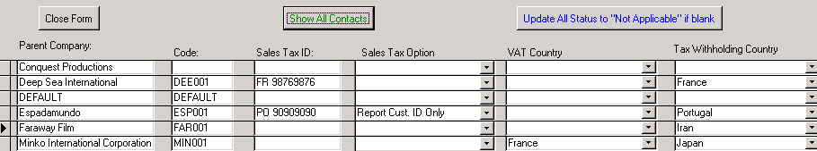

* Advanced Settings window cosmetic changes with selecting Local or Server settings. Comet switches to default System or General setting based on Local or Server selection.
* The Invoice View screen, available from Advanced Settings, Updates and Patches now has calc button to update base currency amounts.
* Comet allows changing the Contract exchange rate, or Contract currency country, even if invoices have been created or paid. Comet adjusts the Contract Currency and application of payment amounts so that the base currency application amounts are adjusted to match the adjusted invoices and license fee amounts. Note that previously reported amounts based on the base currency values will be different after these actions.

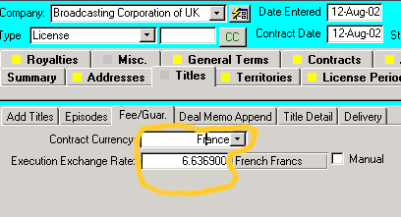

* Comet allows deleting of receipt applications to invoice records, and will log the action to the activity log (SQL users only). Deletion available from the “Actions” tab in the Receipts screen.
* Comet has new button in Updates and Patches screen, to view and fix invoices and/or applications of receipts which have incorrect base currency amounts due to changes in contract currency or contract exchange rates after invoices or payments have been applied. Comet prompts to print report prior to making changes. Comet performs this scan when performing an update on any version prior to 2002-Aug-12 and provides a report without making any changes to the data.
* The "Invoice View" screen, also available from the Updates and Patches screen has buttons to automatically adjust incorrect invoice amounts.
* Report 189 "Contracts by Customer showing Payment Information" has checkbox option to only include customers with unpaid invoices. Title shows “Contracts by Customer-Customers with Unpaid Fees or Invoices”. This filter extended to exclude voided contracts and include contracts for customers who have unbilled license fees, even if all invoices issued have been paid.

**2002-08-06 19:16**

* Cosmetic changes made to the entry of VAT information in the Company profile section. Fields moved around, aligned.
* Accounting interface improvements:

o Comet will prompt for deleting the tentative postings and journal entries separately. Previously, Comet would automatically delete the tentative postings and prompt to delete the journal postings. At some point, when you are completely comfortable with the interface, we can set the security on the output journal table so that no changes may be made once a transaction is posted. This is now possible since reversals are quite easy.

* + If a transaction is re-posted, Comet will not re-post tentative postings already posted. Therefore, when the "Create Tentative Postings" button is pressed, the original tentative postings may be left there, since they will never create new journal entries. This is because Comet checks to see if a journal entry has been created prior to creating a new one.

* + To adjust a transaction, manual entries may be made to the tentative posting area, and the entire transaction re-posted. Only the new entries will cause the creation of journal entries. These adjustments can include reversal of some or all of the previously posted items.

o Comet will not post to the Journal negative debit/credit entries. Instead, Comet will take the tentative posting value of debit minus credit and post positive values as debits, and negative values will be posted as a positive credit value. However, the tentative postings may hold negative values for easy screen identification of reversals and/or adjustments.

* + Comet will re-open the accounting interface popup menu when an accounting interface form is closed.

# Comet Invoice and Amount Paid Adjustment/Import Screen

1. **Overview:**

This module allows for the straightforward import of total amounts invoiced and total amounts paid for each title in a contract. It also allows adjusting existing balances. Comet will create new invoices, credit memos, and receipts as necessary, and provide all of the necessary linking, so that the ending balance in Comet equals the new amount entered in the Updated Value columns for invoiced amounts and paid amounts..

1. **How to open the screen:**
   1. From the Comet menu, select Modules->Setup->Advanced Settings
   2. Click on the “Updates and Patches” button.

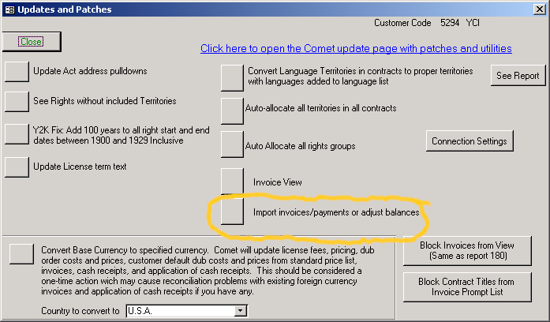

Click on the button Import invoices/payments or adjust balances. The following screen will open up.

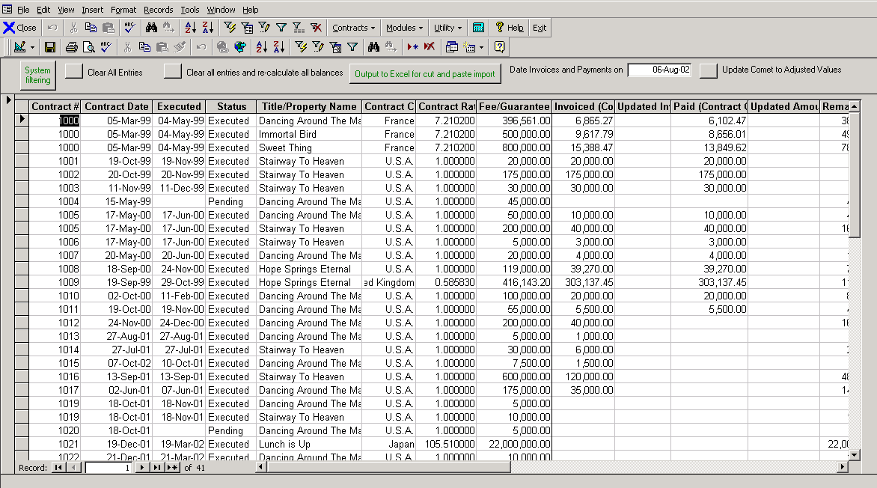

To view current invoice balance amounts, click on the button “



This will populate the table with the values as shown.

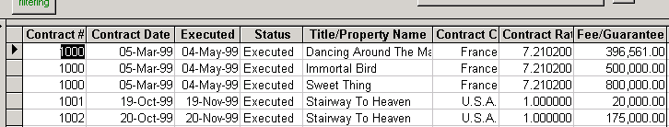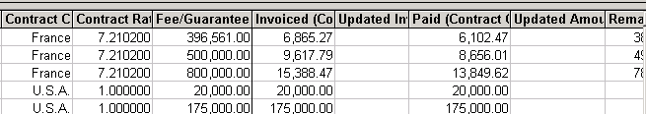

The columns shown are defined as follows:

|  |  |
| --- | --- |
| Contract Curr. | The contract currency, typically $USD or Euros but can be any currency. Invoices created for this contract will be generated in the contract currency. |
| Contract Rate | The fixed Contract Exchange rate, aka Execution Rate |
| Fee/Guarantee (Contract Currency) | The License fee for the title (In the contract currency). |
| Invoiced (Contract Currency): | The amount invoiced in the contract currency. This amount only includes license fee invoices. |
| Updated Invoiced Amount (Contract Currency): | Enter a new amount here in the contract currency. Comet will create a new invoice or credit memo to adjust the amount invoiced to the amount entered. |
| Paid (Contract Currency): | The computed amount paid for the title (in the contract currency). |
| Updated Amount Paid (Contract Currency): | Enter a new amount paid here. Comet will create a new cash receipt, and apply it to the existing invoices in the order of the due date or entry sequence if there is no due date. If the adjusted amount paid is greater than the invoiced amount, Comet will create an invoice so that the payment may be applied in full. |
| Remaining to Invoice | This is a computed amount of the un-invoiced amount (Contract currency). |
| Remaining to Receive | This is a computed amount of the unpaid license fee, not related to the invoiced amounts (Contract currency). |

# III. Running the update

When ready to perform the update, enter the date you wish the computer-generated transactions will have by entering a value in the date box.



Then press the Update button as shown:



and Comet will create transactions as entered.

# IV. Special Considerations

* If the new value column is left blank, Comet will not make a change. The one exception is when the payment amount exceeds the invoiced amount, when Comet will create an invoice so that the total amount invoiced equals the total amounts paid.
* Click on the ‘Export to Excel” to work with the values in Excel. You may cut and paste columns back into Comet and then perform the update.
* The amounts shown in the table are temporary local user values, and are not saved to the main database tables until the “Update Comet to Adjusted Values” button is pressed. If performing a Comet update before pressing the Update button, the values entered will be deleted and must be re-entered.

**2002-07-29 06:44**

* (Standard invoice format) If there is no due date for the invoice, Comet used to use the invoice date as the due date. Comet will show a blank field if there is no due date. Note that the due date is typically in the invoice description text.
* This update converts language territories entered into exclusions to the proper territory and the language of the territory. For example, an exclusion entered as “Belgium French” with a no language exclusion would be converted to “Belgium” with “French” in the language field.
* “Clear Amounts” button in Receipts screen (in the “Calculations” tab) replaces the “Clear All” button and does not clear values on first page, or the payment currency or exchange rate.
* (bug fix) in Receipts Screen, Receipt Finder tab, values returned were fixed at receipts applied to invoice #22. Now fixed to use entered value.
* Some base data was released where “Congo, Republic of the (Zaire)” was set as a language based territory in error. This version clears the checkbox.
* (Harmless message box bug fixed) When moving into license term, leaving it blank, then moving to rights tab, harmless message box appeared. Problem fixed.
* (Report filter modification) Active Customer filter for report #89 “Contracts by Customer showing Payment Information” ignores unpaid materials invoices. If active customer checkbox is selected, Customer included in report only if unpaid license fees and/or overages invoices.

**2002-07-18 01:43**

* When opening the Company Profile, Comet sorts the records by company name.
* (Contract General Terms) Comet utilizes the default sort order when adding general terms to a contract.
* Print Preview available from system wide invoice creation popup window (unless requested to be hidden)

**2002-07-17 13:40**

* “Comments” column on Interest Tracking Report by Title and by Customer reports now word wrap for unlimited size comments
* Reports 189 and 32 and other “Contracts by Title (or Customer) have the NOD field width increased to not cut off the dates. Report 189 has a smaller left margin and wider Rights column.
* New “Inactive” checkbox added to bottom of Customer Profiles. May be used as future report filter criteria (to exclude inactive customers).
* Slight change to allocation calculation basis in report 195, “Allocated Receipt amounts by Title”. Previously, receipt amounts were allocated pro-rata by the value portion of the license fee. In the uncommon instance of a VAT-only receipt, with no invoice value portion applied, deductions including bank charges for that receipt would have a 0% allocation, causing a problem where the sum of the allocated receipt deductions did not match the total un-allocated deductions when reconciled. This issue was fixed by allocating the deductions based on the Value + VAT amounts applied, instead of just the Value. The new allocation % will be the same as the original allocation % unless a receipt was applied to VAT only, or to a mixture of VAT and Non-VAT invoices.
* (cosmetic fix) No overlap of “Not 100%” caption in payment terms with other caption.
* (Design change) Caption removed above Invoice Pay To Address, showing “Payable by wire transfer to:”. This caption was not in the “New VAT Universal” format. Add the caption to the invoice pay-to address in bank account setup screen at the top.
* New Bank Account setup screen. Available from menu:Modules->Setup->Bank Accounts. Replaces previous table view. Note new button “Prefix All Accounts with “Payable by wire transfer to:”” available to update all existing bank accounts

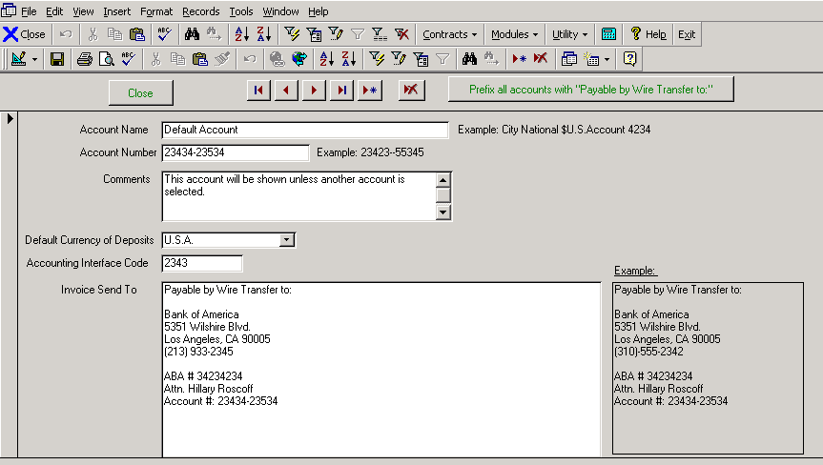

* Modifications to Report 194 , “Revenue Recognition by AICPA SOP 00-2”, now computes the end of the holdback period to determine the start of availability period, and uses modified logic. Shown is the logic used to determine the revenue start date and amounts.

#### Report 194, “Revenue Recognition by AICPA SOP 00-2”, logic

1. **Determine the NOD or Delivery Date, if any**

Comet checks to see if there is a delivery date for the title. Comet then checks for a NOD. If there is no NOD, but a delivery date is available, Comet will use the delivery date as the NOD date. If there is both an NOD and Delivery date, Comet uses the earlier of the two as the NOD date. If there is neither a NOD or Delivery data, no revenue is recognized.

# Find the Execution Date

Comet uses the earlier of the Deal Memo Signed date or Contract execution date. If neither is available, and the contract is set as “Executed”, Comet uses the earlier of the NOD date or Delivery Date as the Execution date.

# Find the Start of Availability Date

Comet only looks to non-void Executed contracts for delivery information.

Comet first checks to see if the right category is using the contract level start and end dates, as indicated by the “Use Contract default license period/term”. If so, since there are no holdbacks at the contract level, Comet looks to the override start date at the contract level. If there is one, this is considered the start of availability date. If not, Comet uses the Contract execution date as the first available date.

If the “Use Contract default license period/term” checkbox is unchecked, this activates holdbacks and start and end dates at the right category level. If there is an Override Start Date at the right category level, comet considers that date the first available date. If the “No holdback” checkbox is checked, Comet uses the contract execution date as the first available date. If there is a holdback entered, Comet will attempt to compute the end of holdback date using events as entered. If the end of holdback date is determined, Comet will use it. Otherwise, Comet will use the Contract execution date as the availability start date.

## Determination of the Revenue Recognition date

If there is a valid Start of Availability date (from section III) and there has been either NOD or Delivery from section I, Comet sets the revenue recognition date at the later of

* 1. The first available date from section III.
  2. The earlier of NOD or Delivery from section I

If there is a valid revenue recognition date, Comet will recognize the allocated license fee on the revenue recognition date.

# Special rights allocation adjustment for exclusions

Comet has a right category allocation %. There may be some situations where a title is excluded from the right category by using the “Included Titles” tab. If so, Comet will create an adjustment to the allocation pro-rata based on the allocation % for other rights so that the total allocation for the title will equal 100%.

For example, if the rights categories are entered as

Theatrical: 50%

Pay TV: 20%

### Free TV: 30%

Total: 100%

And the title is excluded from Pay TV, the adjusted allocation will be:

Theatrical: 62.5%

Pay TV: 0.0%

### Free TV: 37.5%

Total: 100%

* The revenue for overages supplement of report 194 now shows a Revenue Recognition date which is the end of the reporting period date if available, or if not the due date for the invoice created for the overage. An additional column showing the revenue recognition date in “Year-quarter” format has been added.
* Problem fixed in global system filter where, after filter applied, Comet would popup with input box and no contracts would appear.
* Report 189 "Contracts by Customer showing Payment Information" has checkbox option to only include customers with unpaid invoices. Title shows “Contracts by Customer-Customers with Unpaid Fees or Invoices”
* Report 32, "Contracts by Title, excluding materials" has option to only show titles with unpaid invoices. Title shows “Contracts by Title-Titles With Unpaid Fees or Invoices”
* General report screen only shows yellow filter area if filter options exists.
* Report 154 has improved message to prevent entry of start and end dates instead of receipt #’s.

**2002-07-08 09:33**

* On invoice print preview, Comet will not prompt to print sales and accounting copies.
* (Receipts screen) Foreign Currency VAT amount applied based on sum total of Foreign amounts applied instead of Base currency amounts multiplied by receipt exchange rate. Value shows if customer rate not entered.

**2002-07-08 02:18**

* New report #196 “Overage/Royalty invoices” lists “disposition” type invoices
* New report #197 “Overage Amounts and invoiced amounts” shows all overage amounts and how much has been invoiced
* (Improvement and fix) Comet converts the overage/royalty portion of the “License Fee + Overage” column in the listed reports to the base currency amount at the invoice exchange rate. If not invoiced, Comet uses the current exchange rate. If invoiced, and there is no Overage amount entered, Comet uses the Invoiced amount (base currency, invoice rate). If no Overage base currency entered, Comet assumes it is the system base currency.

|  |  |
| --- | --- |
| Report # | Report Name |
| 26 | Contracts by Customer with Rights-All Customers |
| 27 | Contracts by Customer with Rights-new page each |
| 28 | Contracts by Title |
| 30 | Contracts by Title with Deposit Information |
| 31 | Contracts by Title, All Titles with Contracts |
| 32 | Contracts by Title, excluding materials |
| 33 | Contracts by Title, Selected Title |
| 34 | Contracts by Title, selected, excluding Material |
| 158 | Contracts by Customer, all Customers with Contract |
| 171 | Contracts by Customer, Selected Customer |
| 189 | Contracts by Customer showing Payment Information |

* When printing report #194, “Revenue Recognition by AICPA SOP 00-2”, Comet prompts to print a report of overage amounts due by title and report period.

**2002-07-03 15:29**

* Possible issue where, upon previewing multi-title invoice, the reprint banner from the previous invoice would show “i.e. “*** Sales Copy ***” . Workaround is to press the “Print Invoice” button instead of printing from the print preview mode.
* Caption for “First Available:” date in title setup changed to

“First Available (completed product):” to avoid confusion with first license availability date.

* Report 194 , “Revenue Recognition by AICPA SOP 00-2”, has improved exception messages and contract entry status messages. Problem where revenue from sub-distribution contracts not being included fixed.
* New report 195, useful for showing payments over time periods allocated by title.

**2002-07-02 02:32**

* (New report) Report 194, “Revenue Recognition by AICPA SOP 00-2” (U.S. Revenue recognition rules, replacing FAS-53), report creates table showing revenue recognized with some modification according to SOP 00-2 standards, typically when product may be exploited and the materials have been delivered, or the product is available to deliver and a Notice of Delivery is issued. For more information on SOP 00-2, see

<http://www.nysscpa.org/cpajournal/2001/1000/features/f103201.htm>

<http://www.aicpa.org/members/div/acctstd/general/tpa1.htm>

Comet looks at the following information:

* + Title Completion Date (“First Available” field in title setup)
  + NOD date
  + Contract status
  + Contract type
  + Contract Execution date
  + Delivery date
  + Start of License Override date

To provide an estimate of the revenue start date. Comet then looks at the right category allocation and creates an allocation adjustment in the event the title is excluded from one or more rights groups.

* (Receipts) New method to re-open receipts by pressing button on receipt form next to close button. This button clears out “Date Closed” and re-enables entry.
* (Receipts) Receipt number may be searched for within calculations tab.
* (Receipts) “Update Historical” button, which fills in values for imported data, moved to “Actions” tab.
* (Receipts) Comet has new receipt search function. When entering an invoice number, Comet will list all receipts that were applied to that invoice. Double-clicking receipt number opens receipt.

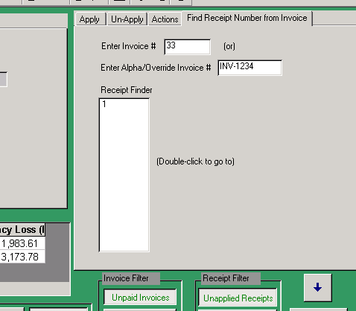

(Receipts) When a receipt is closed, Comet will allow users to search by and select most fields,

**2002-07-01 02:17**

* Notice of Delivery screen changed to “Notices and Delivery” since it contains more information.
* New system filter option on Contract numbers, to allow ranges and other standard filter criteria. Shown is global filter option:

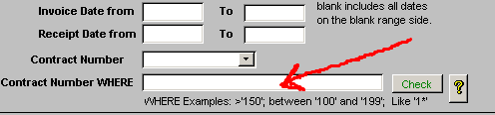

This field allows a user to specify an advanced filter criteria using standard SQL WHERE clauses for the Contract Number. Examples are:

= '100' [The contract number must equal 100]

>='100' [The contract number is greater than or equal to 100]

Like 'LC*' [Any contract starting with LC]

Like '100?' [Any contract with 100 plus any single character]

Between '100' and '199' [Any contract between 100 and 199 inclusive]

Note: You must use single or double quotes around the contract number and wildcard characters.

Pressing the “Check” button will check the validity of the WERE statement.

* (SQL Only-Accounting interface) default Permission on creating receipt postings was erroneously set to “No Permission”. Permission granted in this update.
* Column heads (headings) added to bank account pull downs in Cash receipts and Accounting Interface entry fields.
* Field now visible in Receipts screen to enter approved deduction account (optional entry)

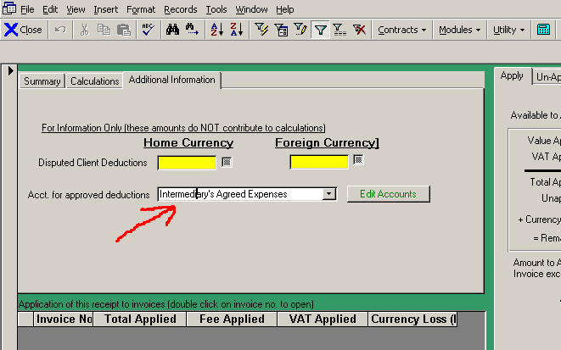

* (Licensing Entity) Comet prompts to include Licensor VAT number within the Licensor Invoice Address.
* (deal memo and invoices) Improved fallback to Licensee Name if address information missing or unavailable.
* (VAT Customers only) Check that VAT setup information is valid prior to printing invoices.
* In updates and patches, Comet allows selective block of Contract Titles to exclude from invoice prompt screen.
* Report 139, “Invoices Due at Invoice Exchange Rate”, has closing parenthesis in report title.
* Report 141 had incorrect column heading, changed from “VAT Paid Invoice Rate” to “Total Paid (Value and VAT) Invoice Rate”
* Comment added to report #115, “Under and Over-Applied Cash Receipts” that the amounts are in the base currency “at the Invoice exchange rate"
* Accounting interface has new available amounts:
  + (Revenue posting) Cost of Sale (Home Currency Contract Rate)
  + (Invoice Posting) Cost of Sale (Home Currency Contract Rate)
  + (Invoice Posting) “Cost of Sale (Home Currency)” changed to Cost of Sale (Home Currency Invoice Rate)
* Comet contains a new due date functionality when creating and specifying royalty statements. By entering the number of days after the reporting period the report is due as shown here:

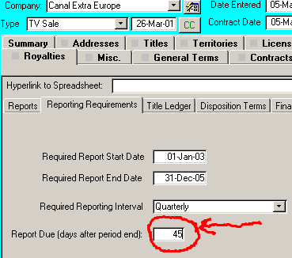

Comet will fill in the “Due date” for each report as shown here:

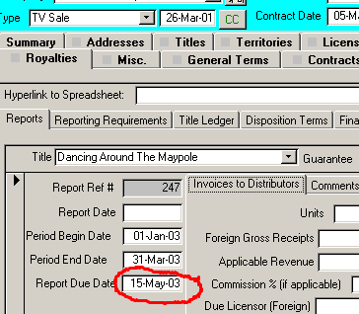

* New view of title information available. By clicking on the title in the Contract Title Detail tab, a new form view is visible which allows easy view and entry of information.

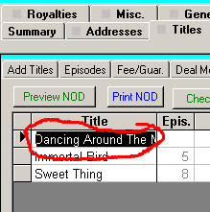

Comet will show view as shown here:

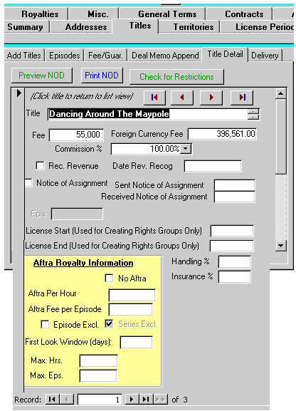

* When entering a license term end date, Comet will automatically replace the avail report text and prompt to replace the deal memo text.
* When entering a license term end date from the Right Summary screen, Comet will automatically replace the avail report text and create deal memo text if blank. If not blank, Comet will prompt to replace it.
* Report 115, “Under and Over applied cash receipts”, now has main title width increased to not cut off ends.
* (Invoicing) When printing invoices, Comet prompts to print Accounts and Sales copies.
* New report #193 “Receipts and Application Reconciliation Summary” shows receipts and full reconciliation of amounts in base currency and application to invoices. Fields shown include:

|  |  |
| --- | --- |
| Receipt # |  |
| Check/WT # |  |
| Payment Date |  |
| Deposit Account |  |
| Currency of Payment |  |
| Net Deposit |  |
| Net Deposit-FC |  |
| Bank Charges-Licensor |  |
| Gross Payment |  |
| Withholding Tax |  |
| Intermediary Amount |  |
| Approved Deductions |  |
| Net Credit Including VAT |  |
| Net Credit Excluding VAT (Base currency invoice rate) |  |
| Amount Applied (Base Currency Contract Rate) |  |
| VAT Amount applied (Base currency Invoice Rate) |  |
| Amount Applied (Base currency Invoice Rate) |  |
| VAT Applied (Base currency Invoice Rate) |  |
| Currency Gain/Loss (Base Currency Invoice Rate) |  |
| Unapplied Amount | The total receipt amount that has not been applied |
| Exchange Rate | The Comet exchange rate table rate or customer override rate as entered. |
| Invoices applied to | List of invoices the receipt was applied to |
| Titles Applied To | List of titles related to the invoices that the receipt was applied to |
| Contracts Applied to | List of contracts linked to the invoices that the receipt was applied to |
| Customers Applied To | List of customers in the contracts linked to the invoices that the receipt was applied to. This value is different than the customer name selected in the receipt. |
| Receipt Customer | The customer name selected in the receipt |

* (Accounting interface) “All” filter checkbox activated in Accounting Interface reports, available from Accounting Interface splash screen.

**2002-06-21 10:50**

* (development) Send to Comet Titles moved from icon bar to screen. Buttons for reports 190 and 191 moved to icon toolbar.
* (report fix) New Development/Script tracking reports 190, “Recent Project Submissions” date submitted cutoff fixed and word wrap added to title and author(s).
* The Comet Automatic Loader and Updater applet has been improved to automatically detect which version of Office and Access is installed on the desktop. It is available as a hyperlink on the Comet Update page. This applet will:
  + Automatically load all versions of Comet
  + When a new version of Comet is copied to a designated location on the server by IT, this applet will copy it down to the desktop automatically without user intervention.
  + Check to make sure that certain required files are present
  + Create an INI file called CometRun.ini which contains the settings used to load Comet, including the full shortcut and location of the update paths. This file contains complete instructions on which files to set.
  + By default, the automatic updating is disabled, so the applet will simply launch Comet and ignore the update settings. By opening the file CometRun.ini and setting the parameter “Use Comet Update Process”  
    to “YES”, Comet will perform the automatic update based on the other settings in that file.
* (Excel Deal memo) Number of spaces after the “Print Name:” section of the signature lines reduced to 35 spaces to prevent spillover into third column and cause blank page printing.
* Comet has new fields for entering the following dates:
  + Deal Memo Sent to Customer
  + Deal Memo Received from Customer
  + Long Form sent to customer
  + Long Form Received from Customer

These dates are available in the new “Document Dates” tab within a Contract.

* Comet holds a checkbox for “Notice of Assignment Required” and date entry fields for “Notice of Assignment Sent” and “Notice of Assignment Received”. This information is available in the NOD screen and in the Title Detail tab within a contract.
* New report #192 “Contract Document Status” shows the status for the Deal Memo Sent and Deal Memo received, Long form sent and received, Notice of Assignment sent and received.

**2002-06-12 14:36**

* New Development/Script tracking reports 190, “Recent Project Submissions”, and 191, “Active Development Projects”
* Cosmetic changes to Development/Script tracking screen layout and reports
* Development module: user message improved with clipboard import of blank values
* (fix) Comet modular structure problem with screens hiding behind other screens fixed.
* Comet has new expanded direct launch directory in the opening splash. Mouse-click to launch selected area.

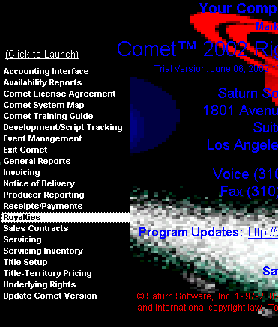

**2002-06-06 17:02**

* (SQL Only) (Development module) Naming problem in “Log Line” fixed
* (Development Module) When using clipboard template import utility, Comet will move record to title if found, or create a new title if not found. Comet also limits import size to not exceed field size capacity.

**2002-06-05 00:29**

* (Bug fix) Problem fixed in new invoice aging reports 186 “Itemized Invoice Aging-Base Currency Invoice Rate” and 187 “Itemized Invoice Aging Report in Foreign Currency”, where the 91-120 column was showing the 0-30 column.
* Comet allows changing the contract exchange rate. Shown is where the base currency license fee amounts will be adjusted to the new rate based on the foreign currency license fee amounts (with a yes/no prompt)

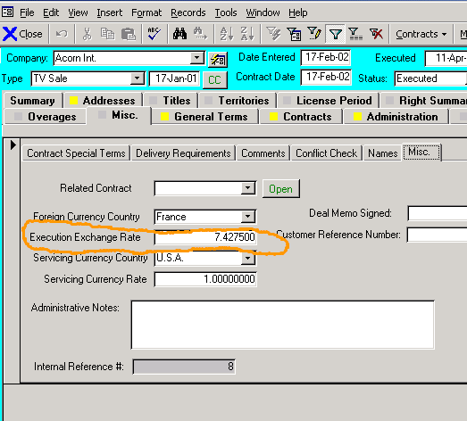

* The Comet Accounting interface has a new account number choice, “<<BANK ACCOUNT CODE>>. This choice will use a new code set up in the Bank Account setup screen called “AccountingInterfaceCode” based on what account the receipt was deposited into as entered in the Comet cash receipts screen.

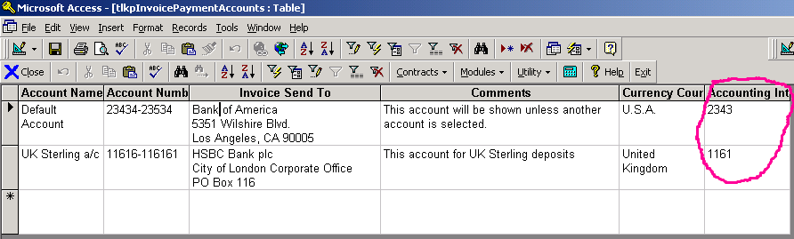

* The Comet Accounting Interface allows setup of “Approved Deductions” as a lookup value.
* Report 60, “License Types”, is a better viewing format and can be edited.
* The Contracts and the Development screen has a list of hyperlinked files. In the contracts screen, it is located in a new sub-tab in the “Misc” tab. By clicking (for existing or new hyperlinks) Comet will open or prompt for a new linked document. By double clicking on an existing hyperlink, Comet will prompt to over-write it. Any registered file may be linked, including Word documents, images, spreadsheets, music files, video files, or email.
* New report 188, “Hyperlinks List”, shows all hyperlinks across Comet.
* New report 189, “Contracts by Customer showing Payment Information” combines the Contracts by Title reports (#32) with Rights and Windows report, grouped by customer. This report requires Legal Size paper.
* (Development Module) A new feature in the Development module has been implemented where Comet will import development coverage data from an e-mail or Word document. This is accomplished by copying the document to the clipboard, and then pressing a button in the center of the Comet development screen as shown:

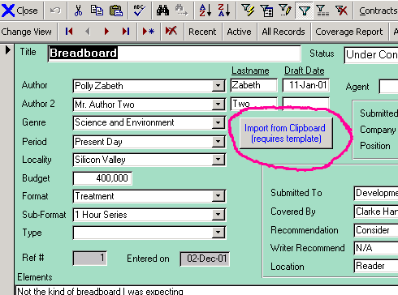

* The document contain data as formatted in the template located at

<http://www.saturnsoftwareinc.com/GenericDevelopmentCoverageTemplate.exe>

**2002-05-31 00:52**

* New output format for former accounting interface, now labeled “Unbilled A/R Postings” screen. Hourglass and record progress added to status bar. Menu selection changed from “Postings” to “Unbilled A/R”
* When printing “Available Only” reports, Comet shows current record information being processed on status bar to avoid impression that application has frozen.
* (SQL Users only) Comet computes the currency gain/loss between the contract rate and the invoice exchange rate. This value is available in the invoice default postings setup as “Currency Loss (Gain)”.
* (SQL Users Only) (Accounting Interface) minor problems with the use of the Accounting Interface floating menu fixed, including the necessity to close the form in order to edit data, the addition of a minimize button, and the forms opened through the interface hiding behind other forms.
* On the accounting interface, the “Alpha Invoice Number” now shows next to the invoice ID number in the invoice postings screen
* There is a new button to open the journal table directly from the Accounting Interface floating menu.
* Accounting interface shows negative amounts in “(12,345.00)” format instead of “-12,345.00”

**2002-05-25 23:33:**

* (bug fixed) In the Contract screen, when entering a new contract, upon entering license term, harmless message “The macro or function set to BeforeUpdate or ValidationRule property for this field is preventing Comet from saving the data in the field” problem has been fixed. Workaround on previous versions is to ignore message.
* When Comet is looking up the “Signature of Deal Memo” event, if there is no signature of deal memo, but there is a Contract Execution date, Comet will use this date instead.
* The manual “Recognize Revenue” checkbox, and the “Date Recognized” boxes have been added to the Contracts screen, Invoicing tab, Invoice Summary by Title sub-tab
* Report 184, “Unrecognized Income by Title”, shows the invoiced amounts next to the License Fee amount.
* All single title invoices show “Credit Note” as document title if amount invoiced including VAT less than 0.
* Some single-title invoices which previously showed “Invoice” as document title changed to “INVOICE”

**2002-05-17 04:40**

* Layout, filtering, and formatting changes to new reports 186 and 187
* When printing Comet standard deal memo/Contract or Comet invoices, if ACT is not being used, contract company name shown instead of ACT error message in customer address window
* Delete Receipt button moved to “Actions” tab and labeled as shown:

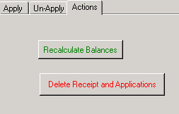

**2002-05-16 03:26**

* New report 186 Itemized Invoice Aging-Base Currency Invoice Rate

Shows an itemized aged debtor report in base currency at the invoice exchange rate. Report output and query output available.

* New report 187 Itemized Invoice Aging Report in Foreign Currency. Shows an itemized aged debtor report in foreign currencies. Report and query output available.
* When opening Title Setup screen, Comet forces re-query of Existing Contracts

**2002-05-13**

* Report 126, Shipments by Customer with Contract/Month Subtotal, sorts by delivery date if commercial invoice date not available.
* Report #180 now includes the override “Alpha invoice number” and is in the Finance report group.
* Report 95, “Territory Report”, has a checkbox option to list conflicting parent and sub-territories.
* The Invoice View screen will prompt to update the base currency amounts if the foreign currency amounts are changed.
* When creating an exclusion description, Comet prompts to show it in Notepad if it exceeds 255 characters.
* If voiding a commercial invoice, dub request, or materials invoice that has never been saved, Comet will provide a message.
* Warning message put in the Contract Producer Reporting Producer/Source tab related to Commission Rate on this screen: *“Note: This commission rate is used only for screen viewing here and in the contract list, and is not used on reports. Please enter the rates by title in the "Commission Rates" tab to enable Comet to compute and report commissions.”*
* Problem fixed, where, if closing cash receipts, Comet tried to disable “Close” button which is not possible if it has the focus. User would hear beep. Problem fixed in this version.
* Comet verifies that the ACT! database is set correctly and exists before launching ACT!. If it is not, ACT! is disabled until Comet is restarted.
* For report 103, “Title Information-Selected Title”, new checkbox option “Show underlying rights oriented version” will open new format which contains more underlying rights information.
* Improvements made to new invoice reconciliation screen, where out-of-balance invoice amounts show in red background.
* Availability Report Format #2 supports the “Worldwide Rights in Perpetuity” checkbox in the title setup.

(SQL Installations only) The following activities are now logged in the Comet Activity Log, which is available as report # and for each contract in the Misc. tab. Shown is a full list, many items added to this version, others already existed in previous versions.

|  |  |
| --- | --- |
| **COMET AREA** | **Logged Activity** |
| Accounting Interface-Logged in separate table. Security settings can prevent changes (no edit or delete of created records) | **Accounting interface postings** |
| Availability Report | **Print availability Report** |
| Company | **Add new customer address** |
| Company | **Create a new customer address from the servicing area** |
| Company | **Create a new customer in system** |
| Company | **Delete Customer name from system** |
| Contract Entry | **Change Contract Date** |
| Contract Entry | **Change contract execution date** |
| Contract Entry | **Change contract number** |
| Contract Entry | **Change Contract Status** |
| Contract Entry | **Change Contract Sub-type** |
| Contract Entry | **Change to contract exchange rate** |
| Contract Entry | **Changes to contract customer company name** |
| Contract Entry | **Delete contract** |
| Contract Entry | **Enter new contract** |
| Contract Entry | **Modify contract customer** |
| Contract Entry | **Open/Edit existing Excel deal memo** |
| Contract Entry | **Perform conflict check** |
| Contract Entry | **Print/create new deal memo (Standard and Excel)** |
| Contract Entry | **View contract** |
| Contract invoicing | **Reverse invoice** |
| Contract License Term, Contract license term rights level | **Change license term text (Contract level and rights level, both with create text button or editing box)** |
| Contract Payment Terms | **Edit payment terms description box** |
| Contract Rights | **Add right category** |
| Contract Rights | **Change holdback text (with "create text button" or by editing box)** |
| Contract Rights | **Copy rights category** |
| Contract Rights | **Remove right category(from right summary and right detail)** |
| Contract Servicing | **Create Dub description** |
| Contract Summary Report | **Create new or open existing contract summary** |
| Contract Territories | **Add territory to contract, including via territory groups** |
| Contract Territories | **Remove all contract territories** |
| Contract Territories | **Remove territory from contract** |
| Contract Titles | **Add title to contract (from groups, single, clicked)** |
| Contract Titles | **Change title license fee (In primary license fee and datasheet view, both foreign and base currency)** |
| Contract Titles | **Remove title from contract** |
| Invoicing | **Print/preview invoice (standard or multi-title or multi-title multi-period)** |
| Invoicing-Logged both in Activity Log and in separate table. Security settings can prevent changes (no edit or delete of created records) | **Create invoice** |
| Notice of Delivery | **Print/Preview NOD (NOD Batch or from contract)** |
| Receipts | **Close cash receipt** |
| Receipts | **Delete receipt** |
| Receipts | **Reverse cash receipt** |
| Receipts-Logged in separate table. Security settings can prevent changes (no edit or delete of created records) | **Create cash receipt** |
| Reporting | **Print Comet general report** |
| Servicing | **Void commercial invoice/shipping invoice** |
| Servicing | **Void dub order** |
| Servicing | **Void materials invoice** |
| System | **User Login** |
| System | **User Logoff** |
| Title Setup | **Add a new title to Title Setup screen** |
| Title Setup | **Delete a title from Comet** |
| Title Setup | **Mark title as inactive or as active (note-log text syntax slightly changed in this version to not include cause in the Action column, only in the Comments column)** |
| Title Setup | **Rename a title** |

**2002-05-02**

* (Additional Report Options) Report 172, Invoice Statement By Customer-Foreign Amounts, and report #51, Invoice Statement By Customer, have checkbox option to show or not show ACT! address. Also, reports allow long title names by word wrap.
* Report #88, Invoice Statement by Customer, uses the alpha (override) invoice number if available
* Report 126, “Shipments by Customer with Contract/Month Subtotal”, in the Date Shipped column, will first try to show the date shipped from a commercial invoice. If the dub request was never put on a commercial, as is the case with satellite delivery, Comet will show the delivery date from the servicing screen instead, if any. This is the same logic that report 124, “Titles Shipped Report (Report by Customer)”, has used since 2001.
* (New screen) Comet has a new invoice reconciliation screen which allows a full view of Comet invoice financial fields, logically grouped. It is available from the Modules->Setup->Advanced Settings screen, pressing the button “Updates and Patches, then pressing the button “Invoice View”.
* Comet loan item support has been improved in the Servicing module. The tape location for loan items may be changed from the dub description popup. The available loan item pulldown box in the Contract Servicing Loan Item tab now shows the list correctly.

(2002-04-30)

* (New report) New report #185, “Accounting Interface Journal” shows the export file from the accounting interface.
* (New report/Screen entry) New report 184 shows all titles where the "Recognize Revenue" checkbox has not been selected, or where it has but the revenue recognition date has not been entered.

**2002-04-29 22:04**

* (improvement) In Notice of Delivery batch screen, the Delivery Date, Delivery Due Date, and Technical Acceptance Date added to screen for population or editing.
* (new feature) In the contract territory input screen, a new button will show all conflicting sub-territories of the selected territory.
* New field in contract title input, “Date Revenue Recognized” for simple manual revenue recognition model. New report #183,” Revenue Report based on Manual Checkbox and Date” shows all revenue manually recognized within a date interval.
* (bug fix) Format 2 Availability report data accuracy problem fixed with sub rights.

**2002-04-25 (interim release)**

* Reports 1, “A/R Aging Report”, Report 31, “Contracts by Title, All Titles with Contracts” and Report 32, “Contracts by Title, excluding materials” show staggered totals to allow additional digits.
* Report 155, ” Receipt Application by Title (Report)” has staggered totals, and includes the report number and customer.

**2002-04-15 12:19 (interim release)**

* (SQL users only) Comet Accounting interface module, previously a stand-alone module, integrated with Comet. Available from the Modules->Accounting menu. Comet capable of exporting invoices, receipts, and revenue into external accounting system.

**2002-04-08 06:50**

* (Minor improvement) When adding a selected title which was already included to the availability report screen, Comet will not show a duplicate error message.
* (availability report interface improvements) Changes made to all availability report settings screen layout to make the interface, particularly for Format 2, easier to use and understand.
* (bug fix) Problem fixed with global conflict check where report was taking excessive time to create and produced erroneous conflicts with parent territories.

**2002-03-29 07:26**

* In a Marketing Materials contract type, The “Territories”, “Right Categories”, and “License Term” tabs are now visible for customers who want to see more information about marketing screener customers. Use is optional, and may be disabled.
* (minor bug fix) Fix to popup box related to licensing entity record when filtering to a territory and running a report that shows the licensing entity. Problem caused by relationship between Licensing Entity VAT territory and filtering process.

* **(New Foreign Currency Report Options) The listed reports contain the options listed below:**

|  |  |
| --- | --- |
| 26 | Contracts by Customer with Rights-All Customers |
| 27 | Contracts by Customer with Rights-New Page Each |
| 73 | Rights and Windows by Related Territory |
| 74 | Rights and Windows by Territory |
| 77 | Rights and Windows by Title |
| 78 | Rights and Windows by Title-One title per page |
| 81 | Sales by Customer-Selected Customer |

1. A “Currency Rate” pulldown prompts for
   1. **“Contract Rate”** at the Date Entered
   2. **“Rate as of**” (defaults to today’s date)
   3. **“Original Currency**” (displaying a mix of currencies with the currency country, defaults to today’s date)
2. A “foreign Currency” option, to show the report in the selected currency (not available if set to show Original Currency option.

Shown is a screen snapshot from the General Reports screen, options setting:



Please note the following:

* If the Currency Option is set to **“Contract Rate”** and the “Currency” option is set to the system base currency, Comet will show the report that existed before this modification, which shows the base currency amount at the execution exchange rate. The date is not available for entry with this setting since Comet uses the contract exchange rate.
* If the Currency Option is set to **“Contract Rate”** and the currency is set to a value other than the contract rate, Comet will convert the contract currency base currency amount at the contract rate to the foreign currency amount using the rate effective at the Contract Entry date. This report is intended to provide third parties with foreign currency equivalents that will not change over time. If the contract entry date is not available, Comet will use the Contract Execution date and then look to the Contract Date.
* If the Currency Option is set to “**Original Currency**”, Comet will show the original contract currency, which does not change with time and hence the date is not visible.
* If the Currency option is set to “**Rate As Of Date**” and the currency is set to a currency other than the base currency, Comet will first convert the contract currency to the base currency equivalent at the As Of Date and then to the foreign currency value as of the same date. Since the exchange rate table only shows rates in relation to once currency, Comet must perform two lookups (a.k.a. triangulation) to convert one rate to another.
* (MDB format only) Comet has the capability, if set, to open up on a network drive set to be read only through network settings.
* (New report) New report #182 “Titles Without an Underlying Rights Contract”. This is a list of titles without an underlying rights agreement entered into Comet. Some of the new available only reports require that an underlying rights agreement be entered, even if the “Worldwide Rights” checkbox is set in the title setup.
* (General Improvement) The Comet contract screen tab order has been moved based on careful consideration of customer feedback, workflow analysis, and ease of data entry.

**BEFORE AFTER**

|  |  |
| --- | --- |
| Summary | Summary |
| Titles | Addresses |
| Addresses | Titles |
| Right Summary | Territories |
| License Term | License Period |
| Territories | Rights Summary |
| Rights | Rights Details |
| Misc. | Payment Terms |
| Royalties | Royalties/Overages |
| Payment Terms | Misc. |
| General Terms | General Terms |
| Administration | Contracts |
| Dates | Administration |
| Invoicing | Dates |
| Servicing | Invoicing |
| Contracts | Servicing |

* (General Improvement ) The Contract Currency is moved to the Titles/License Fee tab
* (General Improvement) A new Conflict Check Date text box, and “CC” (=”Conflict Check”) button were added to the top of the Contract Entry screen in the place of the Foreign Currency Country. The tabbing order of this section was updated.
* (General Improvement) The Comet availability Report settings tab order and tab caption is changed to make the interface more understandable.
* (Improved functionality) If changing the “Description” of the multi-title invoice, Comet will remember the saved changes into the table “tblInvoiceLog” and recall it if reprinting the invoice. Only applies to the Multi-title invoice, not the Multi-title/multi-period invoice.
* (Fix to Display formatting) When showing the total invoice amount for fixed payment invoices in payment terms, Comet does not show a % format.

**2002-03-12 07:39**

* (Non-SQL only) On update, Comet won’t show message regarding SQL currency rate update.
* (Update) Report 12, “Application of Cash Receipts, All Receipts”, report 13, “Application of Cash Receipts, All Receipts” and report 17, “Cash Receipts Journal” now show net credit including VAT/GST for complete reconciliation.
* (New Report) Detailed global conflict check report, which may be run from the Availability Report screen in a new tab called “Global Conflict Check” based on the selected titles, territories and rights.
* (New feature) “Change Customer Name” button provided in company profile. Changes logged to Activity Log
* (New Availability Report Format) Comet has new availability report format, showing only available rights. Underlying rights, exclusions, and license periods are taken into account. This report may be run from a new tab (“Available”) in the availability report settings screen. A button allows users to edit the data used to create this report, and re-run the report incorporating the edits. Also included are the following new queries:
  + A query showing all rights available to license, and the underlying rights license term
  + A query showing all rights licensed
  + A query showing all underlying rights, with a checkbox to show which rights are licensed.

**2002-02-26 15:43**

* (SQL Only) Comet prompts upon SQL update to perform exchange rate update.
* (Update) Report #83, Formatted Sales by Title by Year updated to show sales for range 1997-2002
* (Improvement) Comet Standard Deal Memo shows licensing entity information as selected in contract.
* (New Licensing Entity option) New checkbox in Licensing Entity setup screen allows user to set default licensing entity. This value set during this update to match the Licensor Company name as set up by Saturn, and may be changed.

**2002-02-18 11:35**

* (New Feature and Entry Field) A new field was added to the title information, “Program Format”. This field appears in the Title Setup, Content tab and is intended to be used for entering a free-form title format, such as “26x30’” or “2 Hour Feature”. A new option on the availability report screen (Options if right available) allows this field to be shown after the title name in all availability reports. Button next to selection opens query to edit title formats for all active titles.
* (fix) The toolbars in Event Management and Development do not overlap with the Comet main toolbar, and are repositioned on a new toolbar row.
* Report 26 and 27, Contracts by Customer with Rights, have new checkbox option “Show Price Sold”. Option if set will show, after each title, the price sold (features) or price sold per episode (Series)

**2002-02-15 14:55 (interim release not posted on Internet)**

* (fix) Comet will not accidentally switch into “Sample Database” mode if user presses key during initialization sequence
* (fix) When opening Comet Modular Structure, Comet does not switch focus to Splash screen.
* (fix) (Comet for Office XP only) Comet does not suddenly close when opening Invoice tab within a contract.
* (Improvement) If using the sample data base, Comet gives some navigation pointers when opening up contract or title lists from the splash screen using the buttons.
* (Cosmetic) The “Other Dates” in the Contract Dates tab caption changed to “Override Dates” which more accurately describes entry there.
* (New feature) Comet availability reports have new button to remove obsolete titles selected (if any)
* Correct spelling of report name # 169 from "Current Exchange Rates" to "Current Exchange Rates"
* (improvement) When pressing the “Check Contract Entry button in the Contract Misc. Conflict Check sub-tab, Comet confirms that no entry problems found (if none found) with message box.
* (New Report) Report 181, “Rights and Windows by Customer”, shows rights and windows in a format similar to report #77, “Rights and Windows by Title”, except grouped by Customer and then sorted by Title. “Show Obsolete Titles” option and “Show Underlying and 3rd party Contract” option available as with report #77.

**2002-01-31 02:23**

* (new Availability report option) Availability report by title now has option to show Minimum Guarantee (MG) for each contract , previously only available in the Availability Report by Territory.
* (New Availability Report option and improvement) “Allocate MG for Each Contract”: Turning on this option will show the total license fee for all right categories, each multiplied by the territory allocation %. (new) This option is now used when choosing the Show MG for Each Contract.
* (Fix) In the general reports tab, when the “End Date” is set to the 28th, 29th or 30th, Comet will not warn that the date is not the last day of the month unless the box is visible.
* (Improvement) Comet will show cross-collateralization text, if any, in all Excel-based deal memo formats.
* (improvement) When showing MG column, performance improved and memory use reduced.
* (fix) Possible report stop caused if contract company name missing when showing MG columns is now fixed.
* (Improvement) Comet now asks to fill the event prompt list when opening up the event management form
* (Improvement) Comet will prompt when updating the event management form to include updating the holdbacks, which can be time consuming.
* (Improvement) in Event Management screen, icon heading changed from “Update Data for All Entered Event Dates” to “Populate Comet with Dates Entered in List” for better clarity.
* (Improvement) Speed improved of Avail by Title report.
* (Cosmetic Improvement) Numerous formats where Comet would show fractional amounts without leading 0 as “.234” changed to show as “0.234”. Change made in availability report pricing ($k/ep.), exchange rates.
* Cents amounts shown on multi-title invoice pop-up
* (New Availability report option) Comet has new option to show Contract Execution date, shown as “ED:31-Jan-02” format

**2002-01-23**

* Popup error removed when running the Comet 2000 version with Office XP

**2002-01-18 01:30**

* (New Feature) Report 77 and 78 option to show underlying rights includes 3rd party contracts
* (Improvement) Comet construction of text payment terms shows “before” or “after” if interval and number of periods blank but “before” or “after” selected.
* (New Invoice Layout) Comet multi-title invoice has “condensed titles’ checkbox, which if checked will show titles in “Title1, Title2, etc.” format. Comet supports condensed title VAT invoice format.
* (New Feature) The base currency of Comet may be switched to any currency including the Euro, $US, and Pound Sterling. Capability to make one-time switch of system base currency in “Updates and Patches” screen improved to include license fees, AFTRA amounts per episode/hour, servicing costs and dub prices in dub orders and material invoices, customer default prices, availability report pricing, all invoices, cash receipts, and application of cash.

**2002-01-14**

* (New Feature) Report 77 and 78 have option to show underlying rights contracts with sales contracts. Contract type is shown to right.
* (Fix) Report 77 does not have erroneous popup box when showing obsolete titles
* (Improvement) Contract input, Rights tab, Misc. sub-tab name changed to “Runs/Playdates/Other”. Field layout changed within tab.
* Comet allows canceling new contract entry process after prompt for new contract number
* (New feature) Avail reports have new checkbox option to show licensing entity

**2002-01-11**

* (Improvement) Reports screen-when pressing tab to move between reports, the report name is not included in the tab stop.
* (Fix) Report filter criteria now enabled (unintentionally disabled since 2002-01-10)
* (Improvement) Cosmetic re-positioning of report filter options

**2002-01-10 17:14**

* Overages pulldown sort order is first by sort order column then alphabetical by overage type (if sort order is the same or blank)
* Comet Overage/Distribution Terms setup screen re-formatted and includes sort order field used to sort pulldown.
* Comet standard deal memo: if the contract address is not linked, Comet will show the licensee name in the address box instead.
* On payment terms entry, if choosing “Before” or “After”, result shown in lower case on deal memo or payment terms appendix
* For Payment Terms entry, if there is a “before” or “After” interval selected without selecting “Before” or “After”, comet will default to “Before”
* When showing payment terms without a before or after resulting in “on”, extra space character removed.
* In general reports, if a filter option is not available, it is hidden, instead of being grayed out. This is to emphasize the available filter/checkbox options.
* New licensing entity checkbox option, “Show Logo on VAT Invoice” Set to “false” by default, may be changed in Licensing Entity setup screen.

**2002-01-07 10:20**

* When previewing materials invoices with only one dub, Comet now shows correct amounts and previews detail appendix. Print was working correctly.
* Report 26, “Contracts by Customer with Rights-All Customers” and report 27, “Contracts by Customer with Rights-new page each” have a report settings checkbox option (in the report filter area) to show episodes sold for each series.

**Comet changes prior to 2002:**

<http://www.saturnsoftwareinc.com/CometSupportFiles/CometChangeLog1998Through2001.doc>